Sarah Wood

C#, part 2, ASP

Final Project

Programming Journal

9/13/2016: Got approval to do final project on “Riggers’ Database 2.0 for ASP”. Started new Visual Studio project. Started detailed list for requirements. Built AspUserRole table, imported Riggers database schema, built AspNetUsers table. Configured for Azure.

9/14/2016: Added test data to tables, Started fussing with CSS, created Site.Master, built Test Page.

9/15/2016: Inception Deck finished, Agile documents updated, Home Page begun,

9/16/2016: Home page updated, Logins work, new database did NOT migrate to Azure, Entered test data, wrote copy for About, Contact, Error, Help pages

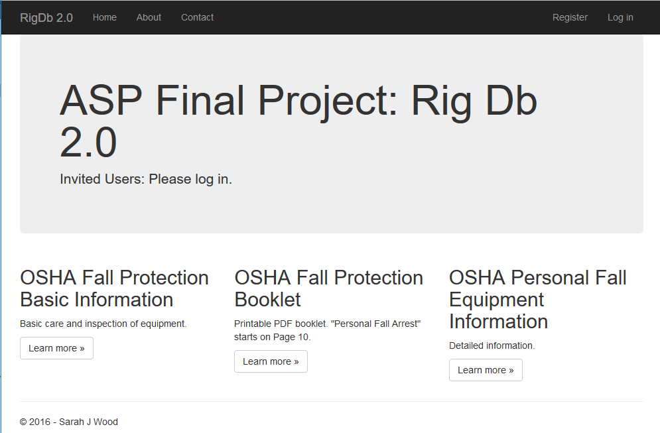

9/19/2016

Paying down tech debt. Integrated with Git, TFS, and Azure.

Project is running on Azure service in the wild at http://sjwasp.azurewebsites.net/

Connected with AzureDB service in VS.

Built Models for Data

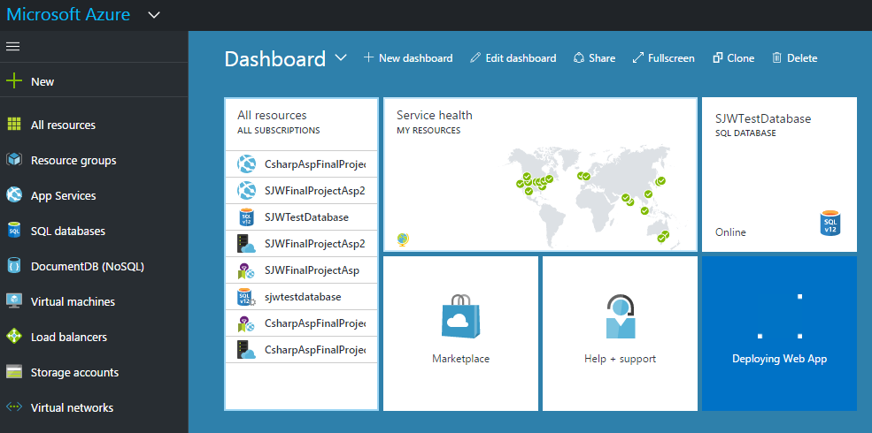

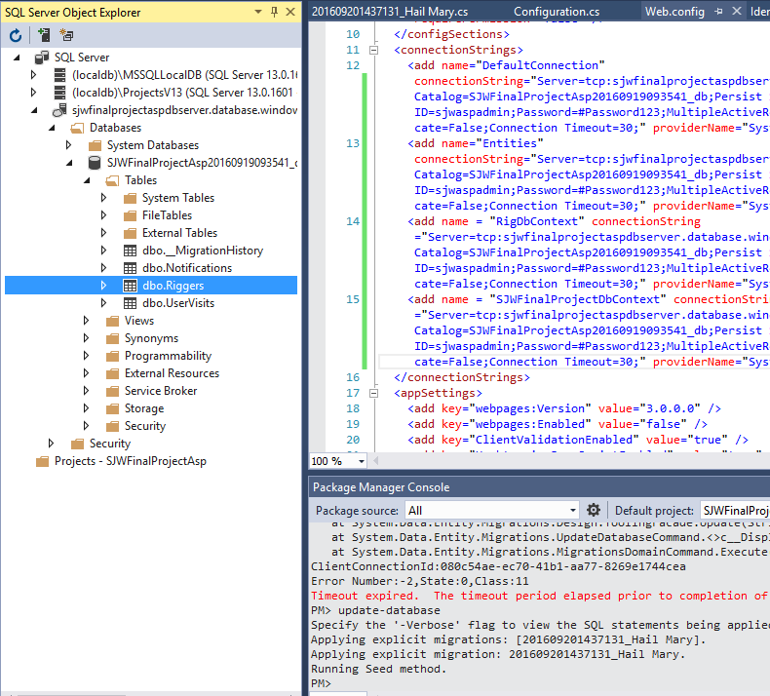

9/20/2016

Hooray! My seed methods completed. I have real code-first tables. Dummy data plugged in to Riggers’ table, user tables are populating: it is actually working!

9/21/2016

Scaffolded special content view for logged-in users. (“Admin” view). Some debugging.

9/22/2016

Added link to logged-in user content page. Built GridView of employees. User can log in and go to employee table.

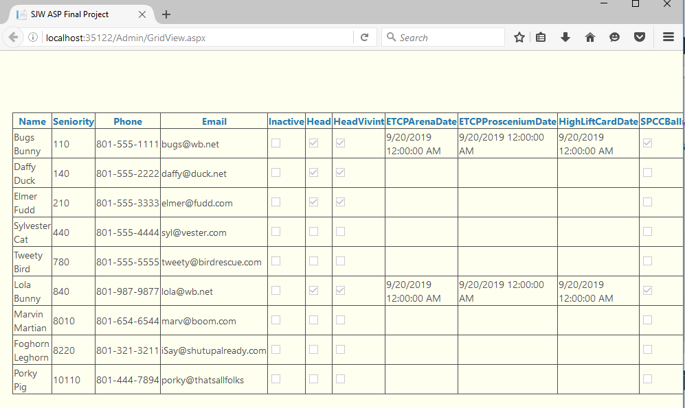

Updated links to get to this data view, and added an “admin only” link to a logged-in user’s navigation header.

Fresh publish, and…

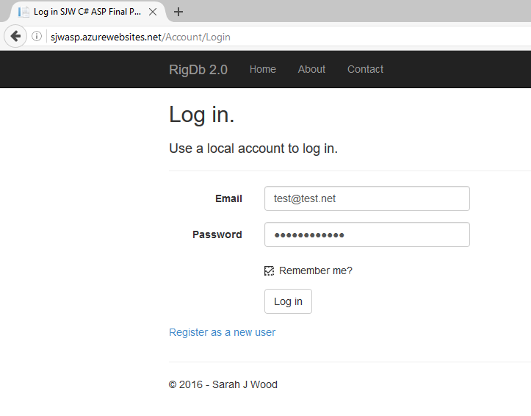

So far, so good.

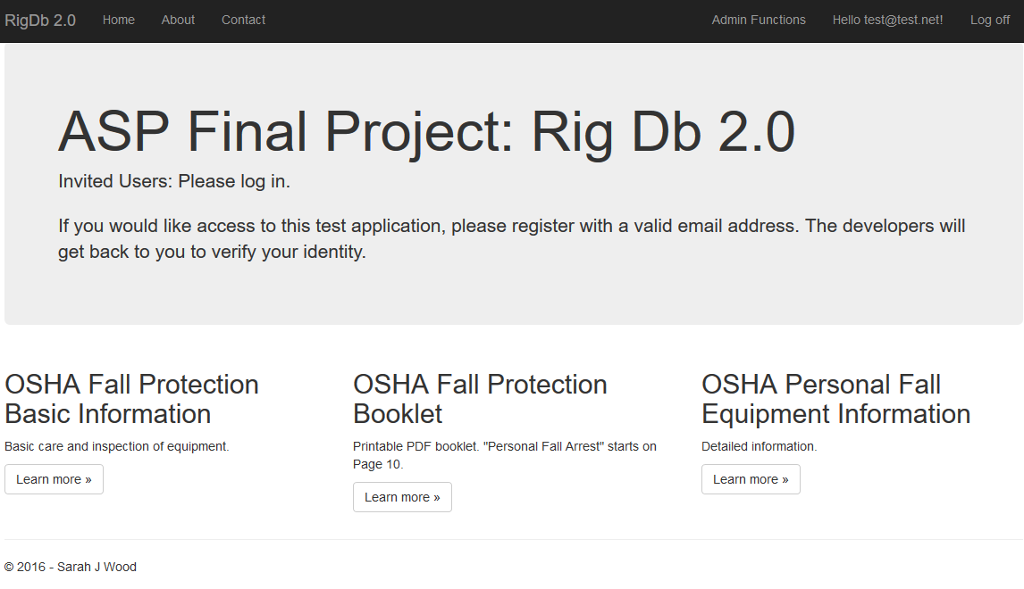

I logged in, and got the “Admin” view of the Home Page. Let’s poke around.

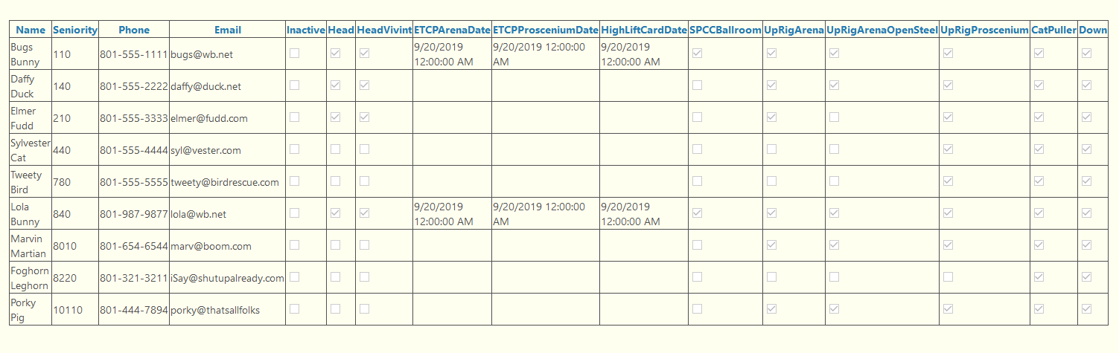

I can get to my data!

There is a fair bit of fussing and improvement to be done, but basic functionality is here.

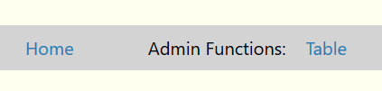

I added “Home” links to the Admin pages.

RELEASE 1.0 time! Check out this website in the wild at <http://sjwasp.azurewebsites.net> (It may only be up for a few weeks: taking advantage of 30-day Microsoft offer.)