Sarah Wood

Tools for Software Development

ACC 3-2

My Master Story List

1pt Menu to select math operator

3pt Flash-card like interface

1pt Answer checking

1pt Reveal correct answer on missed problems

3pt Variable difficulty

5pt Banks of problems

My Burn-Down Chart (actually my Burn-UP chart)

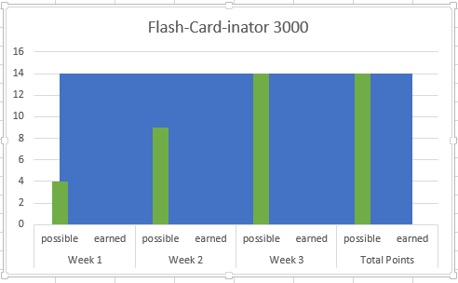

I’ll earn those points. Go team!