Sarah Wood

Tools for Software Development

ACC - Deliverable #1

While I was coding, I realized that it would be far simpler to generate problems at runtime than to build and reference a “bank” of established problems. Addition and multiplication were extremely easy to implement in this way. Subtraction was also pretty straightforward, I simply had to qualify that if “A-B”, then A had to be larger than B.

I’m still polishing division. It’s functional, but not quite perfect. If A ÷ B, then they need to be evenly divisible (%=0). That is where it sits now, but I still get problems that are unlikely in elementary school, like 75 ÷ 5. I may solve this by adding an additional qualifier in the valid problem algorithm that the answer must be 12 or less.

It also depends on the math levels of this particular client school. This may be OK with them. I will check at the next virtual Iteration Meeting.

I also need a better gimmick. Maybe “Math vs. Monsters”, or something to do with cars or dinosaurs.

Screen Caps

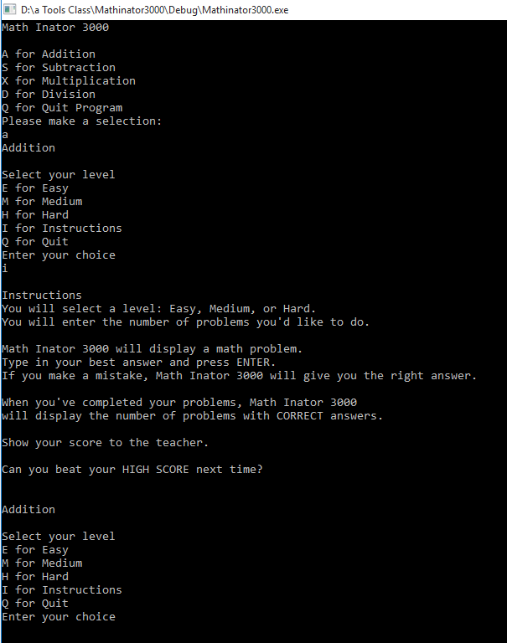

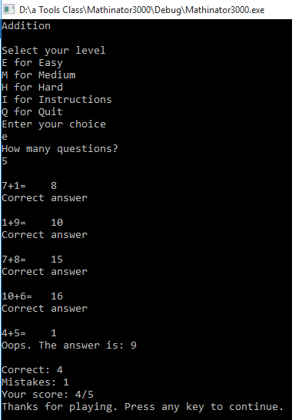

Rinse and repeat for other levels and operands. The “any” key takes you back to the main menu. I thought it would be easier for the client to keep the program open for multiple sessions or students. It would be a pain to have to re-start the whole program again and again.

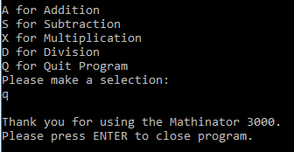

Source Code

&&&&&&&&&&&&&&&&&&&&&&&&&&&&&&&&&&&&&&&&&&&&&&&&&&&&&

/\*

%%%%%%%%%%%%%%%%%%%%%%%%%%%%%%%%%%%%%%%%%%%%%%%%%%%%%%%%%%%%%%%%%%%%%%%%%%%%%%%%%%%%

Math Inator 3000

(if I add graphics, this may change to Math vs Monsters)

%%%%%%%%%%%%%%%%%%%%%%%%%%%%%%%%%%%%%%%%%%%%%%%%%%%%%%%%%%%%%%%%%%%%%%%%%%%%%%%%%%%

Sarah Wood

Tools for Software Development

OWATC Spring 2016

Math teaching program for Agile Elementary

four basic arithmetic operators

practice problems

flexible difficulty

\*/

#include <iostream>

#include <cstdlib>

#include <time.h> //for Randomizer 3000

//no custom namespace required

using namespace std;

void main()

{

//init console

cout << "Math Inator 3000" << endl << endl;

char userEntry;

MAIN:

cout << "A for Addition" << endl;

cout << "S for Subtraction" << endl;

cout << "X for Multiplication" << endl;

cout << "D for Division" << endl;

cout << "Q for Quit Program" << endl;

cout << "Please make a selection:" << endl;

cin >> userEntry;

switch (userEntry)

{

case 'A':

case 'a':

{

A:

cout << "Addition" << endl << endl;

char addLevelChoice;

cout << "Select your level" << endl;

cout << "E for Easy" << endl;

cout << "M for Medium" << endl;

cout << "H for Hard" << endl;

cout << "I for Instructions" << endl;

cout << "Q for Quit" << endl;

cout << "Enter your choice" << endl;

cin >> addLevelChoice;

switch (addLevelChoice)

{

case 'E':

case 'e':

{

unsigned int a, b, userResponse, correctAnswer, correctCounter = 0, mistakeCounter = 0, numOfProblems = 1, problemCounter = 0;

cout << "How many questions?" << endl;

cin >> numOfProblems;

for (int i = 0; i < numOfProblems; i++)

{

srand(time(NULL)); //init Randomizer 3000

a = rand() % 10 + 1; //random number

b = rand() % 10 + 1; //random number

problemCounter++;

cout << '\n' << a << "+" << b << "= " << '\t';

cin >> userResponse;

correctAnswer = a + b;

if (userResponse == correctAnswer)

{

cout << "Correct answer" << endl;

correctCounter++;

}

else

{

cout << "Oops. The answer is: " << correctAnswer << endl;

mistakeCounter++;

}

}

cout << endl << "Correct: " << correctCounter << endl;

cout << "Mistakes: " << mistakeCounter << endl;

cout << "Your score: " << correctCounter << "/" << numOfProblems << endl;

cout << "Thanks for playing. Press any key to continue." << endl;

cin.ignore();

cin.get();

goto MAIN;

}

case 'M':

case 'm':

{

unsigned int a, b, userResponse, correctAnswer, correctCounter = 0, mistakeCounter = 0, numOfProblems, problemCounter = 0;

cout << "How many questions?" << endl;

cin >> numOfProblems;

for (int i = 0; i < numOfProblems;i++)

{

srand(time(NULL));//init Randomizer 3000

a = rand() % 25 + 1; //random number

b = rand() % 20 + 1; //random number

problemCounter++;

cout << '\n' << a << "+" << b << "= " << '\t';

cin >> userResponse;

correctAnswer = a + b;

if (userResponse == correctAnswer)

{

cout << "Correct answer" << endl;

correctCounter++;

}

else

{

cout << "Oops. The answer is: " << correctAnswer << endl;

mistakeCounter++;

}

}

cout << endl << "Correct: " << correctCounter << endl;

cout << "Mistakes: " << mistakeCounter << endl;

cout << "Your score: " << correctCounter << "/" << numOfProblems << endl;

cout << "Thanks for playing. Press any key to continue." << endl;

cin.ignore();

cin.get();

goto MAIN;

}

case 'H':

case 'h':

{

unsigned int a, b, userResponse, correctAnswer, correctCounter = 0, mistakeCounter = 0, numOfProblems, problemCounter = 0;

cout << "How many questions?" << endl;

cin >> numOfProblems;

for (int i = 0;i < numOfProblems;i++)

{

srand(time(NULL));//init Randomizer 3000

a = rand() % 50 + 1; //random number

b = rand() % 50 + 1; //random number

problemCounter++;

cout << '\n' << a << "+" << b << "= " << '\t';

cin >> userResponse;

correctAnswer = a + b;

if (userResponse == correctAnswer)

{

cout << "Correct answer" << endl;

correctCounter++;

}

else

{

cout << "Oops. The answer is: " << correctAnswer << endl;

mistakeCounter++;

}

}

cout << endl << "Correct: " << correctCounter << endl;

cout << "Mistakes: " << mistakeCounter << endl;

cout << "Your score: " << correctCounter << "/" << numOfProblems << endl;

cout << "Thanks for playing. Press any key to continue." << endl;

cin.ignore();

cin.get();

goto MAIN;

}

case'I':

case 'i':

{

cout << endl << "Instructions" << endl;

cout << "You will select a level: Easy, Medium, or Hard." << endl;

cout << "You will enter the number of problems you'd like to do." << endl << endl;

cout << "Math Inator 3000 will display a math problem." << endl;

cout << "Type in your best answer and press ENTER." << endl;

cout << "If you make a mistake, Math Inator 3000 will give you the right answer." << endl << endl;

cout << "When you've completed your problems, Math Inator 3000" << endl;

cout << "will display the number of problems with CORRECT answers." << endl << endl;

cout << "Show your score to the teacher." << endl << endl;

cout << "Can you beat your HIGH SCORE next time?" << endl << endl << endl;

goto A;

}

case'Q':

case 'q':

{

goto MAIN;

}

}//close level choice

break;

}//close addition

case 'S':

case 's':

{ S:

cout << "Subtraction" << endl << endl;

char subtractLevelChoice;

cout << "Select your level" << endl;

cout << "E for Easy" << endl;

cout << "M for Medium" << endl;

cout << "H for Hard" << endl;

cout << "I for Instructions" << endl;

cout << "Q for Exit" << endl;

cout << "Enter your choice" << endl;

cin >> subtractLevelChoice;

switch (subtractLevelChoice)

{

case 'E':

case 'e':

{

unsigned int a, b, userResponse, correctAnswer, correctCounter = 0, mistakeCounter = 0, numOfProblems, problemCounter = 0;

cout << "How many questions?" << endl;

cin >> numOfProblems;

for (int i = 0;i < numOfProblems;i++)

{

do

{

srand(time(NULL));//init Randomizer 3000

a = rand() % 10 + 2; //random number

b = rand() % 10 + 1; //random number

} while (b > a);

problemCounter++;

cout << '\n' << a << "-" << b << "= " << endl;

cin >> userResponse;

correctAnswer = a - b;

if (userResponse == correctAnswer)

{

cout << "Correct answer" << endl;

correctCounter++;

}

else

{

cout << "Oops. The answer is: " << correctAnswer << endl;

mistakeCounter++;

}

}

cout << endl << "Correct: " << correctCounter << endl;

cout << "Mistakes: " << mistakeCounter << endl;

cout << "Your score: " << correctCounter << "/" << numOfProblems << endl;

cout << "Thanks for playing. Press any key to continue." << endl;

cin.ignore();

cin.get();

goto MAIN;

}

case 'M':

case 'm':

{

unsigned int a, b, userResponse, correctAnswer, correctCounter = 0, mistakeCounter = 0, numOfProblems, problemCounter = 0;

cout << "How many questions?" << endl;

cin >> numOfProblems;

for (int i = 0;i < numOfProblems;i++)

{

do

{

srand(time(NULL));//init Randomizer 3000

a = rand() % 20 + 2; //random number

b = rand() % 20 + 1; //random number

} while (b > a);

problemCounter++;

cout << '\n' << a << "-" << b << "= " << endl;

cin >> userResponse;

correctAnswer = a - b;

if (userResponse == correctAnswer)

{

cout << "Correct answer" << endl;

correctCounter++;

}

else

{

cout << "Oops. The answer is: " << correctAnswer << endl;

mistakeCounter++;

}

}

cout << endl << "Correct: " << correctCounter << endl;

cout << "Mistakes: " << mistakeCounter << endl;

cout << "Your score: " << correctCounter << "/" << numOfProblems << endl;

cout << "Thanks for playing. Press any key to continue." << endl;

cin.ignore();

cin.get();

goto MAIN;

}

case 'H':

case 'h':

{

unsigned int a, b, userResponse, correctAnswer, correctCounter = 0, mistakeCounter = 0, numOfProblems, problemCounter = 0;

cout << "How many questions?" << endl;

cin >> numOfProblems;

for (int i = 0;i < numOfProblems;i++)

{

do

{

srand(time(NULL));//init Randomizer 3000

a = rand() % 50 + 2; //random number

b = rand() % 50 + 1; //random number

} while (b > a);

problemCounter++;

cout << '\n' << a << "-" << b << "= " << endl;

cin >> userResponse;

correctAnswer = a - b;

if (userResponse == correctAnswer)

{

cout << "Correct answer" << endl;

correctCounter++;

}

else

{

cout << "Oops. The answer is: " << correctAnswer << endl;

mistakeCounter++;

}

}

cout << endl << "Correct: " << correctCounter << endl;

cout << "Mistakes: " << mistakeCounter << endl;

cout << "Your score: " << correctCounter << "/" << numOfProblems << endl;

cout << "Thanks for playing. Press any key to continue." << endl;

cin.ignore();

cin.get();

goto MAIN;

}

case'I':

case 'i':

{

cout << "Instructions";

cout << "You will select a level: Easy, Medium, or Hard." << endl;

cout << "You will enter the number of problems you'd like to do." << endl << endl;

cout << "Math Inator 3000 will display a math problem." << endl;

cout << "Type in your best answer and press ENTER." << endl;

cout << "If you make a mistake, Math Inator 3000 will give you the right answer." << endl << endl;

cout << "When you've completed your problems, Math Inator 3000" << endl;

cout << "will display the number of problems with CORRECT answers." << endl << endl;

cout << "Show your score to the teacher." << endl << endl;

cout << "Can you beat your HIGH SCORE next time?" << endl;

goto S;

}

case 'Q':

case 'q':

{

goto MAIN;

}

}//close level choice

}//close subtraction

case 'X':

case 'x':

{X:

cout << "Multiplication" << endl << endl;

char multLevelChoice;

cout << "Select your level" << endl;

cout << "E for Easy" << endl;

cout << "M for Medium" << endl;

cout << "H for Hard" << endl;

cout << "I for instructions" << endl;

cout << "Q for Exit" << endl;

cout << "Enter your choice" << endl;

cin >> multLevelChoice;

switch (multLevelChoice)

{

case 'E':

case 'e':

{

unsigned int a, b, userResponse, correctAnswer, correctCounter = 0, mistakeCounter = 0, numOfProblems, problemCounter = 0;

cout << "How many questions?" << endl;

cin >> numOfProblems;

for (int i = 0;i < numOfProblems;i++)

{

srand(time(NULL));//init Randomizer 3000

a = rand() % 6 + 1; //random number

b = rand() % 6 + 1; //random number

problemCounter++;

cout << '\n' << a << "X" << b << "= " << endl;

cin >> userResponse;

correctAnswer = a \* b;

if (userResponse == correctAnswer)

{

cout << "Correct answer" << endl;

correctCounter++;

}

else

{

cout << "Oops. The answer is: " << correctAnswer << endl;

mistakeCounter++;

}

}

cout << endl << "Correct: " << correctCounter << endl;

cout << "Mistakes: " << mistakeCounter << endl;

cout << "Your score: " << correctCounter << "/" << numOfProblems << endl;

cout << "Thanks for playing. Press any key to continue." << endl;

cin.ignore();

cin.get();

goto MAIN;

}

case 'M':

case 'm':

{

unsigned int a, b, userResponse, correctAnswer, correctCounter = 0, mistakeCounter = 0, numOfProblems, problemCounter = 0;

cout << "How many questions?" << endl;

cin >> numOfProblems;

for (int i = 0;i < numOfProblems;i++)

{

srand(time(NULL));//init Randomizer 3000

a = rand() % 9 + 1; //random number

b = rand() % 10 + 1; //random number

problemCounter++;

cout << '\n' << a << "X" << b << "= " << endl;

cin >> userResponse;

correctAnswer = a \* b;

if (userResponse == correctAnswer)

{

cout << "Correct answer" << endl;

correctCounter++;

}

else

{

cout << "Oops. The answer is: " << correctAnswer << endl;

mistakeCounter++;

}

}

cout << endl << "Correct: " << correctCounter << endl;

cout << "Mistakes: " << mistakeCounter << endl;

cout << "Your score: " << correctCounter << "/" << numOfProblems << endl;

cout << "Thanks for playing. Press any key to continue." << endl;

cin.ignore();

cin.get();

goto MAIN;

}

case 'H':

case 'h':

{

unsigned int a, b, userResponse, correctAnswer, correctCounter = 0, mistakeCounter = 0, numOfProblems, problemCounter = 0;

cout << "How many questions?" << endl;

cin >> numOfProblems;

for (int i = 0;i < numOfProblems;i++)

{

srand(time(NULL));//init Randomizer 3000

a = rand() % 12 + 1; //random number

b = rand() % 12 + 1; //random number

problemCounter++;

cout << '\n' << a << "X" << b << "= " << endl;

cin >> userResponse;

correctAnswer = a \* b;

if (userResponse == correctAnswer)

{

cout << "Correct answer" << endl;

correctCounter++;

}

else

{

cout << "Oops. The answer is: " << correctAnswer << endl;

mistakeCounter++;

}

}

cout << endl << "Correct: " << correctCounter << endl;

cout << "Mistakes: " << mistakeCounter << endl;

cout << "Your score: " << correctCounter << "/" << numOfProblems << endl;

cout << "Thanks for playing. Press any key to continue." << endl;

cin.ignore();

cin.get();

goto MAIN;

}

case'I':

case 'i':

{

cout << "Instructions";

cout << "You will select a level: Easy, Medium, or Hard." << endl;

cout << "You will enter the number of problems you'd like to do." << endl << endl;

cout << "Math Inator 3000 will display a math problem." << endl;

cout << "Type in your best answer and press ENTER." << endl;

cout << "If you make a mistake, Math Inator 3000 will give you the right answer." << endl << endl;

cout << "When you've completed your problems, Math Inator 3000" << endl;

cout << "will display the number of problems with CORRECT answers." << endl << endl;

cout << "Show your score to the teacher." << endl << endl;

cout << "Can you beat your HIGH SCORE next time?" << endl;

goto X;

}

case 'Q':

case 'q':

{

goto MAIN;

}

}//close mult level choice

}//close Mult

case 'D':

case 'd':

{D:

char divLevelChoice;

cout << "Division" << endl << endl;

cout << "Select your level" << endl;

cout << "E for Easy" << endl;

cout << "M for Medium" << endl;

cout << "H for Hard" << endl;

cout << "I for instructions" << endl;

cout << "Q for Exit" << endl;

cout << "Enter your choice" << endl;

cin >> divLevelChoice;

switch (divLevelChoice)

{

case 'E':

case 'e':

{

unsigned int a, b, userResponse = 0, correctAnswer, correctCounter = 0, mistakeCounter = 0, numOfProblems, problemCounter = 0;

cout << "How many questions?" << endl;

cin >> numOfProblems;

for (int i = 0;i < numOfProblems;i++)

{

do {

srand(time(NULL));//init Randomizer 3000

a = rand() % 12 + 1; //random number

b = rand() % 6 + 1; //random number

} while ((a%b) != 0);

problemCounter++;

cout << '\n' << a << "/" << b << "= " << endl;

cin >> userResponse;

correctAnswer = a / b;

if (userResponse == correctAnswer)

{

cout << "Correct answer" << endl;

correctCounter++;

}

else

{

cout << "Oops. The answer is: " << correctAnswer << endl;

mistakeCounter++;

}

}

cout << endl << "Correct: " << correctCounter << endl;

cout << "Mistakes: " << mistakeCounter << endl;

cout << "Your score: " << correctCounter << "/" << numOfProblems << endl;

cout << "Thanks for playing. Press any key to continue." << endl;

cin.ignore();

cin.get();

goto MAIN;

}

case 'M':

case 'm':

{

unsigned int a, b, userResponse = 0, correctAnswer, correctCounter = 0, mistakeCounter = 0, numOfProblems, problemCounter = 0;

cout << "How many questions?" << endl;

cin >> numOfProblems;

for (int i = 0;i < numOfProblems;i++)

{

do {

srand(time(NULL));//init Randomizer 3000

a = rand() % 50 + 1; //random number

b = rand() % 10 + 1; //random number

} while ((a%b) != 0);

problemCounter++;

cout << '\n' << a << "/" << b << "= " << endl;

cin >> userResponse;

correctAnswer = a / b;

if (userResponse == correctAnswer)

{

cout << "Correct answer" << endl;

correctCounter++;

}

else

{

cout << "Oops. The answer is: " << correctAnswer << endl;

mistakeCounter++;

}

}

cout << endl << "Correct: " << correctCounter << endl;

cout << "Mistakes: " << mistakeCounter << endl;

cout << "Your score: " << correctCounter << "/" << numOfProblems << endl;

cout << "Thanks for playing. Press any key to continue." << endl;

cin.ignore();

cin.get();

goto MAIN;

}

case 'H':

case 'h':

{

unsigned int a, b, userResponse = 0, correctAnswer, correctCounter = 0, mistakeCounter = 0, numOfProblems, problemCounter = 0;

cout << "How many questions?" << endl;

cin >> numOfProblems;

for (int i = 0;i < numOfProblems;i++)

{

do {

srand(time(NULL));//init Randomizer 3000

a = rand() % 144 + 1; //random number

b = rand() % 12 + 1; //random number

} while ((a%b) != 0);

problemCounter++;

cout << '\n' << a << "/" << b << "= " << endl;

cin >> userResponse;

correctAnswer = a / b;

if (userResponse == correctAnswer)

{

cout << "Correct answer" << endl;

correctCounter++;

}

else

{

cout << "Oops. The answer is: " << correctAnswer << endl;

mistakeCounter++;

}

}

cout << endl << "Correct: " << correctCounter << endl;

cout << "Mistakes: " << mistakeCounter << endl;

cout << "Your score: " << correctCounter << "/" << numOfProblems << endl;

cout << "Thanks for playing. Press any key to continue." << endl;

cin.ignore();

cin.get();

goto MAIN;

}

case'I':

case 'i':

{

cout << "Instructions";

cout << "You will select a level: Easy, Medium, or Hard." << endl;

cout << "You will enter the number of problems you'd like to do." << endl << endl;

cout << "Math Inator 3000 will display a math problem." << endl;

cout << "Type in your best answer and press ENTER." << endl;

cout << "If you make a mistake, Math Inator 3000 will give you the right answer." << endl << endl;

cout << "When you've completed your problems, Math Inator 3000" << endl;

cout << "will display the number of problems with CORRECT answers." << endl << endl;

cout << "Show your score to the teacher." << endl << endl;

cout << "Can you beat your HIGH SCORE next time?" << endl;

goto D;

}

case 'Q':

case 'q':

{

goto MAIN;

}

}//close Div level

}//close Div

case 'Q':

case 'q':

{

cout << endl << "Thank you for using the Mathinator 3000." << endl;

cout << "Please press ENTER to close program." << endl;

cin.ignore(256, '\n'); //ignore up to 256 characters, stop ignoring at any instance of '\n'

cin.get();

}

}

}