Sarah Wood

Tools for Software Development

Build Tools BT 1-1

MS Build

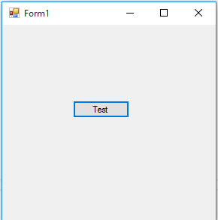

After Modifying Build…

