Sarah Wood

Tools for Software Development

Build Tools BT 1-2

Cmake

FYI, Cmake GUI was not in the Student Files, but it was easy enough to find and download.

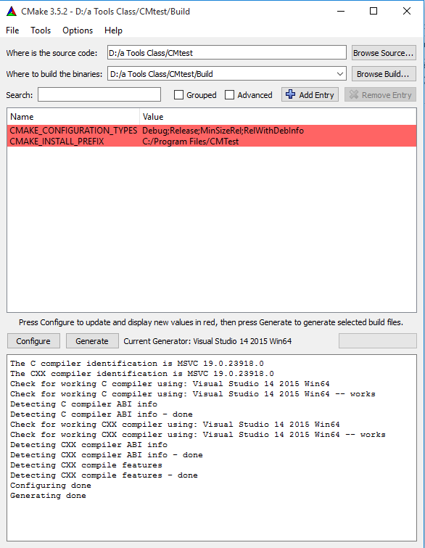

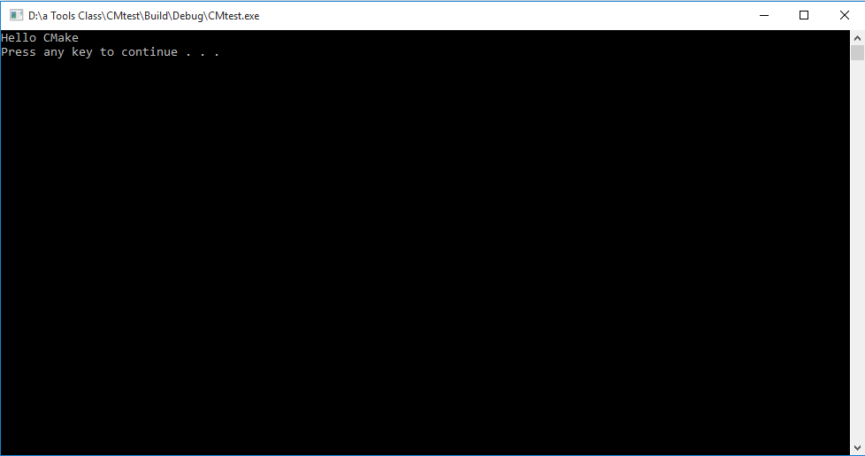

Source Code

(If you copy/paste the code, it will have errors. C++ doesn’t do opening and closing quotes, just generic ones.)

#include<iostream>

#include<cstdlib>

using namespace std;

int main()

{

cout<<"Hello CMake";

cout<<endl;

system("pause");

return 0;

}