Sarah Wood

Tools for Software Development

Build Tools BT 1-3

Cmake with GCC(MinGW)

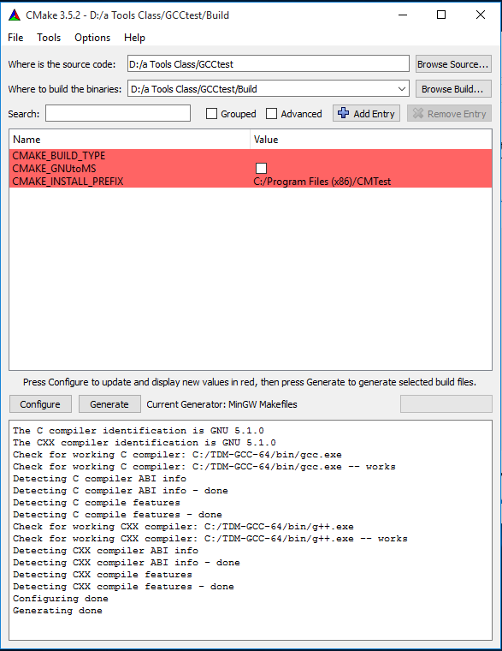

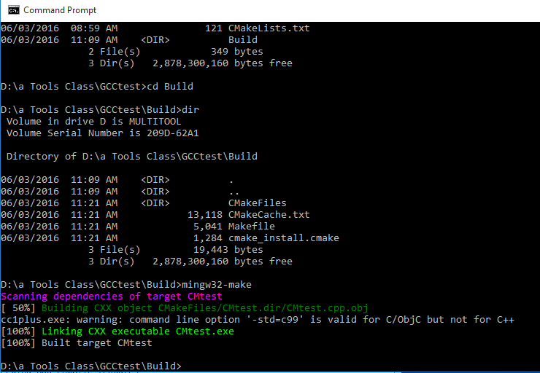

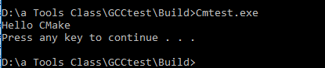

Source Code is the same as the last assignment