Sarah Wood

Tools for Software Development

Build Tools BT 1-4

Javac

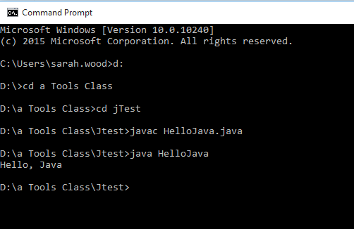

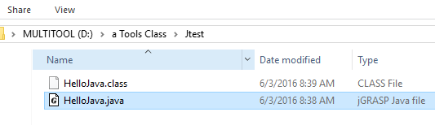

Source Code (as copied from the assignment spec)

