Sarah Wood

Tools for Software Development

IDE 1-1

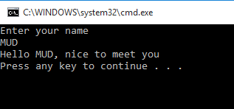

C++ doesn’t use opening and closing quotation marks, so I replaced them with generics. That was the only change I had to make.

Source code

Main.cpp

&&&&&&&&&&&&&&&&&&&&&&&&&&&&&&&&&&&&&&&&&&

#include<iostream>

#include<string>

using namespace std;

int main()

{

string myName;

cout << "Enter your name" << endl;

getline(cin, myName);

cout << "Hello " + myName + ", nice to meet you" << endl;

return 0;

}