Sarah Wood

Tools for Software Development

IDE 1-2

Code Blocks

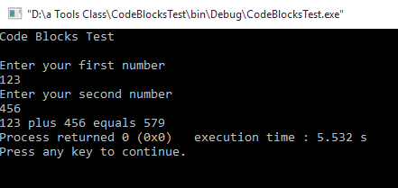

Source code

Main.cpp

&&&&&&&&&&&&&&&&&&&&&&&&&&&&&&&&&&&&&&&&&&

#include <iostream>

#include <string>

using namespace std;

int main()

{

cout<<"Code Blocks Test"<<endl<<endl;

int num1, num2, total;

cout <<"Enter your first number" <<endl;

cin >> num1;

cout << "Enter your second number" << endl;

cin >> num2;

total = num1 + num2;

cout<< num1 << " plus " <<num2 << " equals " <<total;

return 0;

}