Sarah Wood

Tools for Software Development

IDE 1-3

NetBeans IDE

It wouldn’t compile, but eventually I figured out that I didn’t have any libraries installed. Apparently, the “javax.swing” library had what I needed.

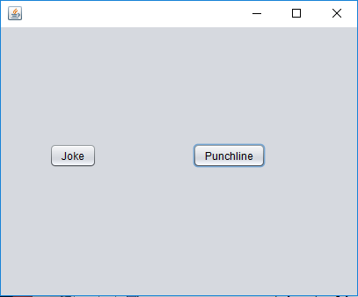

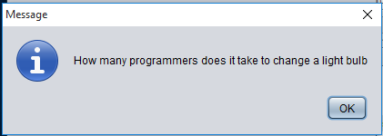

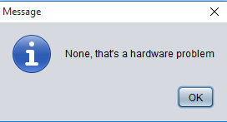

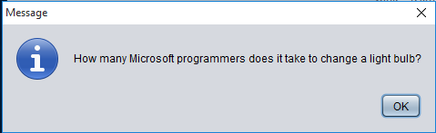

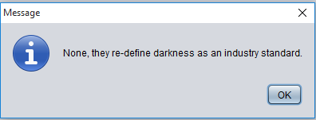

I can change things without breaking the code.

Source code

NewJFrame.java

&&&&&&&&&&&&&&&&&&&&

/*

* To change this license header, choose License Headers in Project Properties.

* To change this template file, choose Tools | Templates

* and open the template in the editor.

*/

/**

*

* @author Sarah.Wood

*/

import javax.swing.*;

public class NewJFrame extends javax.swing.JFrame {

/**

* Creates new form NewJFrame

*/

public NewJFrame() {

initComponents();

}

/**

* This method is called from within the constructor to initialize the form.

* WARNING: Do NOT modify this code. The content of this method is always

* regenerated by the Form Editor.

*/

@SuppressWarnings("unchecked")

// <editor-fold defaultstate="collapsed" desc="Generated Code">

private void initComponents() {

jButton1 = new javax.swing.JButton();

jButton2 = new javax.swing.JButton();

setDefaultCloseOperation(javax.swing.WindowConstants.EXIT_ON_CLOSE);

jButton1.setText("Joke");

jButton1.addActionListener(new java.awt.event.ActionListener() {

public void actionPerformed(java.awt.event.ActionEvent evt) {

jButton1ActionPerformed(evt);

}

});

jButton2.setText("Punchline");

jButton2.addActionListener(new java.awt.event.ActionListener() {

public void actionPerformed(java.awt.event.ActionEvent evt) {

jButton2ActionPerformed(evt);

}

});

javax.swing.GroupLayout layout = new javax.swing.GroupLayout(getContentPane());

getContentPane().setLayout(layout);

layout.setHorizontalGroup(

layout.createParallelGroup(javax.swing.GroupLayout.Alignment.LEADING)

.addGroup(layout.createSequentialGroup()

.addGap(55, 55, 55)

.addComponent(jButton1)

.addGap(109, 109, 109)

.addComponent(jButton2)

.addContainerGap(104, Short.MAX_VALUE))

);

layout.setVerticalGroup(

layout.createParallelGroup(javax.swing.GroupLayout.Alignment.LEADING)

.addGroup(layout.createSequentialGroup()

.addGap(132, 132, 132)

.addGroup(layout.createParallelGroup(javax.swing.GroupLayout.Alignment.BASELINE)

.addComponent(jButton1)

.addComponent(jButton2))

.addContainerGap(145, Short.MAX_VALUE))

);

pack();

}// </editor-fold>

private void jButton1ActionPerformed(java.awt.event.ActionEvent evt) {

// TODO add your handling code here:

JOptionPane.showMessageDialog(rootPane, "How many Microsoft programmers does it take to change a light bulb?");

}

private void jButton2ActionPerformed(java.awt.event.ActionEvent evt) {

// TODO add your handling code here:

JOptionPane.showMessageDialog(rootPane, "None, they re-define darkness as an industry standard.");

}

/**

* @param args the command line arguments

*/

public static void main(String args[]) {

/* Set the Nimbus look and feel */

//<editor-fold defaultstate="collapsed" desc=" Look and feel setting code (optional) ">

/* If Nimbus (introduced in Java SE 6) is not available, stay with the default look and feel.

* For details see http://download.oracle.com/javase/tutorial/uiswing/lookandfeel/plaf.html

*/

try {

for (javax.swing.UIManager.LookAndFeelInfo info : javax.swing.UIManager.getInstalledLookAndFeels()) {

if ("Nimbus".equals(info.getName())) {

javax.swing.UIManager.setLookAndFeel(info.getClassName());

break;

}

}

} catch (ClassNotFoundException ex) {

java.util.logging.Logger.getLogger(NewJFrame.class.getName()).log(java.util.logging.Level.SEVERE, null, ex);

} catch (InstantiationException ex) {

java.util.logging.Logger.getLogger(NewJFrame.class.getName()).log(java.util.logging.Level.SEVERE, null, ex);

} catch (IllegalAccessException ex) {

java.util.logging.Logger.getLogger(NewJFrame.class.getName()).log(java.util.logging.Level.SEVERE, null, ex);

} catch (javax.swing.UnsupportedLookAndFeelException ex) {

java.util.logging.Logger.getLogger(NewJFrame.class.getName()).log(java.util.logging.Level.SEVERE, null, ex);

}

//</editor-fold>

/* Create and display the form */

java.awt.EventQueue.invokeLater(new Runnable() {

public void run() {

new NewJFrame().setVisible(true);

}

});

}

// Variables declaration - do not modify

private javax.swing.JButton jButton1;

private javax.swing.JButton jButton2;

// End of variables declaration

}