Sarah Wood

Tools for Software Development

IDE 1-4

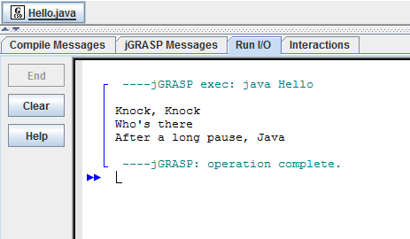

Source code

Hello.java

&&&&&&&&&&&&&&&&&&&&&&&&&&&&&&&&&&&&&&&&&&&&

public class Hello  
{  
 public static void main(String[] args)  
 {  
 System.out.println("Knock, Knock");   
 System.out.println("Who's there");  
 try {  
 Thread.sleep(10000); //1000 milliseconds is one second.  
} catch(InterruptedException ex) {  
 Thread.currentThread().interrupt();  
}  
 System.out.println("After a long pause, Java");  
}  
}