Sarah Wood

Tools for Software Development

IDE 1-5

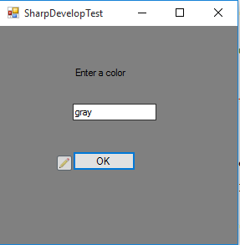

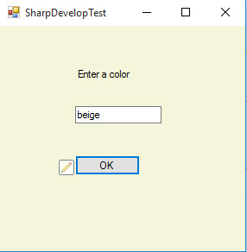

Source code

MainForm.cs

&&&&&&&&&&&&&&&&&&&&&&&&&&&&&&&&&&&&&&&&&&

/*  
 * Created by SharpDevelop.  
 * User: Sarah.Wood  
 * Date: 5/26/2016  
 * Time: 10:47 AM  
 *   
 * To change this template use Tools | Options | Coding | Edit Standard Headers.  
 */  
**using** System;  
**using** System.Collections.Generic;  
**using** System.Drawing;  
**using** System.Windows.Forms;  
  
**namespace** SharpDevelopTest  
{  
    /// <**summary**>  
    /// Description of MainForm.  
    /// <**/summary**>  
    **public** partial class MainForm : Form  
    {  
        **public** **MainForm**()  
        {  
            //  
            // The InitializeComponent() call is required for Windows Forms designer support.  
            //  
            **InitializeComponent**();  
              
            //  
            // **TODO**: Add constructor code after the InitializeComponent() call.  
            //  
        }  
          
        void **Button1Click**(object sender, EventArgs e)  
        {  
              
            string colorChange;  
  
                colorChange = textBox1.Text;  
            **try** {  
            **this**.BackColor = Color.**FromName**(colorChange);      
            } **catch** (Exception) {  
                  
                MessageBox.**Show**("Check your spelling");  
            }  
              
              
        }  
    }  
}