Sarah Wood

Tools for Software Development

IDE 1-6

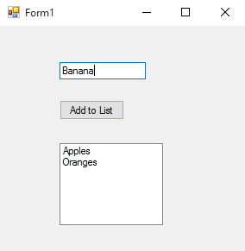

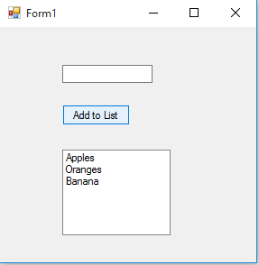

Source code

Form1.cs

&&&&&&&&&&&&&&&&&&&&&&&&&&&&&&

using System;

using System.Collections.Generic;

using System.ComponentModel;

using System.Data;

using System.Drawing;

using System.Linq;

using System.Text;

using System.Threading.Tasks;

using System.Windows.Forms;

namespace WindowsFormsApplication1

{

public partial class Form1 : Form

{

public Form1()

{

InitializeComponent();

}

private void button1_Click(object sender, EventArgs e)

{

string st = textBox1.Text;

listBox1.Items.Add(st);

textBox1.Text = "";

}

}

}