Sarah Wood

Tools for Software Development

Unit Testing 1-1

“Intro to Unit Testing”

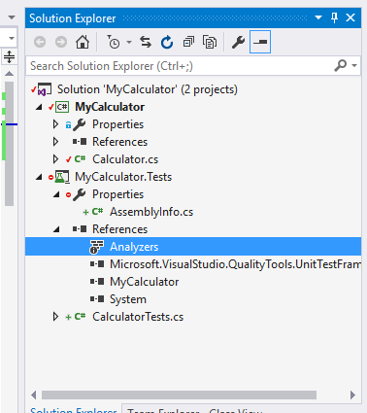

I set everything up as per instructions.

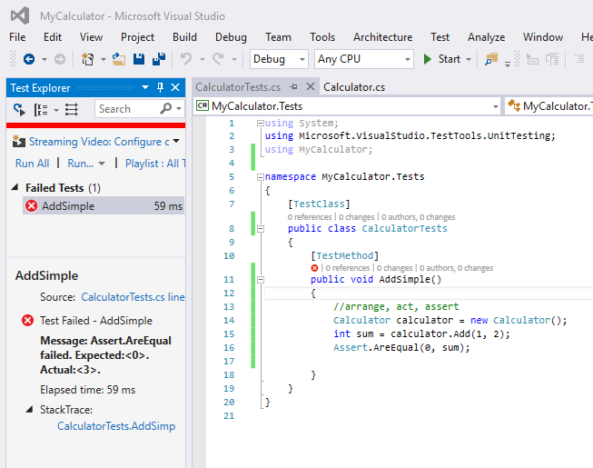

Plan to fail. Especially if 1+2 = 0.

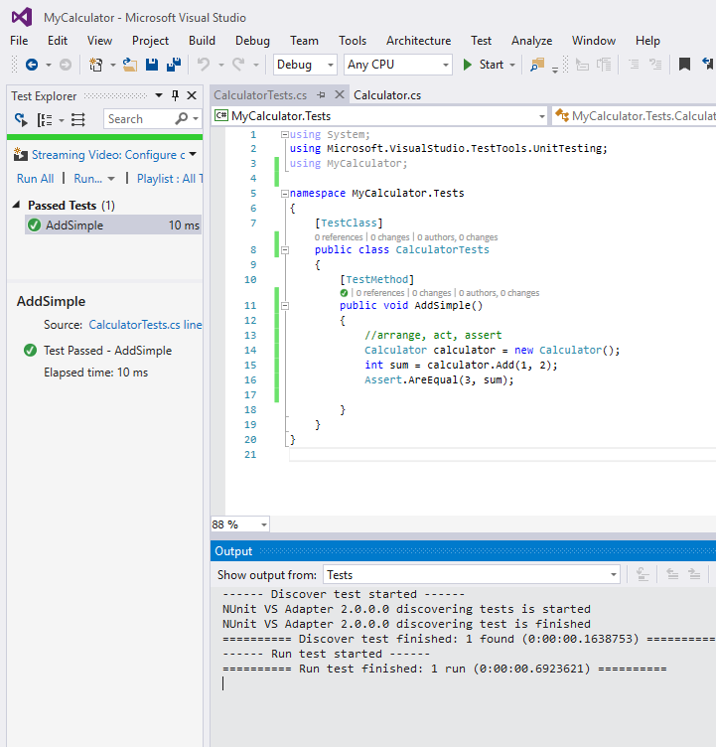

A test with the correct answer passes.

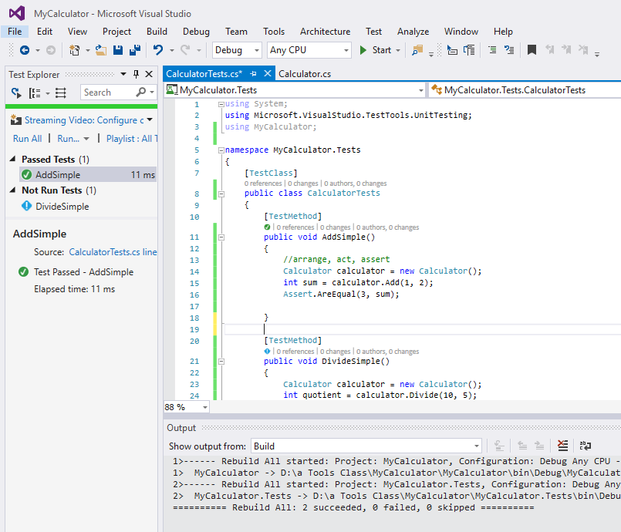

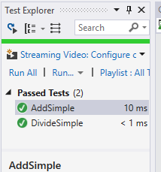

Divide also passed.

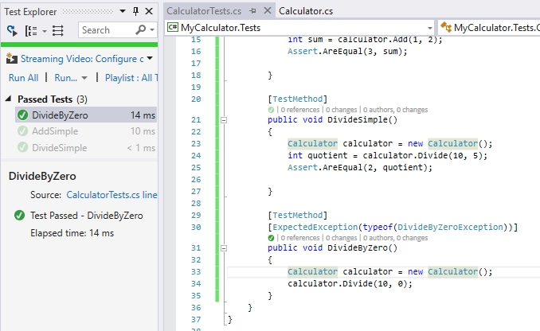

Exception is OK, tests are still working

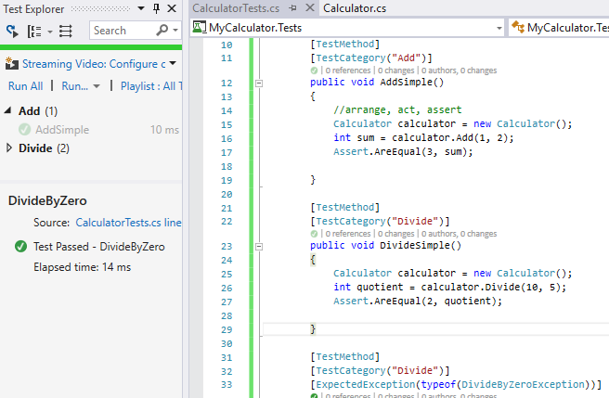

Groupings work.

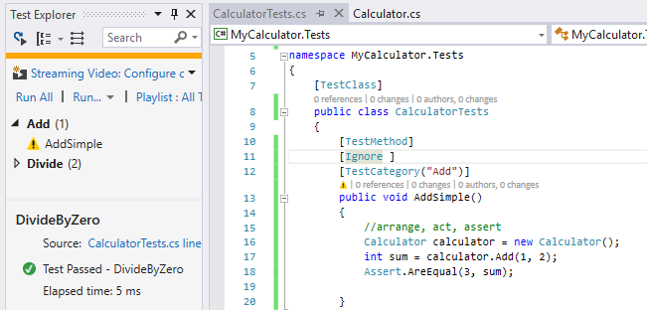

Ignore ignores!