Sarah Wood

Tools for Software Development

Unit Testing 1-2

“Unit Testing User Applications”

June 9, 2016

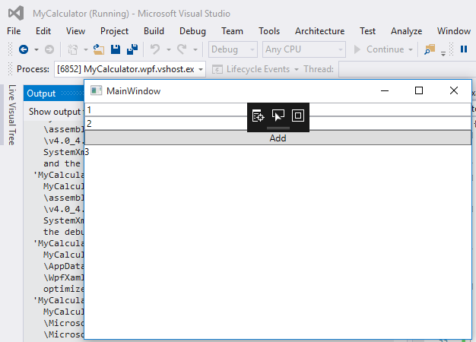

The new instance of Debug seems to be working.

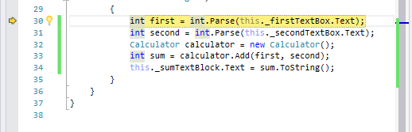

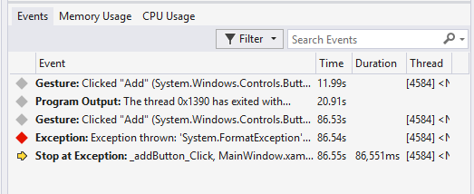

Cool. It threw a format exception at the right place.

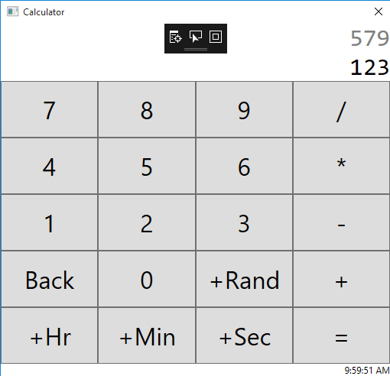

Yup, it’s a calculator. Let’s see what’s backstage.

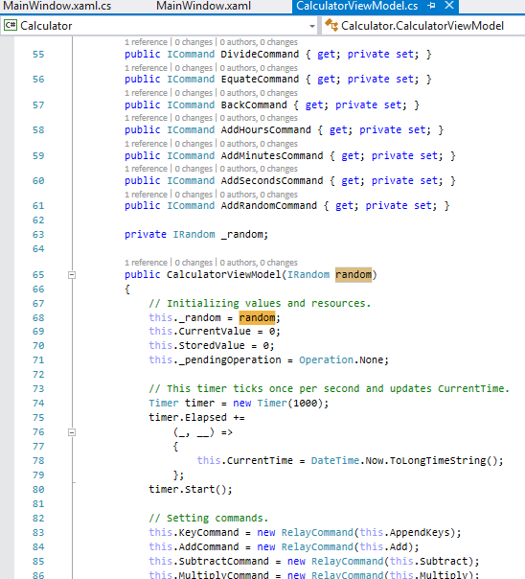

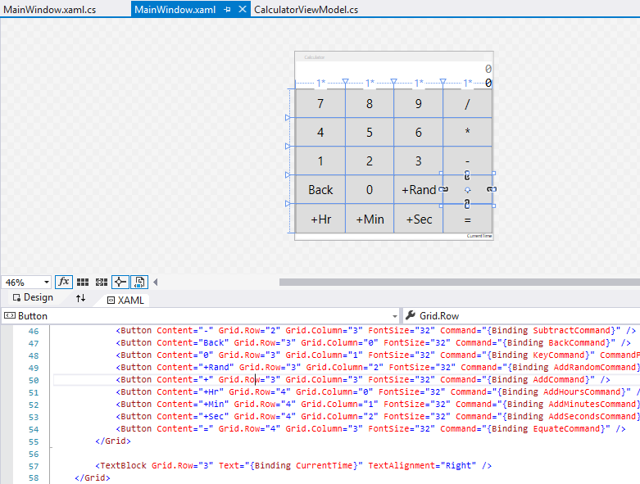

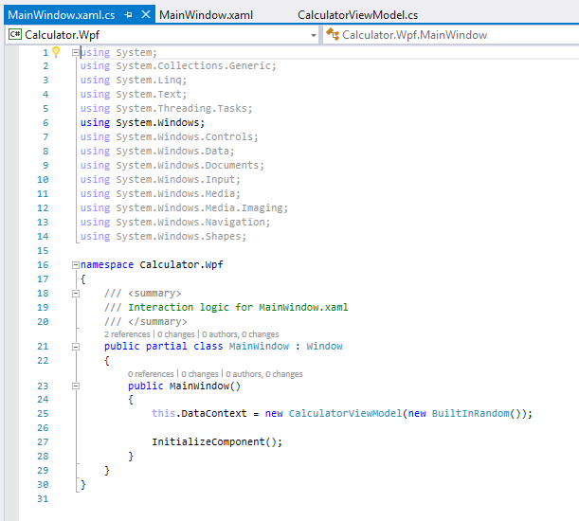

That’s really all there is? Maybe c# isn’t so bad after all.

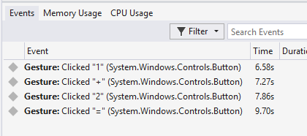

Testing live interface interactions. This is what I’ll need to emulate.

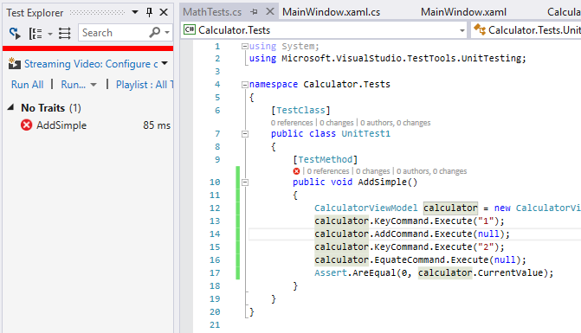

Plan to fail. 0 does not equal 3. Failed test. The test works.

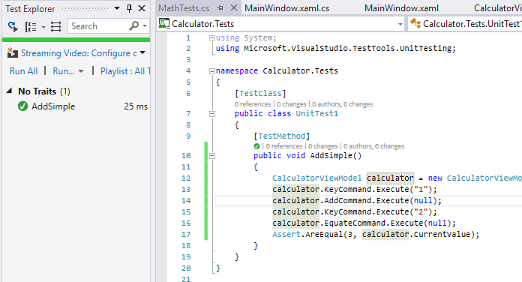

3 = 3. Test passes.

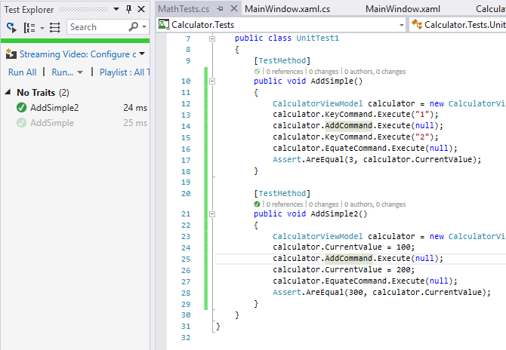

Another test with different values passes.

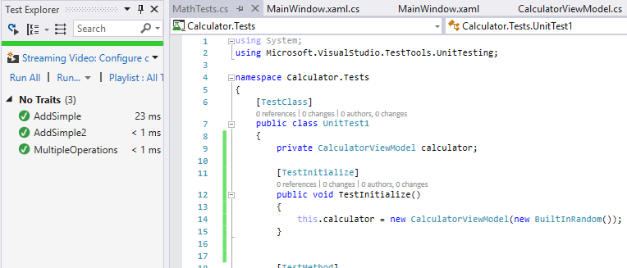

Multiple operations works, and everything is faster if we don’t re-build a calculator every time we need one.