Sarah Wood

Tools for Software Development

Unit Testing 1-3

“Advanced Unit Testing Features”

Setting up automated testing

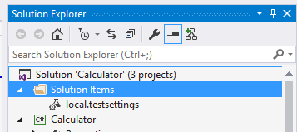

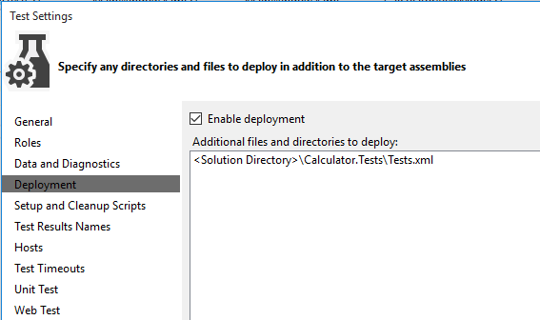

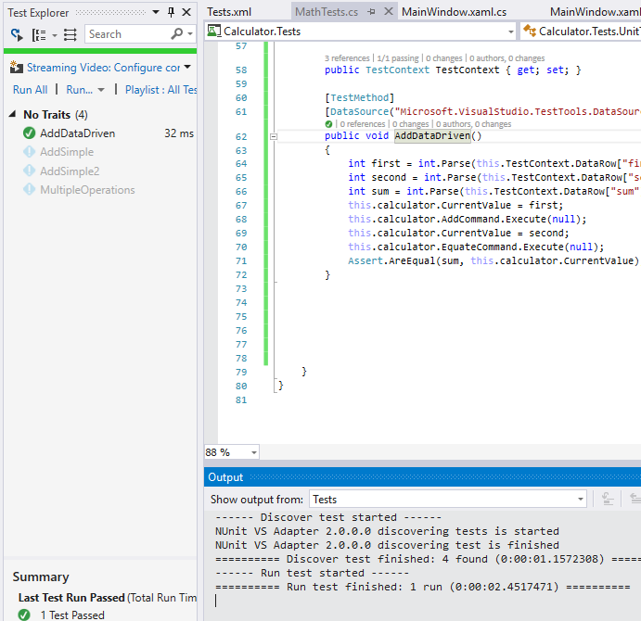

Hooray. First data-driven test passed.

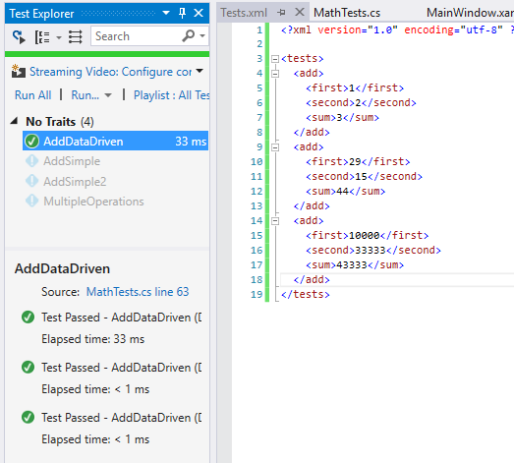

More data, more tests passed.

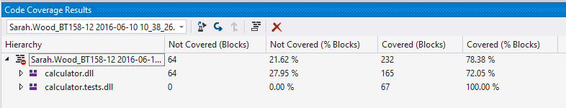

Code coverage. There’s a fair bit not covered.

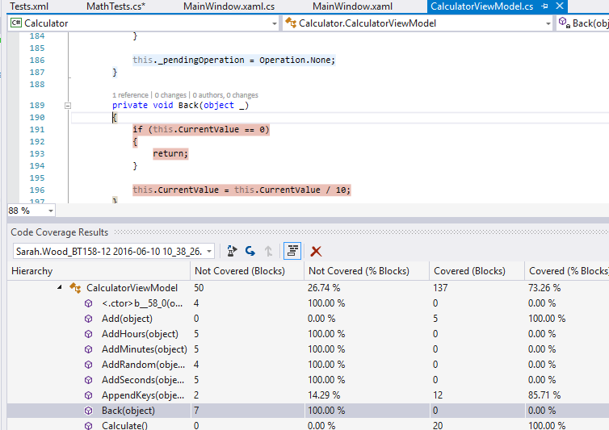

Here’s some of what’s not covered (in red).

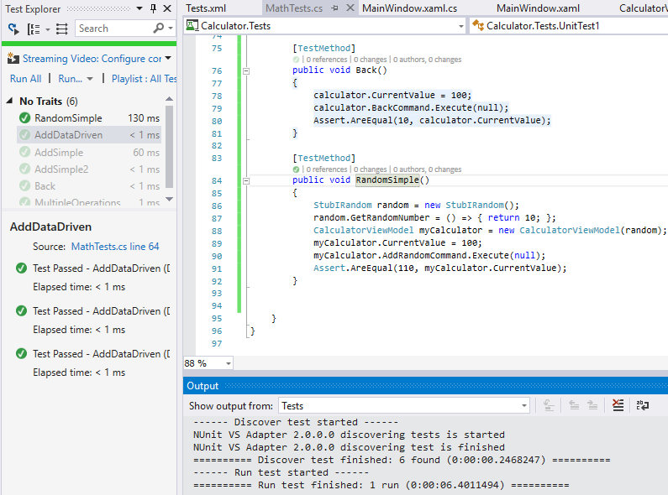

Fakes and Stubs.

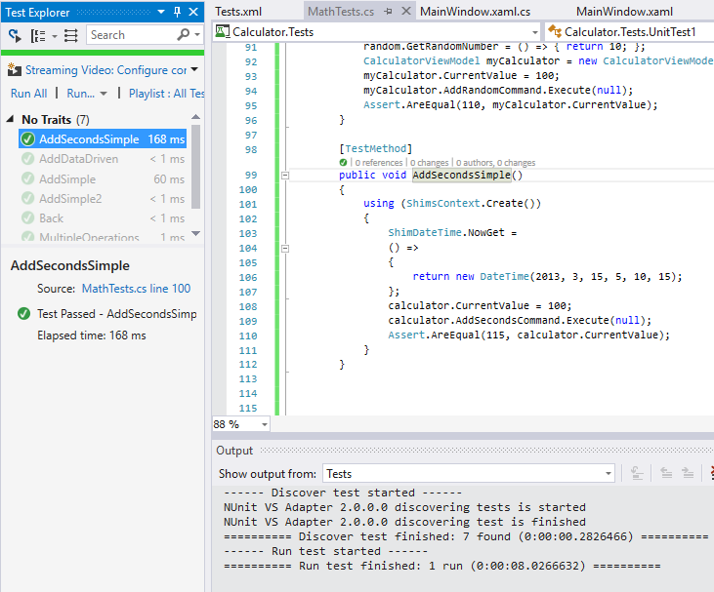

Shim for AddSeconds.

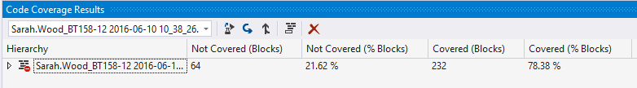

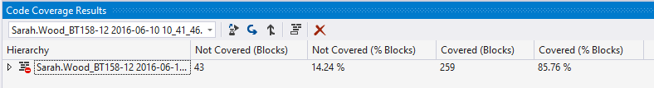

We covered ~7% more code with Fakes, Shims, and Stubs.