Sarah Wood

Tools for Software Development

Unit Testing 1-4

“Testing with Visual Studio”

June 10, 2016

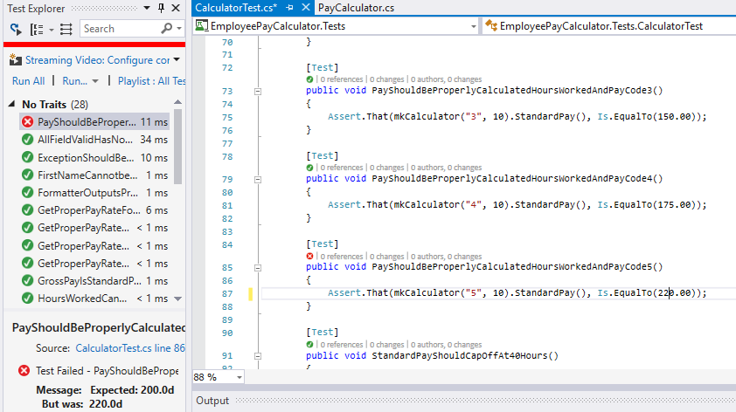

Found the source of the failed test. If the rate was right, the test was miscalculated. Fixed it.

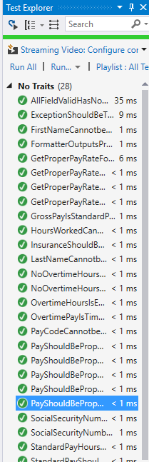

Hooray. It passed. Everything passed.

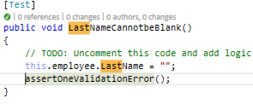

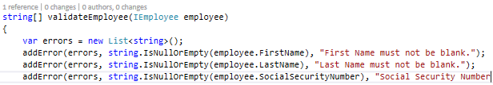

Fixed last name validation.

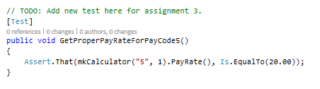

Ok, Rate5 should be $20. Fixed here, in rate calc test, and in rate case switch in PayCalculator.cs.

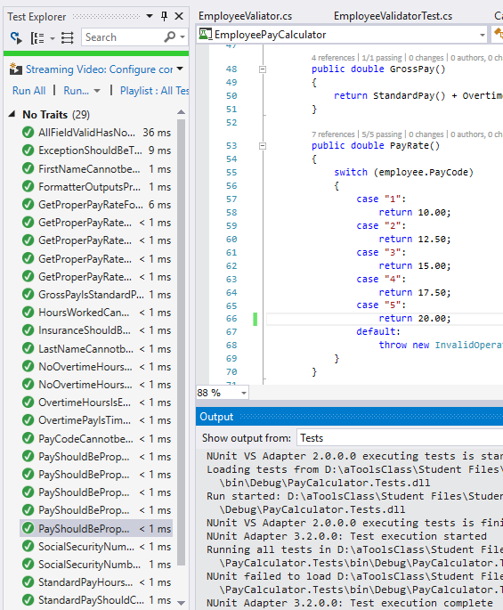

Everything passes.