Sarah Wood

Tools for Software Development

Version Control 1-2

GitHub “Walkthrough: Basic Git Functions”

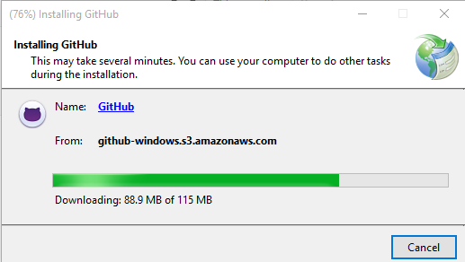

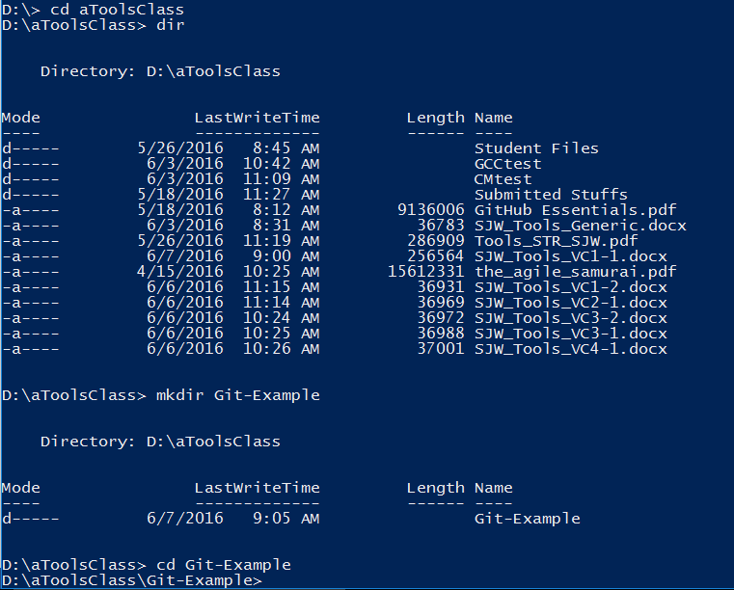

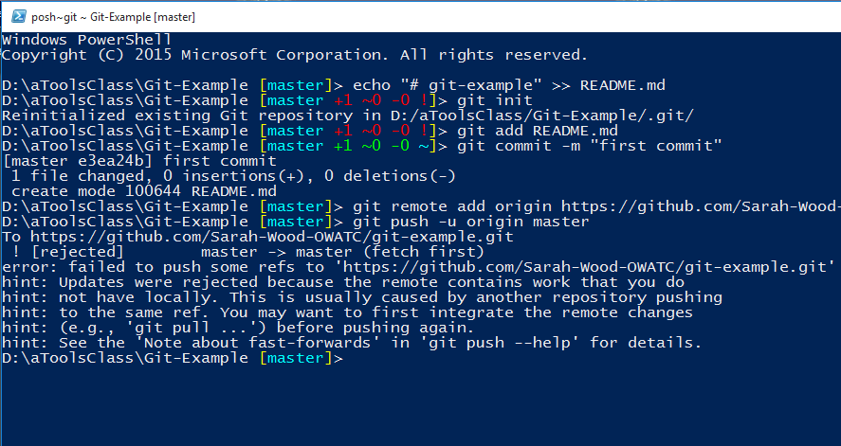

I kept failing the push. The commit shows up, and the README.md file is there. Let’s try “integrate the remote changes”.

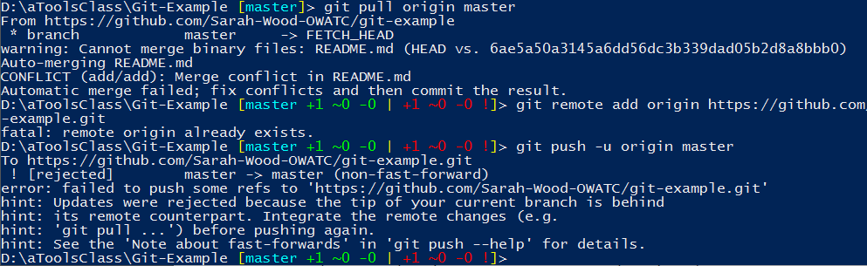

Pulling worked, but still didn’t let me push from the command line.

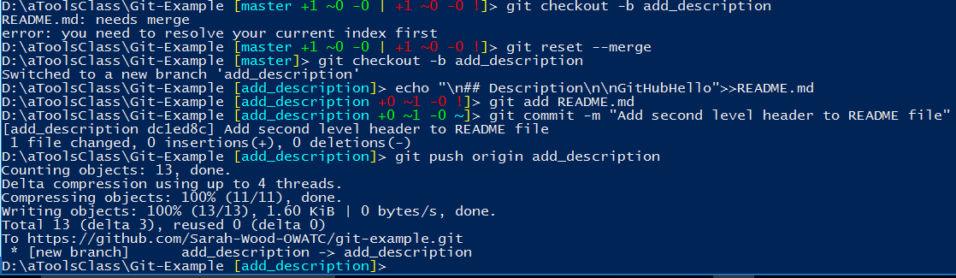

OK, I had to reset the merge index. Then it let me add the new branch.

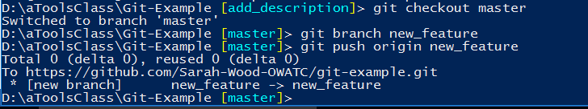

Branch #2 looks OK. Let’s go to github.com and see what we have wrought.

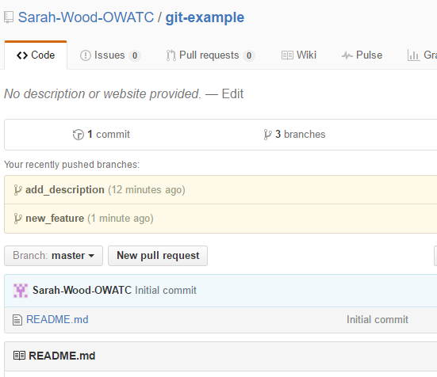



Let’s see what the green button does.

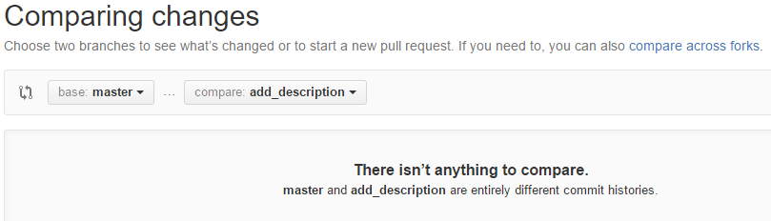

Not much here.

I changed the description and website for the repo, easy enough. Let’s assign me my own issues.

