Sarah Wood

Tools for Software Development

Version Control 3-1

GitHub “Walkthrough: My New Release”

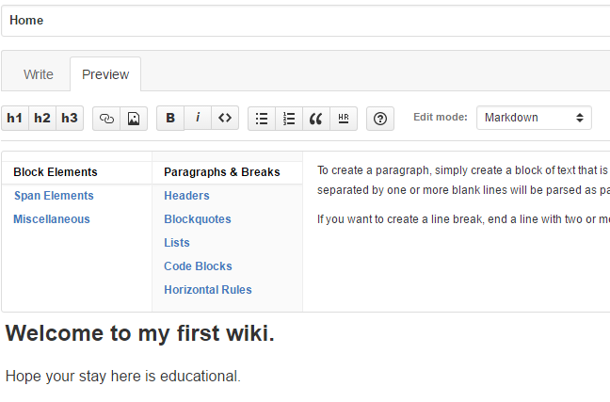

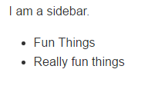

Sidebars & lists.

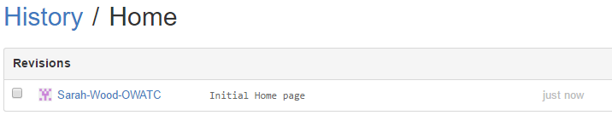

Revisions

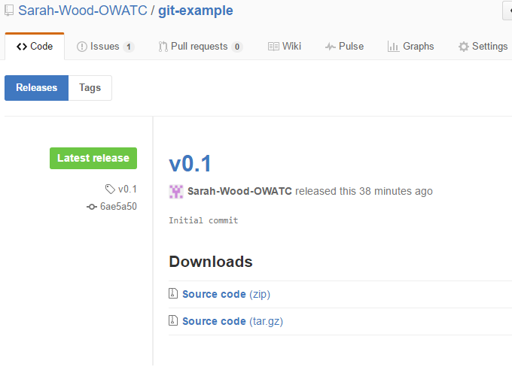

V 0.1 is published.