Sarah Wood

Tools for Software Development

Version Control 3-1

GitHub “Walkthrough: Local & Remote Repositories”

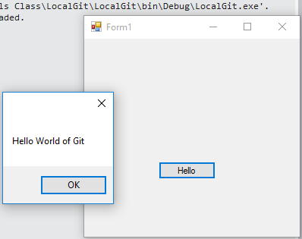

It works, let’s add it to the repo.

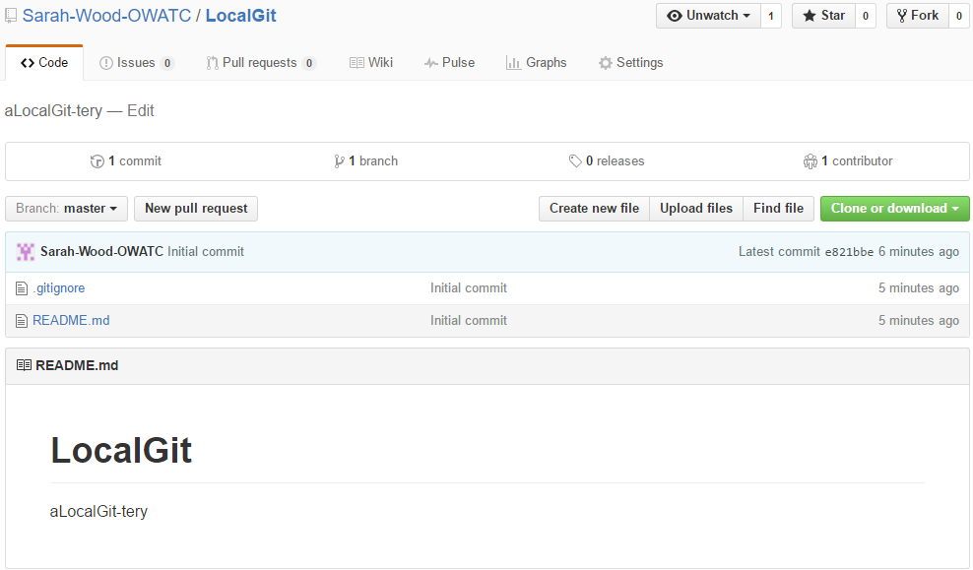

And here it is. Oops, I don’t see the code or executable.

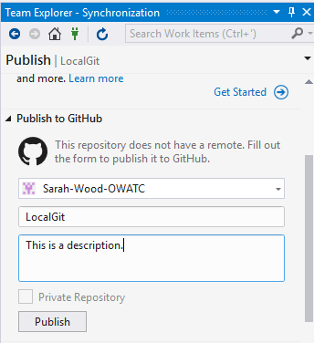

Let’s publish what we have to GitHub.

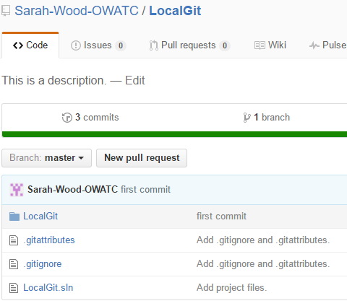

Hooray, project files. That looks better.