Sarah Wood

Tools for Software Development

Version Control 3-2

GitHub “Walkthrough: Repositories & IDEs”

June 8, 2016

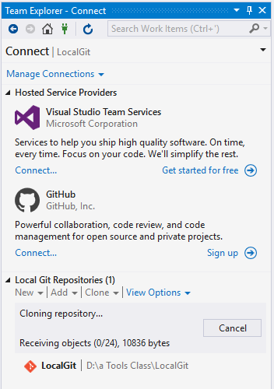

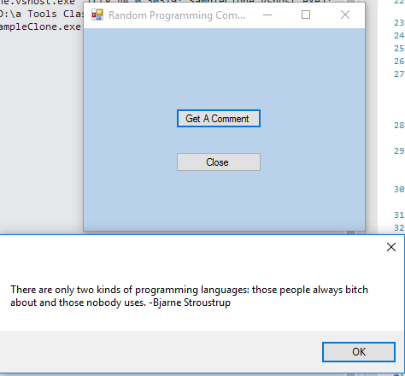

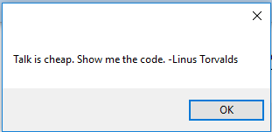

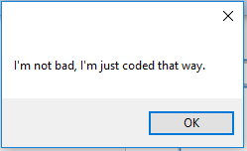

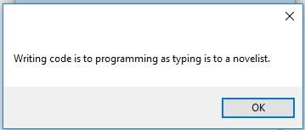

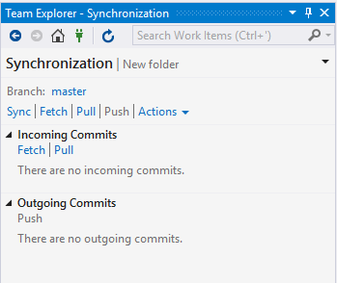

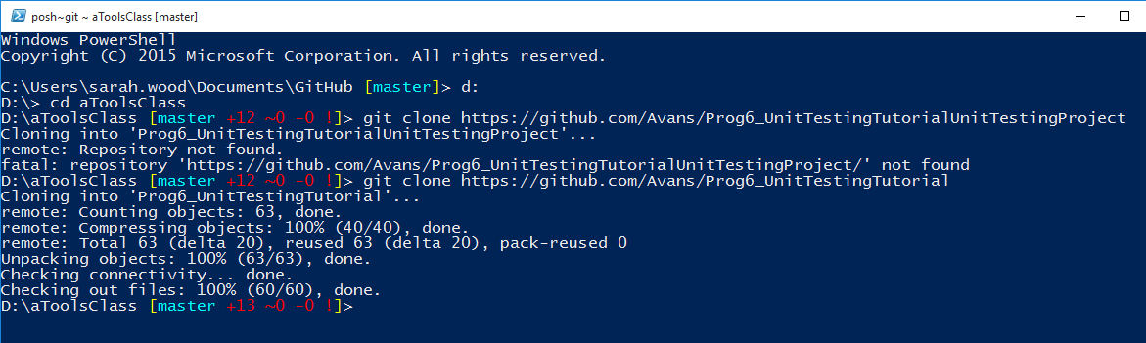

The github address given on Canvas is the one above that does not work. I navigated to Avans project site in a web browser and found the correct repo name.