Sarah Wood

Tools for Software Development

Version Control 4-1

GitHub “Walkthrough: GitShell Push & Pull”

June 8, 2016

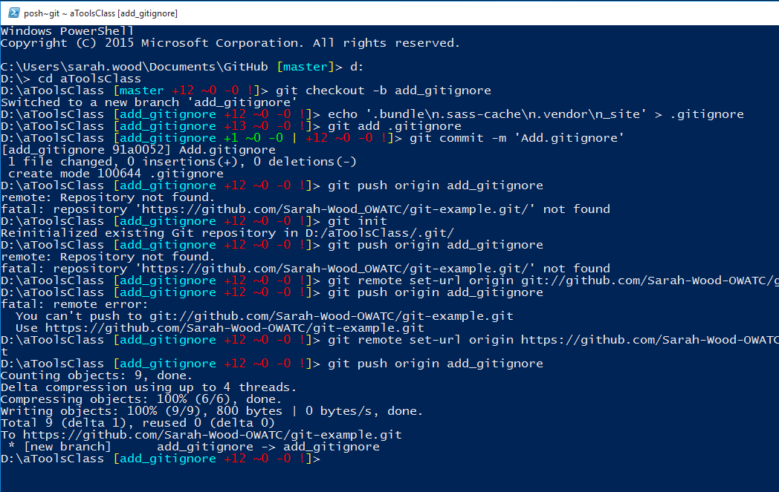

Learning from mistakes… I had a typo in my origin URI. Learned how to fix it. Let’s check the repo in a web browser.

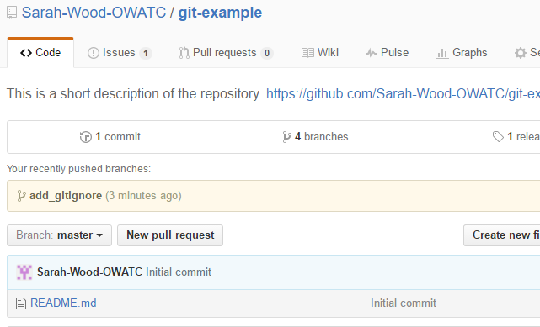

And there it is.

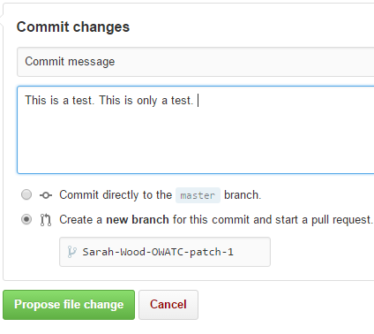

I added a line to my readme, and here is the commit box.

