Sarah Wood

Embedded Programming

BeagleBone Black

C2-B1

“Putty”

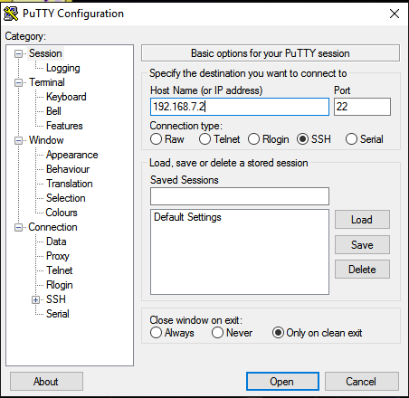 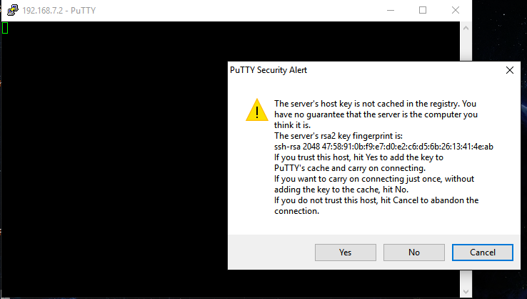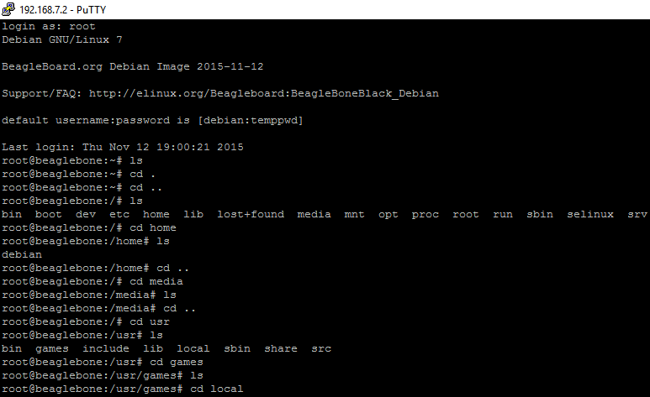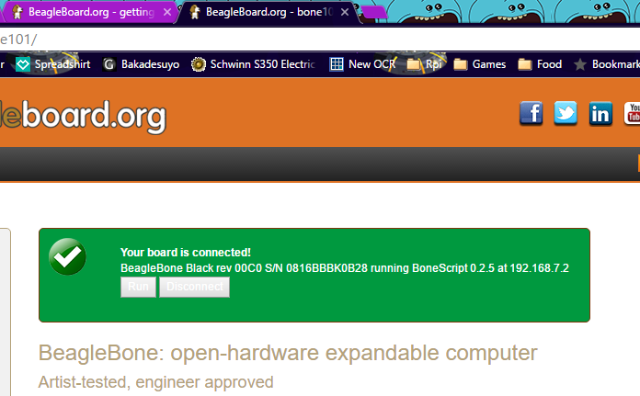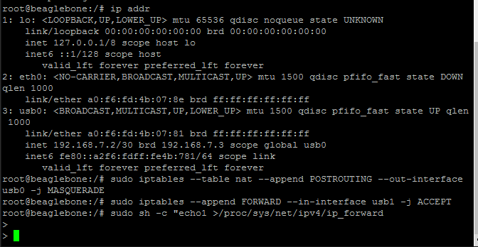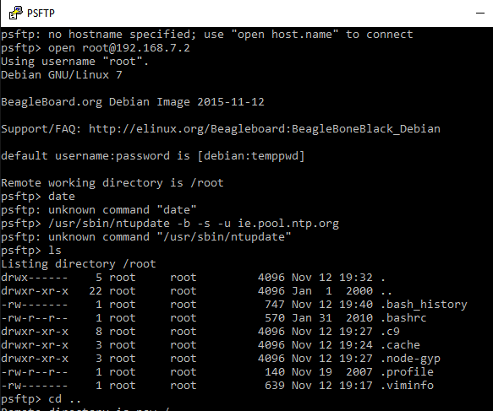

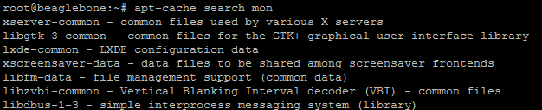

I’ll spare you the list of packages that came up from this search. “Wavemon” is specified in the book, but it wasn’t on my device, so I chose the “bluez” Bluetooth manager package.

