Sarah Wood

Embedded Programming

BeagleBone Black

C2-B2

“Cloud9”

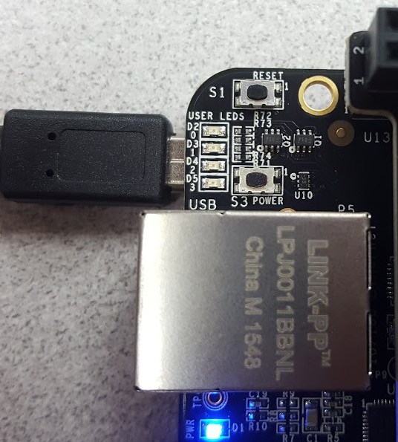

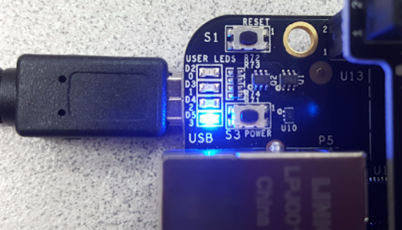

Page 52

&&&&&&&&&&&&&&&&&&&&&&&&&&&&&&&&&&&

var b = require('bonescript'); // using BoneScript

var LED3Pin = "USR3"; // USR3 is D5 on the BBB

b.pinMode(LED3Pin, b.OUTPUT); // set up LED3Pin as an output

var isOn = false; // isOn will be a Boolean flag

setInterval(toggleLED, 500); // each half second call toggleLED()

function toggleLED(){

isOn = !isOn; // invert the isOn state on each call

if (isOn) b.digitalWrite(LED3Pin, 1); // light the LED

else b.digitalWrite(LED3Pin, 0); // turn off the LED

console.log('LED On is: ' + isOn); // output the state

}

Beagleboard.org offered this alternative

&&&&&&&&&&&&&&&&&&&&&&&&&&&&

var b = require('bonescript');

var led = "USR3";

var state = 0;

b.pinMode(led, 'out');

toggleLED = function() {

state = state ? 0 : 1;

b.digitalWrite(led, state);

};

timer = setInterval(toggleLED, 100);

stopTimer = function() {

clearInterval(timer);

};

setTimeout(stopTimer, 3000);