Sarah Wood

Embedded Programming

BeagleBone Black

C3-B1

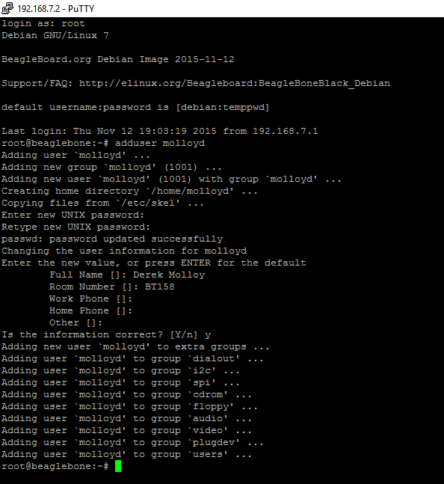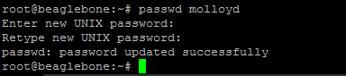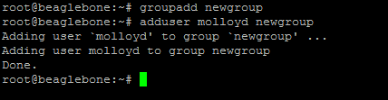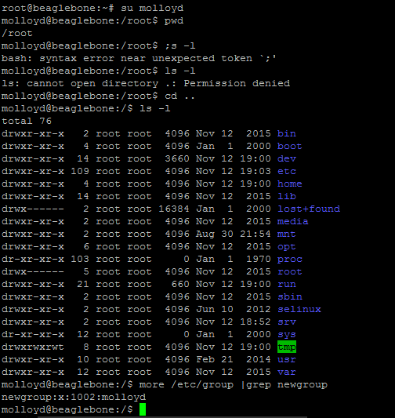

Derek Molloy added to users & newgroup.

Now to give him Super User superpowers.

