Sarah Wood

Embedded Programming

C5-A2

I included temperature sensing in part 1 of this assignment. I suppose I was getting a little ahead of myself. Please see the source code included in that assignment to see how I implemented temperature.

A formula we could use in widely variable environments is:

formula

(D is air density in kg/m3

P is pressure in Pascals (Pd Dry air, Pv Vapor Pressure)

R is the gas constant (287.058 Joules for dry air Rd, 461.495 J for water vapor Rv)

T is temperature in Kelvin

Improving Ultrasonic Range Sensing:

The SR04 I used in class only has a range of about 4 meters. The MaxBotics Rangefinder has a range up to 6.5 meters. Beyond that, you would likely want to use light rather than sound as a medium. Sound in air bounces off many things, and it is difficult to use at distance. It IS perfect for close-range object avoidance. ( machinedesign.com has great resources regarding selection of sensors)

There is a “USB Weather Board” that is Arduino compatible, and includes many sensors: light, barometer, humidity, and temperature. (~$35)

If you have a need for separate sensors, I have included selections for each sensor.

Two good humidity sensors are:

Keyes DHT11 (~$2)

SATHI-60 (~$350)

Two good barometers are:

DIP Air Pressure DIP-6 (~$2)

BMP180 (~$10)

A good anemometer is:

SEN_WIN_H28 (~$70)

(Most anemometers are large, expensive, and use proprietary interfaces.)

The basic datasheet for our SR04 ultrasonic sensor is:

**Ultrasonic Ranging Module HC - SR04**

● **Product features:**

Ultrasonic ranging module HC - SR04 provides 2cm - 400cm non-contact

measurement function, the ranging accuracy can reach to 3mm. The modules

includes ultrasonic transmitters, receiver and control circuit. The basic principle

of work:

(1) Using IO trigger for at least 10us high level signal,

(2) The Module automatically sends eight 40 kHz and detect whether there is a

pulse signal back.

(3) IF the signal back, through high level , time of high output IO duration is

the time from sending ultrasonic to returning.

Test distance = (high level time×velocity of sound (340M/S) / 2,

● **Wire connecting direct as following:**

 5V Supply

 Trigger Pulse Input

 Echo Pulse Output

 0V Ground

**Electric Parameter**

**Working Voltage DC 5 V**

**Working Current 15mA**

**Working Frequency 40Hz**

**Max Range 4m**

**Min Range 2cm**

**MeasuringAngle 15 degree**

**Trigger Input Signal 10uS TTL pulse**

**Echo Output Signal Input TTL lever signal and the range in**

**proportion**

**Dimension 45*20*15mm**

Wiring diagram

The Weather Board is an Arduino Shield, so no wiring is necessary. Here is a picture of the Weather Shield on a Sparkfun Arduino clone.

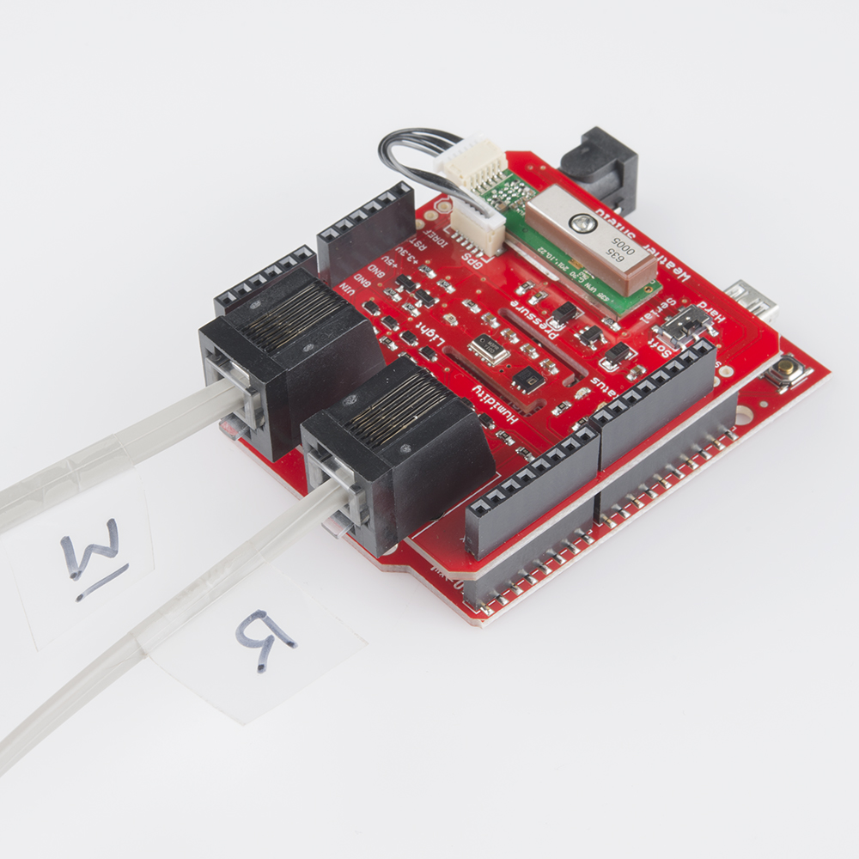

R connects to a Rain sensor , and W connects to an anemometer.

Here are the datasheets for the surface mount sensors on this board.

Barometer

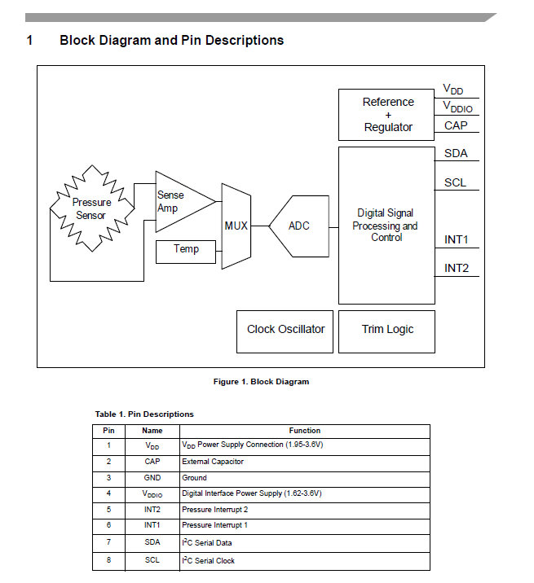

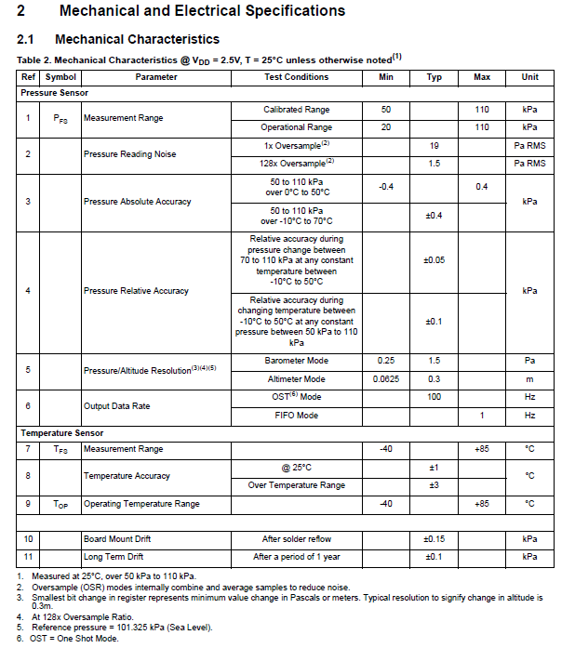

Humidity Sensor

