Sarah Wood

Embedded Programming

Ch7 Assg 1

Arduinoid: The Saga

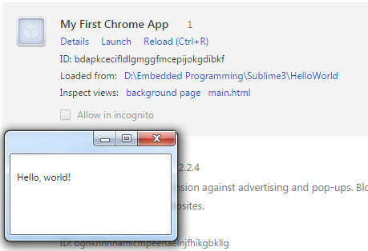

I read Appendix 4, and learned how to create Chrome apps. The book code worked well, and with the serial app, I was able to see raw data from the accelerometer.

Then I tried the Arduinoid code from Chapter 7.

I downloaded the book code from the GitHub repository, but I could not get it to run. Three lines of Javascript hung, no matter which browser I tried. The style sheet loaded, I got a lovely background and audio, but no game. Basic troubleshooting showed good signal and output from the Arduino. When I logged console errors in Chrome, I found this.

In serial-device.js, the offending lines were #24, 26, & 27:

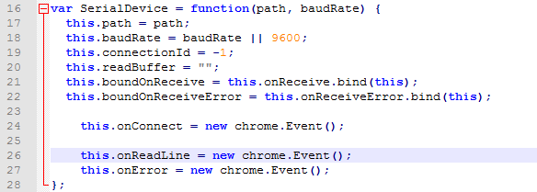

I tried different syntaxes (syntaces?), but to no avail. I tried new $.Event(); That shifted the error to game-controller.js, which needed the “chrome” label, and had no idea what to do with the generic Event. I got the same result from

new jQuery.Event();

Tom tried to help me figure it out. The last student to make this work didn’t include the “serial-device.js” code. $#@!

There is a GitHub forum on this very issue: apparently this style of event creation is deprecated. It would need to be instantiated as a “Custom Event” with “polyfill”. As this is my first project with Javascript, I have no idea how to do that.

I built a project for it in Visual Studio, but got the same errors and no help from the IDE on how to solve them.

As a last ditch, I tried running my Processing sketch from the last section in-browser with “Processing.js”, but ran into an “same-source” file access errors. $\*(&&#$@!!!!!

OK, I’ll have to learn Javascript. When I do, retooling this to actually work will be a worthy project.

Three days is long enough. I have filed this project under “Javascript”, so that when I get there, it will be waiting.