Sarah Wood

Embedded Programming

Chapter 13

Assignment 1

Screen Caps

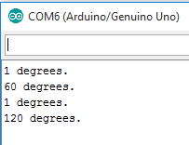

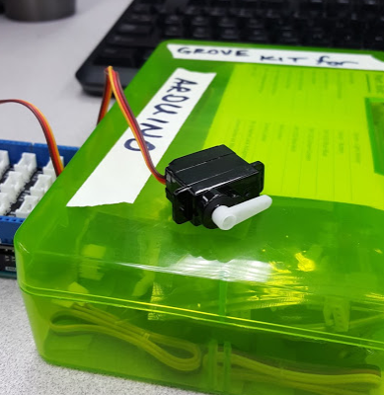 Looks like one degree sits here.

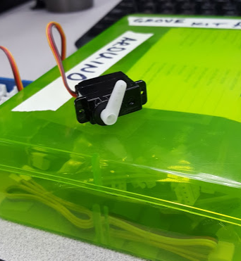 Sixty degrees

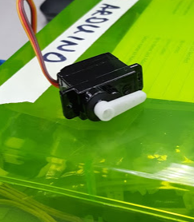 Back to zero

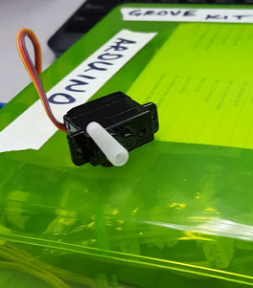 120 degrees.

Source Code

( I included Serial Servo, since the “Blaminatr” code is in the next assignment)

&&&&&&&&&&&&&&&&&&&&&&&&&&&&&&&&&&&&&&&&&&&&&&&&&

SerialServo.cpp

&&&&&&&&&&&&&&&&&&&&&&&&&&&&&&&&&&&&&&&&&&&&&&&&&

#include <Servo.h>

const unsigned int MOTOR_PIN = 8;

const unsigned int MOTOR_DELAY = 15;

const unsigned int SERIAL_DELAY = 5;

const unsigned int BAUD_RATE = 9600;

Servo servo;

void setup() {

Serial.begin(BAUD_RATE);

servo.attach(MOTOR_PIN);

delay(MOTOR_DELAY);

servo.write(1);

delay(MOTOR_DELAY);

}

void loop() {

const unsigned int MAX_ANGLE = 3;

char degrees[MAX_ANGLE + 1];

if (Serial.available()) {

int i = 0;

while (Serial.available() && i < MAX_ANGLE + 1) {

const char c = Serial.read();

if (c != -1 && c != '\n')

degrees[i++] = c;

delay(SERIAL_DELAY);

}

degrees[i] = 0;

int value = atoi(degrees);

if (value == 0)

value = 1;

Serial.print(value);

Serial.println(" degrees.");

servo.write(value);

delay(MOTOR_DELAY);

}

}