Sarah Wood

Embedded Programming

Chapter 8

Assignment 1

Build custom RCA cable

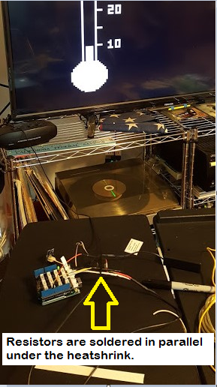

Demonstrate running Thermometer on TV

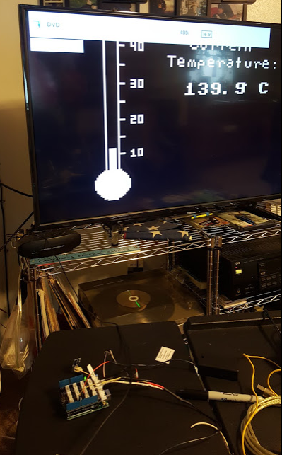

Still needs a little tuning between the sensor and the output. But it works!

Include Source code

&&&&&&&&&&&&&&&&&&&&&&&&&&&&&&&&&&&&&&&&&&&&&&&&&&&&

ThermometerTV.cpp

%%%%%%%%%%%%%%%%%%%%%%%%%%%%%%%%%%%%%%%%%%%%%%%%

#include <TVout.h>

#include <fontALL.h>

#include "thermometer.h"

const float SUPPLY_VOLTAGE = 5.0;

const float MIN_TEMP = 5.5;

const float MAX_TEMP = 40.0;

const unsigned int SCREEN_WIDTH = 120;

const unsigned int SCREEN_HEIGHT = 96;

const unsigned int TEMP_SENSOR_PIN = A0;

const unsigned int SCALE_X_MIN = 8;

const unsigned int SCALE_Y_MIN = 6;

const unsigned int SCALE_Y_MAX = 75;

const unsigned int SCALE_WIDTH = 3;

const unsigned int SCALE_HEIGHT = SCALE_Y_MAX - SCALE_Y_MIN;

float current_temperature = 0.0;

unsigned long last_measurement = millis();

TVout TV;

void setup() {

TV.begin(NTSC, SCREEN_WIDTH, SCREEN_HEIGHT);

TV.bitmap(0, 1, thermometer);

TV.select_font(font4x6);

TV.set_cursor(20, 4);

TV.print("40");

TV.set_cursor(20, 24);

TV.print("30");

TV.set_cursor(20, 44);

TV.print("20");

TV.set_cursor(20, 64);

TV.print("10");

}

void loop() {

unsigned long current_millis = millis();

if (abs(current_millis - last_measurement) >= 1000) {

current_temperature = get_temperature();

last_measurement = current_millis;

int y_pos = mapfloat(

current_temperature, MIN_TEMP, MAX_TEMP, SCALE_Y_MAX, SCALE_Y_MIN);

TV.draw_rect(

SCALE_X_MIN, SCALE_Y_MIN, SCALE_WIDTH, SCALE_HEIGHT, BLACK, BLACK);

TV.draw_rect(

SCALE_X_MIN, y_pos, SCALE_WIDTH, SCALE_Y_MAX - y_pos, WHITE, WHITE);

TV.select_font(font6x8);

TV.set_cursor(53, 1);

TV.print("Current");

TV.set_cursor(40, 11);

TV.print("Temperature:");

TV.select_font(font8x8);

TV.set_cursor(50, 25);

TV.print(current_temperature, 1);

TV.print(" C");

TV.draw_circle(88, 27, 1, WHITE);

}

}

const float mapfloat(

float x, float in_min, float in_max, float out_min, float out_max)

{

return (x - in_min) * (out_max - out_min) / (in_max - in_min) + out_min;

}

const float get_temperature() {

const int sensor_voltage = analogRead(TEMP_SENSOR_PIN);

const float voltage = sensor_voltage * SUPPLY_VOLTAGE / 1024;

return (voltage * 1000 - 500) / 10;

}

&&&&&&&&&&&&&&&&&&&&&&&&&&&&&&&&&&&&&&&&&&&&&&&&&&&&

thermometer.cpp

%%%%%%%%%%%%%%%%%%%%%%%%%%%%%%%%%%%%%%%%%%%%%%%%

#include <Arduino.h>

#include <avr/pgmspace.h>

#include "thermometer.h"

PROGMEM const unsigned char thermometer[] = {

20, 94,

B00000000, B11110000, B00000000,

B00000001, B00001000, B00000000,

B00000010, B00000100, B00000000,

B00000010, B00000100, B00000000,

B00000010, B00000100, B00000000,

B00000010, B00000111, B10000000, // 40.0

B00000010, B00000100, B00000000,

B00000010, B00000100, B00000000,

B00000010, B00000100, B00000000,

B00000010, B00000100, B00000000,

B00000010, B00000100, B00000000,

B00000010, B00000100, B00000000,

B00000010, B00000100, B00000000,

B00000010, B00000100, B00000000,

B00000010, B00000100, B00000000,

// ...

B00000010, B00000111, B10000000, // 35.0

B00000010, B00000100, B00000000,

B00000010, B00000100, B00000000,

B00000010, B00000100, B00000000,

B00000010, B00000100, B00000000,

B00000010, B00000100, B00000000,

B00000010, B00000100, B00000000,

B00000010, B00000100, B00000000,

B00000010, B00000100, B00000000,

B00000010, B00000100, B00000000,

B00000010, B00000111, B10000000, // 30.0

B00000010, B00000100, B00000000,

B00000010, B00000100, B00000000,

B00000010, B00000100, B00000000,

B00000010, B00000100, B00000000,

B00000010, B00000100, B00000000,

B00000010, B00000100, B00000000,

B00000010, B00000100, B00000000,

B00000010, B00000100, B00000000,

B00000010, B00000100, B00000000,

B00000010, B00000111, B10000000, // 25.0

B00000010, B00000100, B00000000,

B00000010, B00000100, B00000000,

B00000010, B00000100, B00000000,

B00000010, B00000100, B00000000,

B00000010, B00000100, B00000000,

B00000010, B00000100, B00000000,

B00000010, B00000100, B00000000,

B00000010, B00000100, B00000000,

B00000010, B00000100, B00000000,

B00000010, B00000111, B10000000, // 20.0

B00000010, B00000100, B00000000,

B00000010, B00000100, B00000000,

B00000010, B00000100, B00000000,

B00000010, B00000100, B00000000,

B00000010, B00000100, B00000000,

B00000010, B00000100, B00000000,

B00000010, B00000100, B00000000,

B00000010, B00000100, B00000000,

B00000010, B00000100, B00000000,

B00000010, B00000111, B10000000, // 15.0

B00000010, B00000100, B00000000,

B00000010, B00000100, B00000000,

B00000010, B00000100, B00000000,

B00000010, B00000100, B00000000,

B00000010, B00000100, B00000000,

B00000010, B00000100, B00000000,

B00000010, B00000100, B00000000,

B00000010, B00000100, B00000000,

B00000010, B00000100, B00000000,

B00000010, B00000111, B10000000, // 10.0

B00000010, B00000100, B00000000,

B00000010, B00000100, B00000000,

B00000010, B00000100, B00000000,

B00000010, B00000100, B00000000,

B00000010, B00000100, B00000000,

B00000010, B00000100, B00000000,

B00000010, B00000100, B00000000,

B00000010, B00000100, B00000000,

B00000010, B00000100, B00000000, // 5.5

B00000111, B11111110, B00000000,

B00001111, B11111111, B00000000,

B00011111, B11111111, B10000000,

B00111111, B11111111, B11000000,

B01111111, B11111111, B11100000,

B01111111, B11111111, B11100000,

B11111111, B11111111, B11110000,

B11111111, B11111111, B11110000,

B11111111, B11111111, B11110000,

B11111111, B11111111, B11110000,

B11111111, B11111111, B11110000,

B11111111, B11111111, B11110000,

B01111111, B11111111, B11100000,

B01111111, B11111111, B11100000,

B00111111, B11111111, B11000000,

B00011111, B11111111, B10000000,

B00001111, B11111111, B00000000,

B00000111, B11111110, B00000000,

B00000001, B11111000, B00000000,

B00000001, B11111000, B00000000,

};

&&&&&&&&&&&&&&&&&&&&&&&&&&&&&&&&&&&&&&&&&&&&&&&&&&&&

thermometer.h

%%%%%%%%%%%%%%%%%%%%%%%%%%%%%%%%%%%%%%%%%%%%%%%%

/***

* Excerpted from "Arduino: A Quick-Start Guide, Second Edition",

* published by The Pragmatic Bookshelf.

* Copyrights apply to this code. It may not be used to create training material,

* courses, books, articles, and the like. Contact us if you are in doubt.

* We make no guarantees that this code is fit for any purpose.

* Visit http://www.pragmaticprogrammer.com/titles/msard2 for more book information.

***/

#ifndef THERMOMETER_H

#define THERMOMETER_H

extern const unsigned char thermometer[];

#endif