Sarah Wood

Embedded Programming

Chapter 9

Assignment 1

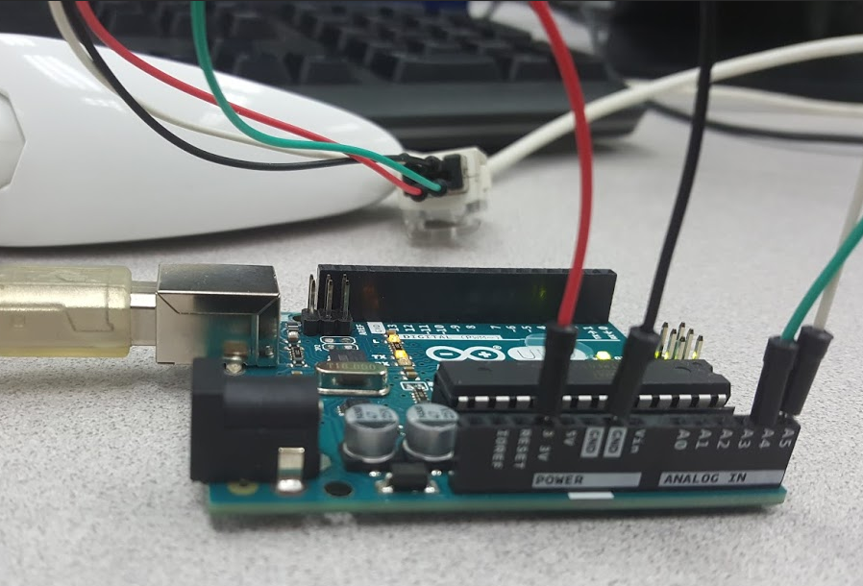Nintendo Wii Nunchuk controller

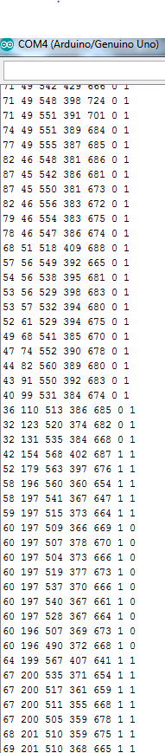

Basic Hardware functionality was pretty simple.

(Am I the only one who gets a little nervous if a new thing works the first time?)

Here is a pic of the Pragduino code working on my TV.

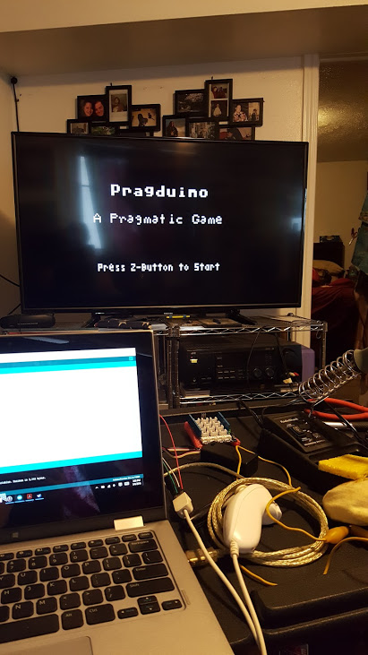

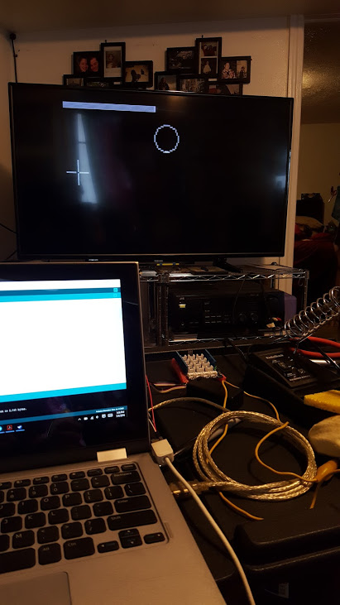

This is hard. The tracking is smooth, but slow. What if I give myself more time?

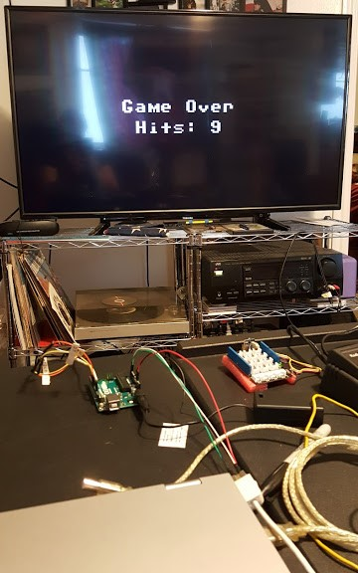

OK, maybe that’s too easy. I’ll fine-tune the game controls at some point.

(Bonus!) I got the 3D cube code from Arduino Playground. It worked great, and was very responsive.

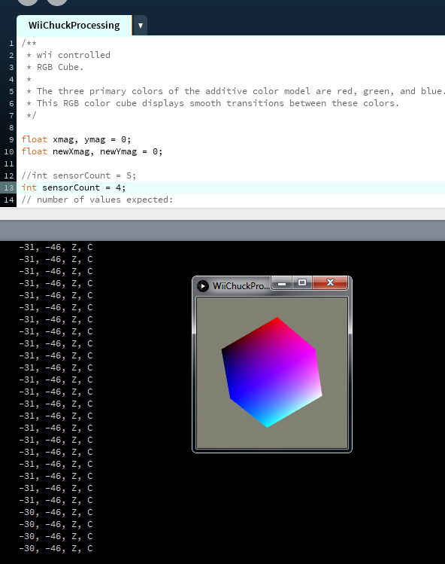

The source code for basic functionality is straight out of the book. Here it is for reference.

Main.cpp

++++++++++++++++++++++++++++++++++++++++++++++++++++++++++++++

#include <Wire.h>

#include "nunchuk.h"

const unsigned int BAUD_RATE = 19200;

Nunchuk nunchuk;

void setup() {

Serial.begin(BAUD_RATE);

nunchuk.initialize();

}

void loop() {

if (nunchuk.update()) {

Serial.print(nunchuk.joystick_x());

Serial.print(" ");

Serial.print(nunchuk.joystick_y());

Serial.print(" ");

Serial.print(nunchuk.x_acceleration());

Serial.print(" ");

Serial.print(nunchuk.y_acceleration());

Serial.print(" ");

Serial.print(nunchuk.z_acceleration());

Serial.print(" ");

Serial.print(nunchuk.z_button());

Serial.print(" ");

Serial.println(nunchuk.c_button());

}

}

Nunchuck.cpp

++++++++++++++++++++++++++++++++++++++++++++++++++++++++++++++++++

#include <Arduino.h>

#include <Wire.h>

#include "nunchuk.h"

#define NUNCHUK_DEVICE_ID 0x52

void Nunchuk::initialize() {

Wire.begin();

Wire.beginTransmission(NUNCHUK_DEVICE_ID);

Wire.write((byte)0x40);

Wire.write((byte)0x00);

Wire.endTransmission();

update();

}

bool Nunchuk::update() {

delay(1);

Wire.requestFrom(NUNCHUK_DEVICE_ID, NUNCHUK_BUFFER_SIZE);

int byte_counter = 0;

while (Wire.available() && byte_counter < NUNCHUK_BUFFER_SIZE)

_buffer[byte_counter++] = decode_byte(Wire.read());

request_data();

return byte_counter == NUNCHUK_BUFFER_SIZE;

}

void Nunchuk::request_data() {

Wire.beginTransmission(NUNCHUK_DEVICE_ID);

Wire.write((byte)0x00);

Wire.endTransmission();

}

char Nunchuk::decode_byte(const char b) {

return (b ^ 0x17) + 0x17;

}

Nunchuck.h

+++++++++++++++++++++++++++++++++++++++++++++++++++++++++++++++++

/***

* Excerpted from "Arduino: A Quick-Start Guide, Second Edition",

* published by The Pragmatic Bookshelf.

* Copyrights apply to this code. It may not be used to create training material,

* courses, books, articles, and the like. Contact us if you are in doubt.

* We make no guarantees that this code is fit for any purpose.

* Visit http://www.pragmaticprogrammer.com/titles/msard2 for more book information.

***/

#ifndef __NUNCHUK_H__

#define __NUNCHUK_H__

#define NUNCHUK_BUFFER_SIZE 6

class Nunchuk {

public:

void initialize();

bool update();

int joystick_x() const { return _buffer[0]; }

int joystick_y() const { return _buffer[1]; }

int x_acceleration() const {

return ((int)(_buffer[2]) << 2) | ((_buffer[5] >> 2) & 0x03);

}

int y_acceleration() const {

return ((int)(_buffer[3]) << 2) | ((_buffer[5] >> 4) & 0x03);

}

int z_acceleration() const {

return ((int)(_buffer[4]) << 2) | ((_buffer[5] >> 6) & 0x03);

}

bool z_button() const { return !(_buffer[5] & 0x01); }

bool c_button() const { return !(_buffer[5] & 0x02); }

private:

void request_data();

char decode_byte(const char);

unsigned char _buffer[NUNCHUK_BUFFER_SIZE];

};

#endif

Pragduino is also straight out of the book. Here it is for reference.

Pragduino uses the “Nunchuck.cpp” and “Nunchuck.h” files as included above.

Pragduino.cpp

$$$$$$$$$$$$$$$$$$$$$$$$$$$$$$$$$$$$$$$$$$$$$$$$$$$$$

#include <Wire.h>

#include <TVout.h>

#include <fontALL.h>

#include "nunchuk.h"

const int WIDTH = 128;

const int HEIGHT = 96;

const int CH_LEN = 8;

const int MAX_TARGET = 10;

const int TARGET_LIFESPAN = 1500;

TVout tv;

Nunchuk nunchuk;

boolean up, down, left, right, c_button, z_button;

int chx, chy;

int chvx, chvy;

int target_x, target_y, target_r;

unsigned int target_count;

unsigned int hits;

unsigned long target_creation;

enum GameState {

INTRO, STARTING, RUNNING, DONE

};

GameState state;

void init_game() {

up = down = left = right = c_button = z_button = false;

chx = WIDTH / 2;

chy = HEIGHT / 2;

chvx = 1;

chvy = 1;

state = INTRO;

target_count = 0;

hits = 0;

create_target();

}

void create_target() {

target_r = random(7, 11);

target_x = random(target_r, WIDTH - target_r);

target_y = random(target_r, HEIGHT - target_r);

target_count++;

target_creation = millis();

}

void setup() {

randomSeed(analogRead(A0));

tv.begin(PAL, WIDTH, HEIGHT);

nunchuk.initialize();

init_game();

}

void loop() {

check_controls();

switch (state) {

case INTRO: intro(); break;

case STARTING: start_game(); break;

case RUNNING: update_game(); break;

case DONE: game_over(); break;

}

tv.delay_frame(1);

}

void check_controls() {

up = down = left = right = c_button = z_button = false;

if (nunchuk.update())

{

if (nunchuk.joystick_x() < 70)

left = true;

if (nunchuk.joystick_x() > 150)

right = true;

if (nunchuk.joystick_y() > 150)

up = true;

if (nunchuk.joystick_y() < 70)

down = true;

c_button = nunchuk.c_button();

z_button = nunchuk.z_button();

}

}

void move_crosshairs() {

if (left) chx -= chvx;

if (right) chx += chvx;

if (up) chy -= chvy;

if (down) chy += chvy;

if (chx <= CH_LEN)

chx = CH_LEN + 1;

if (chx >= WIDTH - CH_LEN)

chx = WIDTH - CH_LEN - 1;

if (chy <= CH_LEN)

chy = CH_LEN + 1;

if (chy >= HEIGHT - CH_LEN)

chy = HEIGHT - CH_LEN - 1;

}

void draw_crosshairs() {

tv.draw_row(chy, chx - CH_LEN, chx - 1, WHITE);

tv.draw_row(chy, chx + 1, chx + CH_LEN, WHITE);

tv.draw_column(chx, chy - CH_LEN, chy - 1, WHITE);

tv.draw_column(chx, chy + 1, chy + CH_LEN, WHITE);

}

bool target_hit() {

if (z_button)

return (target_x - chx) * (target_x - chx) +

(target_y - chy) * (target_y - chy) < target_r * target_r;

return false;

}

void check_target() {

if (target_hit()) {

hits++;

create_target();

}

int remaining_time = millis() - target_creation;

if (remaining_time >= TARGET_LIFESPAN) {

create_target();

}

int w = map(TARGET_LIFESPAN - remaining_time, 0, TARGET_LIFESPAN, 0, WIDTH);

tv.draw_rect(0, 0, w, 3, WHITE, WHITE);

}

void intro() {

tv.select_font(font8x8);

tv.printPGM(28, 20, PSTR("Pragduino"));

tv.select_font(font6x8);

tv.printPGM(16, 40, PSTR("A Pragmatic Game"));

tv.select_font(font4x6);

tv.printPGM(18, 74, PSTR("Press Z-Button to Start"));

if (z_button) {

state = STARTING;

z_button = false;

delay(200);

}

}

void start_game() {

tv.clear_screen();

tv.select_font(font8x8);

tv.printPGM(40, 44, PSTR("READY?"));

if (z_button) {

init_game();

state = RUNNING;

}

}

void game_over() {

tv.clear_screen();

tv.select_font(font8x8);

tv.printPGM(28, 38, PSTR("Game Over"));

int x = (WIDTH - 7 * 8) / 2;

if (hits > 9)

x = (WIDTH - 8 * 8) / 2;

tv.printPGM(x, 50, PSTR("Hits: "));

tv.print(x + 6 * 8, 50, hits);

if (z_button) {

state = STARTING;

z_button = false;

delay(200);

}

}

void update_game() {

tv.clear_screen();

tv.draw_circle(target_x, target_y, target_r, WHITE);

move_crosshairs();

draw_crosshairs();

check_target();

if (target_count == MAX_TARGET + 1) {

state = DONE;

z_button = false;

delay(200);

}

}