Sarah Wood
Embedded Programming
BeagleBone Black
C10-B1
Complete the example for the temperature sensor (pp. 384-385). Make sure it builds and runs.
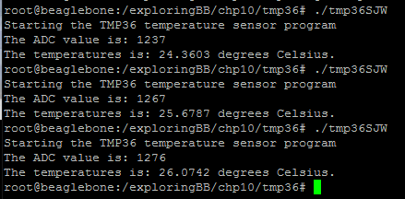
I altered the program slightly for better temperature accuracy.

Install the apache webserver (p. 389). Create a basic HTML page (p. 390) and using a browser, browse to the page just created. Take a screen capture of the page.


Demonstrate to the instructor and submit your code.

Source Code
tmp36SJW.cpp
%%%%%%%%%%%%%%%%%%%%%%%%%%%%%%%%%%%%%
/* A TMP36 temperature sensor application
* Written by Derek Molloy for the book "Exploring BeagleBone: Tools and
* Techniques for Building with Embedded Linux" by John Wiley & Sons, 2014
* ISBN 9781118935125. Please see the file README.md in the repository root
* directory for copyright and GNU GPLv3 license information. */

#include<iostream>
#include<fstream>
#include<string>
#include<sstream>
#include<stdlib.h>
using namespace std;

#define LDR_PATH "/sys/bus/iio/devices/iio:device0/in_voltage"

int readAnalog(int number){ // returns the input as an int
stringstream ss;
ss << LDR_PATH << number << "_raw";
fstream fs;
fs.open(ss.str().c_str(), fstream::in);
fs >> number;
fs.close();
return number;
}

float getTemperature(int adc_value){
float cur_voltage = adc_value * (1.80f/4096.0f);
float diff_degreesC = (cur_voltage-0.75f)/0.01f;
return (45.0f + diff_degreesC);
}

int main(int argc, char* argv[]){
int ain = 0;
cout << "Starting the TMP36 temperature sensor program" << endl;
if (argc>1) ain = atoi(argv[1]);
int value = readAnalog(ain);
cout << "The ADC value is: " << value << endl;
float temperature = getTemperature(value);
cout << "The temperatures is: " << temperature << " degrees Celsius." << endl;
return 0;
}

