Sarah Wood
Embedded Programming
BeagleBone Black
C8-B1

Pages 286-287
I downloaded the i2c tools, and got dumps of figures.
Pages 289-290
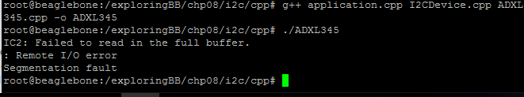
I got some figures, then the buffer croaked. I re-built, and
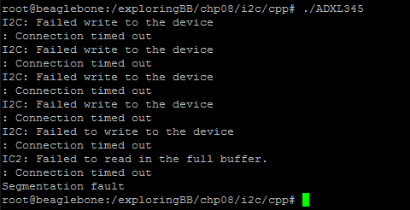
Then I couldn't find the device. Hmm.
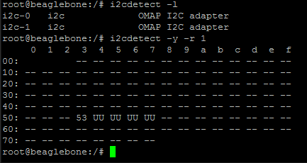
There is the device. Let's just try again and see what happens. SMEG! Again, I got a second or so of readings before the buffer dumped out.
Pages 293-296
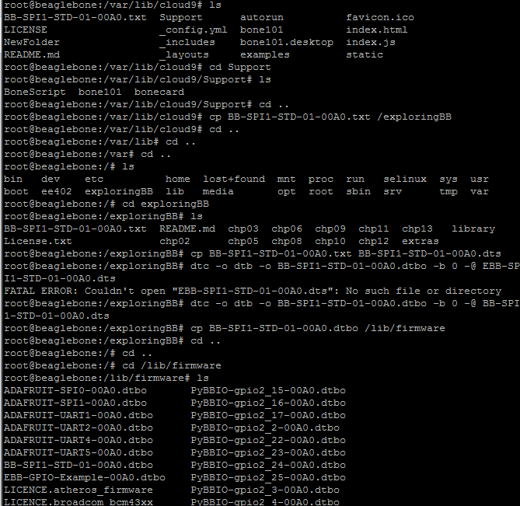
I had to get the overlay from the 'net. (http://elinux.org/BeagleBone_Black_Enable_SPIDEV) I downloaded it to my local Windows machine, uploaded to the BBB via Cloud9, and then manipulated, compiled, and copied it via Putty. Here you can see that the compiled blob object is in the firmware directory.
I had a difficult time disabling the HDMI to allow hardware access for SPI. The instructions on page 225 didn't work for me. My mmcblk0p1 didn't contain uEnv.txt . It only had a NFS-uEnv.txt for network booting.
It actually turns out that uEnv.txt is in the boot directory. D'oh. ( http://dev.iachieved.it/iachievedit/adventures-in-beaglebone-black-device-overlays-and-spi/ )
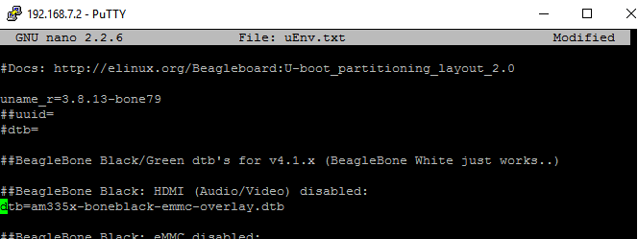
Hey, there it is. I disabled the HDMI (for now). I rebooted, and reloaded the SPI device tree overlay.

Pages 298-299

Well, smeg. I fouled something up. BBB won't boot. Must have been overzealous in the uEnv.txt file. Good thing I stashed a microSD card in my BBB box.
OK, we've re-flashed, reconfigured for networking, and re-loaded the SPI driver. (The “BB-SPIDEV0-00A0.dts” isn't included in this OS distribution. I also can't find it in the author's website or github repo. The versions I found poking around the 'net were custom versions. I will see if the ADAFRUIT SPI dtbo works for this exercise. )
Nope.

Pages 312-320 follow the Arduino example
Since this class operates on an Arduino UNO, rather than the PRO MINI, I followed the instructions at the end of the chapter. I did not have a logic-level translator to get the UNO to communicate via 3.3v. The school also did not have one.

Tom gave me a “free pass” on this portion of the assignment.

I will read the chapter again very carefully. I may get a logic-level translator for my final project, as that would allow me to use the UNO as a slave controller.

