Sarah Wood
Embedded Programming
BeagleBone Black
C9-B1
Complete the example for the distance sensor (p. 352). Make sure it builds and runs.
Since the book uses a different sensor, I used the code found at: http://github.com/luigif/hcsr04
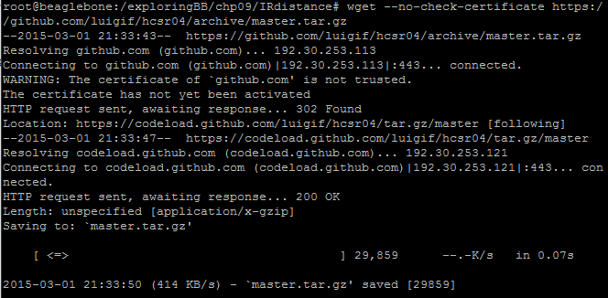
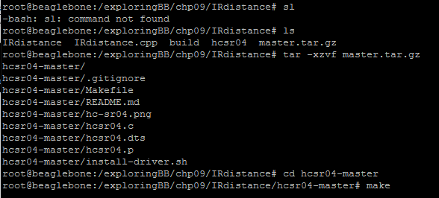

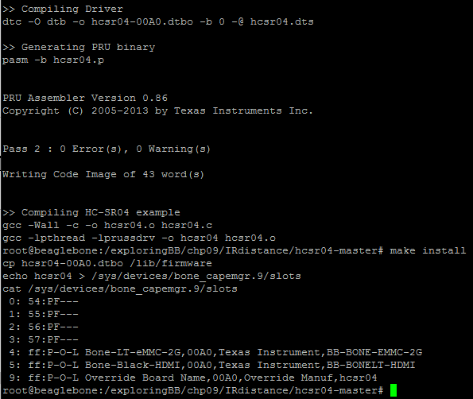
The build was very smooth. You can see the new device in slot 9. Let's see what it does.
No love yet. It could be the cape. I'll shutdown, remove it properly, and reboot. I will also double-check schematic against actual wiring.
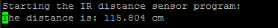
Hooray.

Complete the example for the accelerometer (p. 354). Make sure it builds and runs.
Demonstrate to the instructor and submit your code.
I didn't include the conditioning circuitry as illustrated. The author states that it may be overkill anyway.
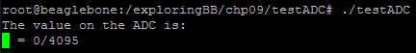

Source code
I have included the repo for the hcsr04 code. He does adjust it every so often, so you'll want the most recent code.

Accelerometer code is as per the book. It can also be found in the book's git repo.
/* A Test ADC Application
* Written by Derek Molloy for the book "Exploring BeagleBone: Tools and
* Techniques for Building with Embedded Linux" by John Wiley & Sons, 2014
* ISBN 9781118935125. Please see the file README.md in the repository root
* directory for copyright and GNU GPLv3 license information. */

#include<iostream>
#include<fstream>
#include<string>
#include<sstream>
#include<cmath>
using namespace std;

#define LDR_PATH "/sys/bus/iio/devices/iio:device0/in_voltage"

int readAnalog(int number){
stringstream ss;
ss << LDR_PATH << number << "_raw";
fstream fs;
fs.open(ss.str().c_str(), fstream::in);
fs >> number;
fs.close();
return number;
}

int main(int argc, char* argv[]){
cout << "The value on the ADC is:" << endl;
for(int i=0; i<1000; i++){
int value = readAnalog(0);
cout << " = " << readAnalog(0) << "/4095 " << '\r' << flush;
usleep(50000);
}
return 0;
}

