Sarah Wood
Embedded Programming
BeagleBone Black
C10-B2
Complete the CGI script example on page 391. Make sure it is runnable. Run the script.
Demonstrate to the instructor and submit your code.

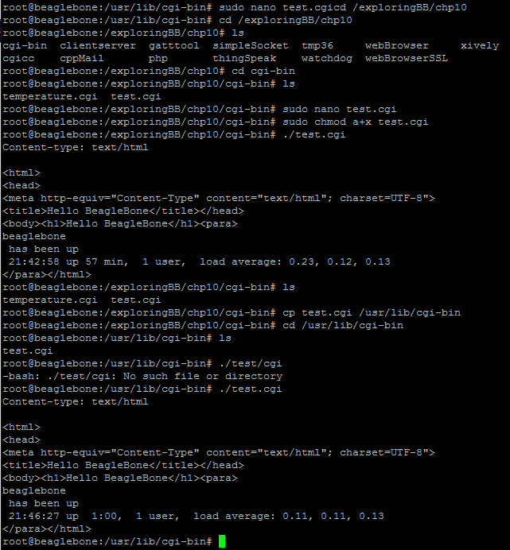

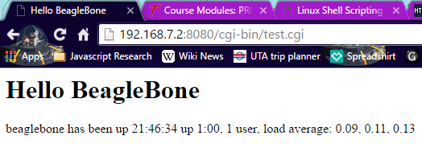
Source Code:

#!/bin/bash
echo "Content-type: text/html"
echo ""
echo '<html>'
echo '<head>'
echo '<meta http-equiv="Content-Type" content="text/html"; charset=UTF-8">'
echo '<title>Hello BeagleBone</title></head>'
echo '<body><h1>Hello BeagleBone</h1><para>'
hostname
echo ' has been up '
uptime
echo '</para></html>'

