Sarah Wood
Embedded Programming
BeagleBone Black
C5-B1
Scripting practice

Follow the author's video on how to set up your BBB to connect to the internet:
http://derekmolloy.ie/beaglebone/getting-started-usb-network-adapter-on-the-beaglebone/ (Links to an external site.)
Clone the author’s git repository onto your BBB using PuTTY and the following commands:
- sudo apt-get install git
- git clone https://github.com/derekmolloy/exploringBB.git (Links to an external site.)
Study the scripts in the chapter to see how each scripting language performs. Feel free to try any script or to compile and build any project.
Go to the /chp05/makeLED directory. Here is the C/C++ code. Build and run this project. A C++ compiler is already loaded on your BBB. Take a screen capture of the PuTTY session while you run the makeLED project. Submit.
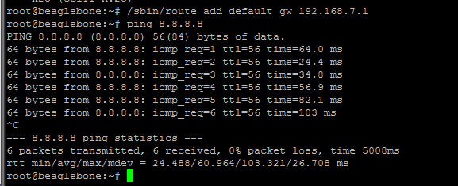
Ping google works.
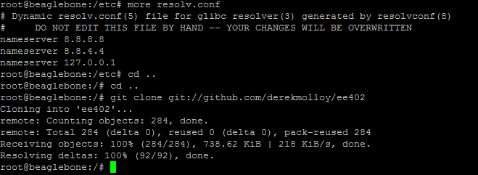
I was able to clone some of the author's utility programs, let's repeat for more book related stuff.
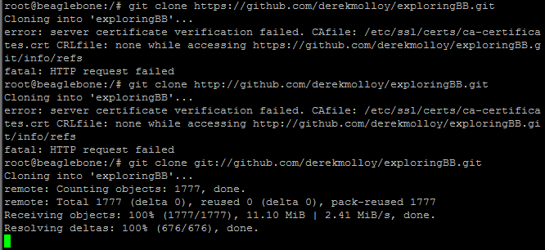
Good to know. HTTPS and HTTP both failed, but GIT transfer protocol worked just fine.

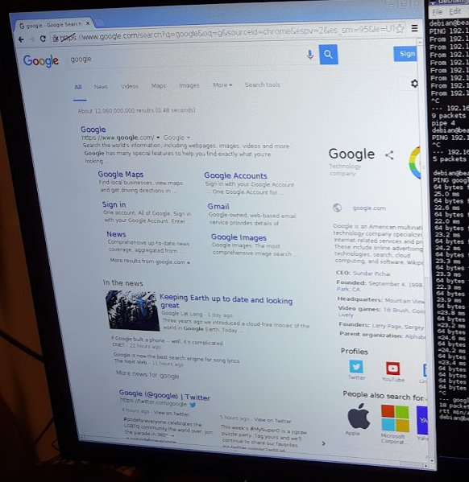
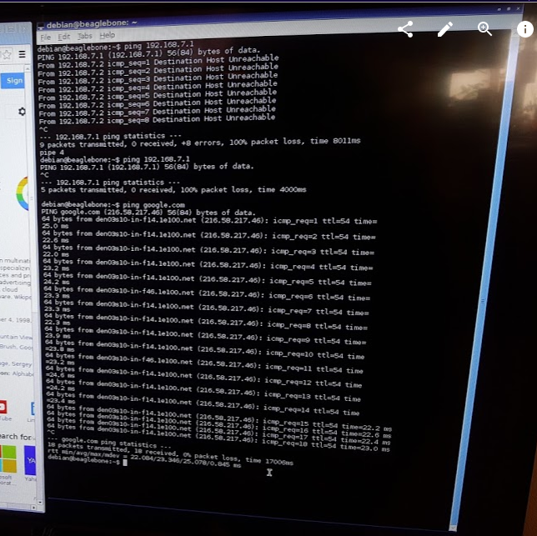
This shows both the BBB web browser Chromium and the terminal connecting to Google. BBB was easy to connect to my TV, and the graphics quality is awesome! Now off to MakeLED.
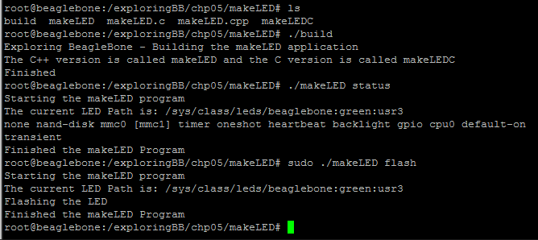
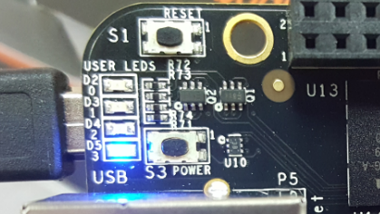
The LED3 is pulsing rapidly. That's hard to show in a still photo.
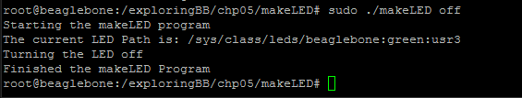
And LED3 is off.

