Sarah Wood
Embedded Programming
BeagleBone Black
C5-B2
makeLEDOOP

On page 192 in your text is the code for an application. This code is on your BBB in the chp05/makeLEDOOP/ directory. Build this program per the instructions on page 193. Test the code on your BBB. Feel free to make any changes or improvement to the application, rebuild and run it. Show your instructor the BBB running the code. When you are done, restore the LEDs to their normal state using the method on page 194.

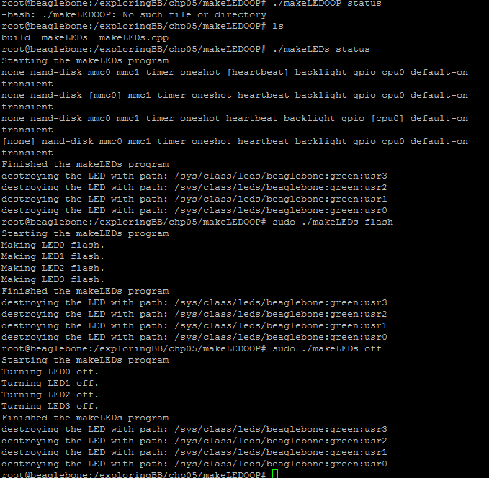
Simple Flashy LED works.

I tried to implement a simple “chase” sequence (1-2-3-4, repeat), I had to go around the “per-LED” logic provided, and build a simple sequence of states.

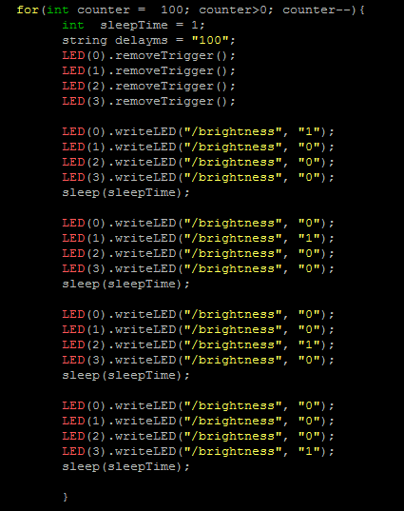
Nathan verified that the chase sequence did actually chase. I restored the system LEDs as per instructions.
