Sarah Wood
Embedded Programming
BeagleBone Black C11-B1
Run the GTK+, "Hello World" example on pp. 436-437. To do this correctly, you must open a VNC connection as shown on the bottom of p. 434. Compile the code as shown on p. 437 and run the program, ./gtksimple.
I installed the x11-apps package, and Xming. Here is Sarah's normal Windows desktop. The yellow guy is a cartoon character, a Cromulon from “Rick and Morty”.
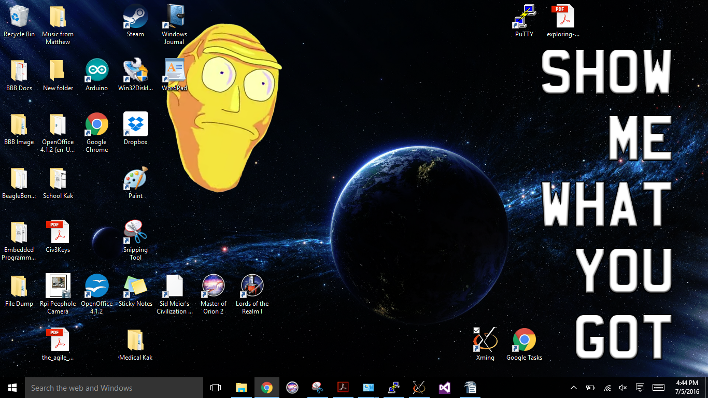
X-eyes was scaled interestingly. Here is Sarah's desktop with X-eyes.
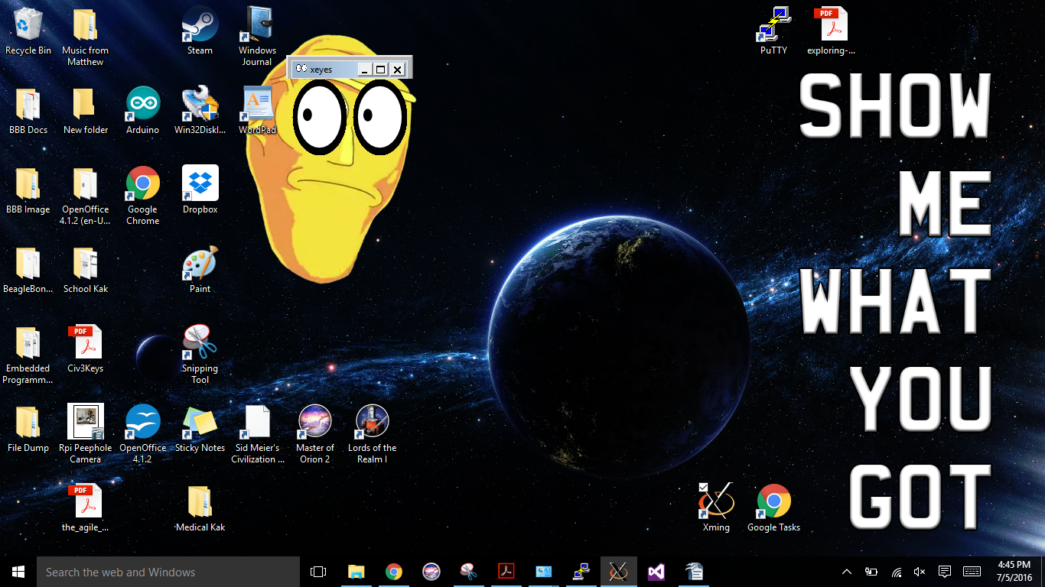
My Cromulon follows my cursor around. Neat. Now on to GTKsimple.

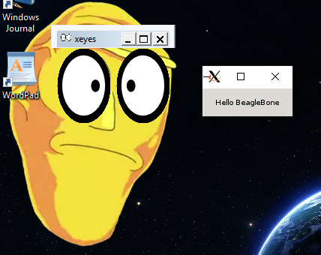
GTKsimple works. The Cromulons might not vaporize the planet after all.
Once this has been done, using the same procedure, complete the GTK+ temperature sensor example on pp. 438-439.
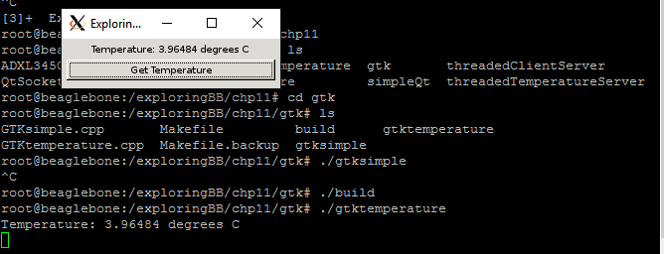
Submit a screen captures of the code running and a copies of the code.

The temperature was around 3 degrees C. Time for some, er, adjustments.

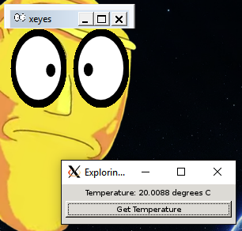
Better. My tablet says it's 21 degrees, so we're close.
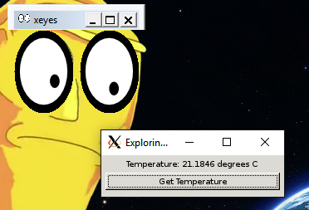
And when I warm the sensor, we get...

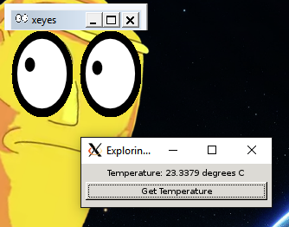

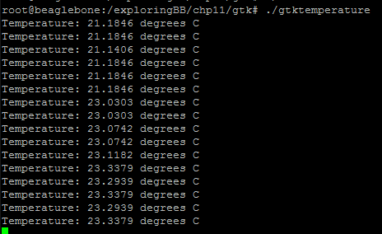
New temps. Awesome. It works. The world is safe from the Cromulons.
SOURCE CODE
GTKtemperature.cpp (adjusted)
&&&&&&&&&&&&&&&&&&&&&&&&&&&&&&&&&&&&
/* A program for a GTK Temperature application
* Written by Derek Molloy for the book "Exploring BeagleBone: Tools and
* Techniques for Building with Embedded Linux" by John Wiley & Sons, 2014
* ISBN 9781118935125. Please see the file README.md in the repository root
* directory for copyright and GNU GPLv3 license information. */

#include<gtk/gtk.h>
#include<iostream>
#include<fstream>
#include<string>
#include<sstream>
#include<stdlib.h>
using namespace std;

#define LDR_PATH "/sys/bus/iio/devices/iio:device0/in_voltage"

// Same function as in Chapter 10 to read the ADC value
int readAnalog(int number){
stringstream ss;
ss << LDR_PATH << number << "_raw";
fstream fs;
fs.open(ss.str().c_str(), fstream::in);
fs >> number;
fs.close();
return number;
}

// The callback function that is associated with the button
// it passes a pointer to the label, so that it can be changed
// when the button is pressed
static void getTemperature(GtkWidget *widget, gpointer temp_label){
// cast the generic gpointer into a GtkWidget label
GtkWidget *temperature_label = (GtkWidget *) temp_label;
int adc_value = readAnalog(0);
float cur_voltage = adc_value * (1.80f/4096.0f);
float diff_degreesC = (cur_voltage-0.75f)/0.01f;
float temperature = 42.0f + diff_degreesC;
stringstream ss;
ss << "Temperature: " << temperature << " degrees C";
// set the text in the label
gtk_label_set_text( GTK_LABEL(temp_label), ss.str().c_str());
ss << endl; // add a \n to the string for the standard output
g_print(ss.str().c_str()); //output to the terminal (std out)
}

int main(int argc, char *argv[]){
GtkWidget *window, *temp_label, *button, *button_label;
gtk_init(&argc, &argv);
window = gtk_window_new(GTK_WINDOW_TOPLEVEL);
gtk_window_set_title(GTK_WINDOW (window), "Exploring BB");

// Fix the size of the window so that it cannot be resized
gtk_widget_set_size_request(window, 220, 50);
gtk_window_set_resizable(GTK_WINDOW(window), FALSE);
// Place a border of 5 pixels around the inner window edge
gtk_container_set_border_width (GTK_CONTAINER (window), 5);

// Quit application if X button is pressed
g_signal_connect(window, "destroy", G_CALLBACK (gtk_main_quit), NULL);

// Set up the window to contain two vertically stacked widgets using a vbox
GtkWidget *vbox = gtk_vbox_new(FALSE, 5); //spacing of 5
gtk_container_add (GTK_CONTAINER (window), vbox); //add vbox to window
gtk_widget_show (vbox); // set the vbox visible

// This is the label in which to display the temperature
temp_label = gtk_label_new ("Temperature is Undefined");
gtk_widget_show(temp_label); // make it visible
gtk_label_set_justify( GTK_LABEL(temp_label), GTK_JUSTIFY_LEFT);
// Add the label to the vbox
gtk_box_pack_start (GTK_BOX (vbox), temp_label, FALSE, FALSE, 0);

// Create a button and connect it to the getTemperature() callback function
button = gtk_button_new();
button_label = gtk_label_new ("Get Temperature"); //label for text on button
gtk_widget_show(button_label); // show label
gtk_widget_show(button); // show button
gtk_container_add(GTK_CONTAINER (button), button_label); // add label to button
// Connect the callback function getTemperature() to the button press
g_signal_connect(button, "clicked", G_CALLBACK (getTemperature), (gpointer) temp_label);
// Add the button to the vbox
gtk_box_pack_start (GTK_BOX (vbox), button, FALSE, FALSE, 0);

gtk_widget_show(window);
gtk_main();
return 0;
}

