Sarah Wood
Embedded Programming
BeagleBone Black
C11-B2
Run the Qt, "Hello World" example on pp. 442-443.
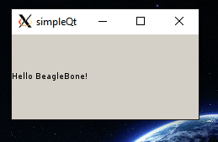
Once this has been done, using the same procedure, complete the Qt temperature sensor example on pp. 449-452.
Submit a screen captures of the code running and a copies of the code.
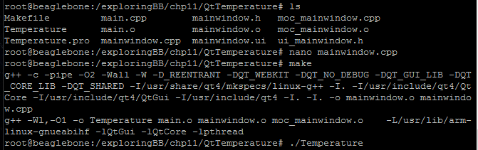
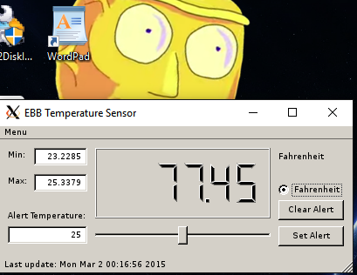

Sweet. It works, is reasonably accurate, and refreshes regularly.
Here is the C++ code that I used. My adjustments are highlighted.
SOURCE CODE
$$$$$$$$$$$$$$$$$$$$$$$$$$$$$$$$$$$$$$$$$$$$
/* A program for a Qt Temperature Sensor application
* Written by Derek Molloy for the book "Exploring BeagleBone: Tools and
* Techniques for Building with Embedded Linux" by John Wiley & Sons, 2014
* ISBN 9781118935125. Please see the file README.md in the repository root
* directory for copyright and GNU GPLv3 license information. */

#include "mainwindow.h"
#include "ui_mainwindow.h"
#include <fstream>
#include <sstream>
using namespace std;

#define LDR_PATH "/sys/bus/iio/devices/iio:device0/in_voltage"

// Constructor used to set up the default values for the created object
MainWindow::MainWindow(QWidget *parent) :
QMainWindow(parent), ui(new Ui::MainWindow) {
ui->setupUi(this);
this->isFahrenheit = false; // default to Celsius
this->isAlertSet = false; // no alert set
statusBar()->showMessage("No alert set"); // status at bottom of window
this->timer = new QTimer(this); // create a new timer
// when the timer times out, call the function on_updateTemperature()
connect(timer, SIGNAL(timeout()), this, SLOT(on_updateTemperature()));
this->maxTemperature = -100.0f; // pick an impossible min
this->minTemperature = 200.0f; // pick an impossible max
this->on_updateTemperature(); // explicitly update the display
timer->start(5000); // set the time out to be 5 sec
}

MainWindow::~MainWindow() { // destructor, destroys UI
delete ui;
}

void MainWindow::on_setAlertButton_clicked() { // set the alert temperature
int sliderValue = ui->alertTempSlider->value(); // get the slider value
if(sliderValue < getTemperature()){ // lower than current temp?
QMessageBox::warning(this, "EBB Temperature",
"Alert setting too low!", QMessageBox::Discard);
}
else{ // alert value fine
QString tempStr("Alert is set for: "); // form a message
tempStr.append(QString::number(sliderValue)); // with the alert temp
statusBar()->showMessage(tempStr); // display the message
this->isAlertSet = true; // alert is set
this->alertTemperature = sliderValue; // alert temp set
}
}

void MainWindow::on_isFahrenheitRadio_toggled(bool checked){
this->isFahrenheit = checked; // pressed the toggle button
if(checked){
ui->isCelsiusLabel->setText("Fahrenheit"); // display F on top-right
}
if(!checked){
ui->isCelsiusLabel->setText("Celsius"); // display C on top-right
}
this->on_updateTemperature(); // update the temperature value
}

void MainWindow::on_clearAlertButton_clicked(){// remove the alert
this->isAlertSet = false;
statusBar()->showMessage("No alert set");
}

void MainWindow::on_alertTempSlider_valueChanged(int value) {
ui->alertEdit->setText(QString::number(value)); // update alert text field
}

float MainWindow::getTemperature(){ // read the temperature
int adc_value = readAnalog(0); // get the ADC value
float cur_voltage = adc_value * (1.80f/4096.0f); // convert to voltage
float diff_degreesC = (cur_voltage-0.75f)/0.01f; // using TMP36 data sheet
return(42.0f + diff_degreesC); // return the temperature deg C
}

int MainWindow::readAnalog(int number){ // same as Chapter 10 code
stringstream ss;
ss << LDR_PATH << number << "_raw";
fstream fs;
fs.open(ss.str().c_str(), fstream::in);
fs >> number;
fs.close();
return number;
}

float MainWindow::celsiusToFahrenheit(float valueCelsius){
return ((valueCelsius * (9.0f/5.0f)) + 32.0f);
}

void MainWindow::on_updateTemperature() { // called whenever temp updated
float temperature = this->getTemperature();
QDateTime local(QDateTime::currentDateTime()); //display sample time
statusBar()->showMessage(QString("Last update: ").append(local.toString()));
if(temperature >= this->maxTemperature){ // is this the max temperature?
this->maxTemperature = temperature;
ui->maxEdit->setText(QString::number(temperature));
}
if(temperature <= this->minTemperature){ // is this the min temperature?
this->minTemperature = temperature;
ui->minEdit->setText(QString::number(temperature));
}
if(this->isFahrenheit){ // is the display in Fahrenheit?
ui->temperatureLCD->display((double)this->celsiusToFahrenheit(temperature));
}
else{ // must be Celsius
ui->temperatureLCD->display((double)temperature);
}
if(this->isAlertSet){ // is the alert enabled?
if(temperature>=this->alertTemperature){ // does this exceed alert temp
QString message("Alert! It is ");
message.append(QString::number(temperature)).append(" degrees C!");
QMessageBox::information(this, "EBB Temp", message, QMessageBox::Ok);
}
}
}

