Sarah Wood
Embedded Programming
BeagleBone Black
C13-B1
Load the overlay code on pp. 510-511. Make sure it builds and runs.
I was much more cautious about following the instructions on disabling HDMI on page 225. I didn't want to have to re-flash my eMMC again.
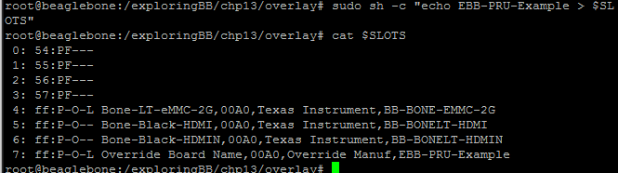
You can see that the HDMI and HDMIN buses are disabled (no L, presumably for “Live”). The new device is enabled on slot 7.

Complete the coding for the ultrasonic sensor pp. 530-534. Make sure it builds and runs.
I skipped the logic-level circuitry and simply added a 1Kohm resistor to the ECHO line to bring the BBB input voltage down to 3.3v.
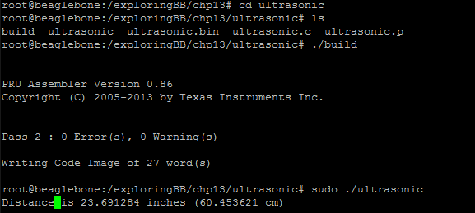
The distance has a quick response time, and refreshes many times a second.
Demonstrate to the instructor and submit your code.
I demonstrated to Tom that it does actually work.

(It's not actually my code, it's just code from the book.)

Source Code
%%%%%%%%%%%%%%%%%%%
ultrasonic.c
%%%%%%%%%%%%%%%%%%
/* PRUSS program to drive a HC-SR04 sensor and display the sensor output
* in Linux userspace by sending an interrupt.
* written by Derek Molloy for the book Exploring BeagleBone
*/
#include <stdio.h>
#include <stdlib.h>
#include <prussdrv.h>
#include <pruss_intc_mapping.h>
#include <pthread.h>
#include <unistd.h>

#define PRU_NUM 0

static void *pru0DataMemory;
static unsigned int *pru0DataMemory_int;

void *threadFunction(void *value){
do {
int notimes = prussdrv_pru_wait_event (PRU_EVTOUT_1);
unsigned int raw_distance = *(pru0DataMemory_int+2);
float distin = ((float)raw_distance / (100 * 148));
float distcm = ((float)raw_distance / (100 * 58));
printf("Distance is %f inches (%f cm) \r", distin, distcm);
prussdrv_pru_clear_event (PRU_EVTOUT_1, PRU0_ARM_INTERRUPT);
} while (1);
}

int main (void)
{
if(getuid()!=0){
printf("You must run this program as root. Exiting.\n");
exit(EXIT_FAILURE);
}
pthread_t thread;
tpruss_intc_initdata pruss_intc_initdata = PRUSS_INTC_INITDATA;

// Allocate and initialize memory
prussdrv_init ();
prussdrv_open (PRU_EVTOUT_0);
prussdrv_open (PRU_EVTOUT_1);

// Map PRU's INTC
prussdrv_pruintc_init(&pruss_intc_initdata);

// Copy data to PRU memory - different way
prussdrv_map_prumem(PRUSS0_PRU0_DATARAM, &pru0DataMemory);
pru0DataMemory_int = (unsigned int *) pru0DataMemory;
// Use the first 4 bytes for the number of samples
*pru0DataMemory_int = 500;
// Use the second 4 bytes for the sample delay in ms
*(pru0DataMemory_int+1) = 100; // 2 milli seconds between samples

// Load and execute binary on PRU
prussdrv_exec_program (PRU_NUM, "./ultrasonic.bin");
if(pthread_create(&thread, NULL, &threadFunction, NULL)){
printf("Failed to create thread!");
}
int n = prussdrv_pru_wait_event (PRU_EVTOUT_0);
printf("PRU program completed, event number %d.\n", n);
printf("The data that is in memory is:\n");
printf("- the number of samples used is %d.\n", *pru0DataMemory_int);
printf("- the time delay used is %d.\n", *(pru0DataMemory_int+1));
unsigned int raw_distance = *(pru0DataMemory_int+2);
printf("- the last distance sample is %d.\n", raw_distance);

// raw_distance is in 10ns samples
// distance in inches = time (ms) / 148 according to datasheet
float distin = ((float)raw_distance / (100 * 148));
float distcm = ((float)raw_distance / (100 * 58));
printf("-- A distance of %f inches (%f cm).\n", distin, distcm);

/* Disable PRU and close memory mappings */
prussdrv_pru_disable(PRU_NUM);
prussdrv_exit ();
return EXIT_SUCCESS;
}

