Sarah Wood
Embedded Programming
BeagleBone Black
C6-B2
Grove Cape

In the /exploringBB/chp06/GPIO directory on your BBB, modify the simple.cpp code to run using a Grove cape.
Use the J6(GPIO2) socket for the LED, and J2(GPIO14) for the button. This document will help. Use vim or any editor you're familiar with to open and modify the code. When you have made these changes, re-build the code and execute. You should see the LED flash. Submit your code.

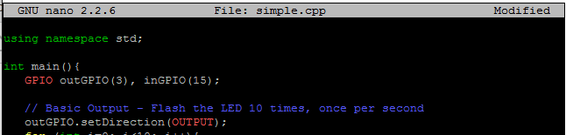
Here is the modified line for GPIO.

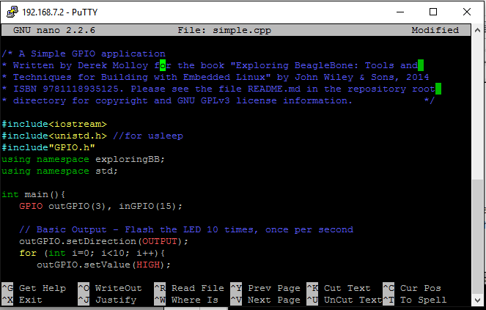
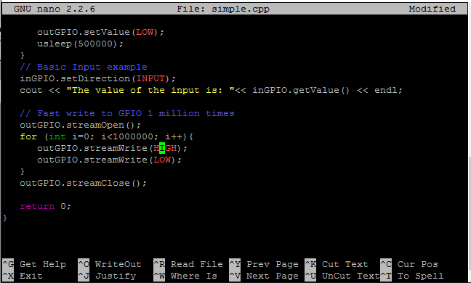
Here is the code in its entirety for reference.

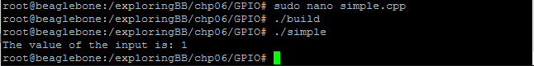
The build was uneventful, and the input was read. I saw light from the LED.

