Sarah Wood
Embedded Programming
Chapter 8
Assignment 3

Modify the TV thermometer so that it switches between degrees Celsius
and degrees Fahrenheit every few seconds. Don’t just change the text;
change the graphics, too.

Screen Caps (Well, OK, pictures of a TV)
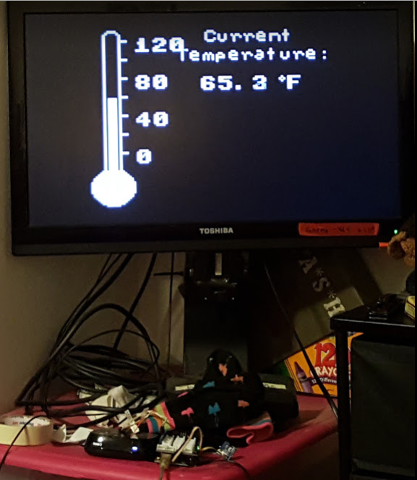
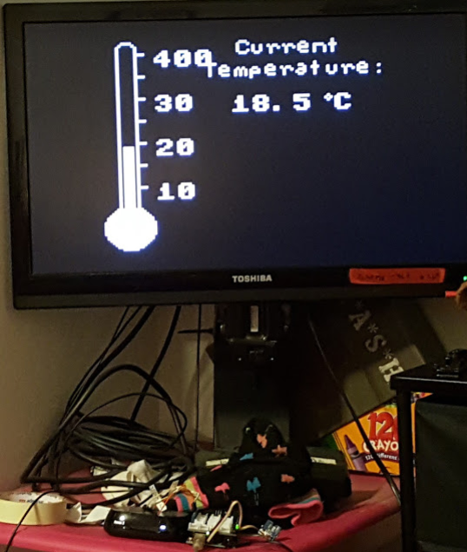

At some point, I'll go back and clear the screen, so that it can never be 400*C. I'll also shift the “Temperature” text down and maybe over a bit, so the three-digit temperatures don't stomp on it.
Source Code (I will spare you reading all the headers.)

#include <TVout.h>
#include <video_gen.h>

//#include "TVout.h"
#include "fontALL.h"
#include "thermometer.h"

const float SUPPLY_VOLTAGE = 5.0;
const float MIN_C_TEMP = 5.5;
const float MAX_C_TEMP = 40.0;
const float MIN_F_TEMP = 0.0;
const float MAX_F_TEMP = 120;
const unsigned int SCREEN_WIDTH = 120;
const unsigned int SCREEN_HEIGHT = 96;
const unsigned int TEMP_SENSOR_PIN = A1;
const unsigned int SCALE_X_MIN = 8;
const unsigned int SCALE_Y_MIN = 6;
const unsigned int SCALE_Y_MAX = 75;
const unsigned int SCALE_WIDTH = 3;
const unsigned int SCALE_HEIGHT = SCALE_Y_MAX - SCALE_Y_MIN;

float current_temperature = 0.0;

unsigned long last_measurement = millis();
TVout TV;

//declare functions
const float mapfloat (float, float, float, float, float);
const float get_temperature();

void setup() {
TV.begin(NTSC, SCREEN_WIDTH, SCREEN_HEIGHT);
TV.bitmap(0, 1, thermometer);
TV.select_font(font4x6);
/*
*
TV.set_cursor(20, 4);
TV.print("40");
TV.set_cursor(20, 24);
TV.print("30");
TV.set_cursor(20, 44);
TV.print("20");
TV.set_cursor(20, 64);
TV.print("10");
*/
}

void loop() {
unsigned long current_millis = millis();
//if (abs(current_millis - last_measurement) >= 1000)
//had to bag “if” statement and just run the code.

current_temperature = get_temperature();
float current_F_temperature = ((current_temperature *1.8) +32);
last_measurement = current_millis;

//setup for C

TV.set_cursor(20, 4);
TV.print("40");
TV.set_cursor(20, 24);
TV.print("30");
TV.set_cursor(20, 44);
TV.print("20");
TV.set_cursor(20, 64);
TV.print("10");

//do celcius

int y_pos = mapfloat(current_temperature, MIN_C_TEMP, MAX_C_TEMP, SCALE_Y_MAX, SCALE_Y_MIN);
TV.draw_rect( SCALE_X_MIN, SCALE_Y_MIN, SCALE_WIDTH, SCALE_HEIGHT, BLACK, BLACK);

TV.select_font(font6x8);
TV.set_cursor(53, 1);
TV.print("Current");
TV.set_cursor(40, 13);
TV.print("Temperature:");
TV.select_font(font8x8);
TV.set_cursor(50, 25);
TV.print(current_temperature, 1);
TV.print(" C");
TV.draw_circle(88, 27, 1, WHITE);
TV.draw_rect(
SCALE_X_MIN, y_pos, SCALE_WIDTH, SCALE_Y_MAX - y_pos, WHITE, WHITE);

//delay X seconds
delay(50000);

//rinse & repeat for farenheit
//setup for F
//note 0*-120*

TV.set_cursor(20, 4);
TV.print("120");
TV.set_cursor(20, 24);
TV.print("80");
TV.set_cursor(20, 44);
TV.print("40");
TV.set_cursor(20, 64);
TV.print("0");

//do farenheit

y_pos = mapfloat(current_F_temperature, MIN_F_TEMP, MAX_F_TEMP, SCALE_Y_MAX, SCALE_Y_MIN);
//TV.draw_rect( SCALE_X_MIN, SCALE_Y_MIN, SCALE_WIDTH, SCALE_HEIGHT, BLACK, BLACK);
TV.draw_rect( SCALE_X_MIN, y_pos, SCALE_WIDTH, SCALE_Y_MAX - y_pos, WHITE, WHITE);
TV.select_font(font6x8);
TV.set_cursor(53, 1);
TV.print("Current");
TV.set_cursor(40, 13);
TV.print("Temperature:");
TV.select_font(font8x8);
TV.set_cursor(50, 25);

TV.print(current_F_temperature, 1);
TV.print(" F");
TV.draw_circle(88, 27, 1, WHITE);

//delay X seconds
delay(50000);

}

const float mapfloat(
float x, float in_min, float in_max, float out_min, float out_max)
{
return (x - in_min) * (out_max - out_min) / (in_max - in_min) + out_min;
}

const float get_temperature() {

//work on tweaking this to get a somewhat accurate reading...done.
//added a zero to the book code in the return line.

const int sensor_voltage = analogRead(TEMP_SENSOR_PIN);
const float voltage = sensor_voltage * SUPPLY_VOLTAGE / 1024;
return (voltage * 1000 - 500) / 100; //divide by one hundred, not by ten.
}

