Sarah Wood
Chapter 16
Assignment 16
“Exception Project”

Screen Caps

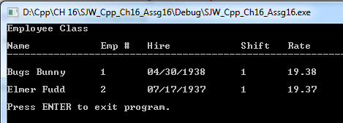

Looks like valid data makes it through the TRY block. Let’s try to break it.

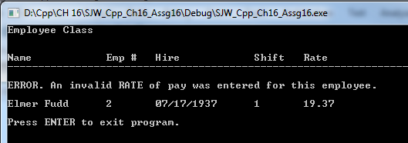

It caught Bugs’ INVALID RATE.
I had to move my output code to live within the TRY block. When I left it near the bottom of the program, the invalid value, and all subsequent object values returned nonsense. It didn’t look like an address or max value, I think it was just garbage that happened to live in that value’s “space”.
This is far from perfect, and I may massage the code to show any valid data for Bugs before throwing the error. It would indicate to the user which employee had the erroneous data, and give the data that IS valid. For instance, they might not even be looking for his RATE right now; they might just need his employee number.

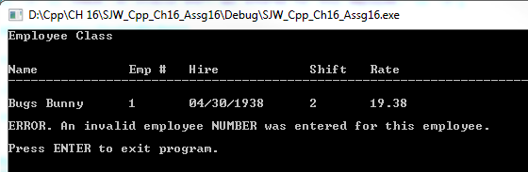

It caught Elmer’s invalid NUMBER.

This looks misleading to the user. It implies that it was Bugs that had the error, rather than Elmer. It supports my previous “wish list” notion to display valid information per object. I might have time to implement that. It’s starting to look important to do so.

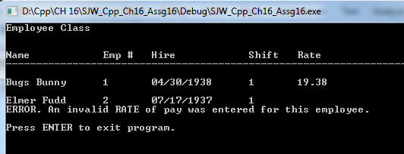

AWESOME! It does NOT display invalid information, DOES display valid data up to the error, and indicates WHICH record is flawed!

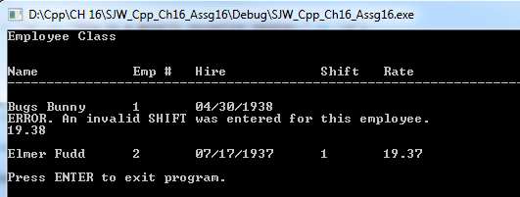

Ok, not totally perfect (Bugs’ rate is out of alignment), but certainly good enough for the time allotted.

Source Code

$$$$$$$$$$$$$$$$$$$$$$$$$$$$$$$$$$$$$$$$$$$$$$$$$$$$$$$$$$$$$$$$$$$$$
Classes.h
%%%%%%%%%%%%%%%%%%%%%%%%%%%%%%%%%%%%%%%%%%%%%%%%%%%%%%%%%%%%%%%%%%%%%

#pragma once
#include <iostream>

using namespace std;

class Employee
{

private:

string name;
int empNumber;
string hireDate;

public:

void setName(string);
void setEmpNumber(int);
void setHireDate(string);

string getName();
int getEmpNumber();
string getHireDate();

class InvalidEmployeeNumber {};

};

class ProductionWorker : public Employee
{
private:

int shiftSelection;
double hourlyRate;

public:

void setShiftSelection(int);
void setHourlyRate(double);

int getShiftSelection();
double getHourlyRate();

class InvalidShift {};
class InvalidPayRate {};

};

$$$$$$$$$$$$$$$$$$$$$$$$$$$$$$$$$$$$$$$$$$$$$$$$$$$$$$$$$$$$$$$$$$$$$
Classes.cpp
%%%%%%%%%%%%%%%%%%%%%%%%%%%%%%%%%%%%%%%%%%%%%%%%%%%%%%%%%%%%%%%%%%%%%

#include <iostream>
#include <iomanip>
#include "Classes.h"

using namespace std;

//Employee mutators
void Employee::setName(string n)
{
name = n;
}

void Employee::setEmpNumber(int num)
{
if (num > 0 && num < 9999)
{
empNumber = num;
}
else
{
throw InvalidEmployeeNumber();
}
}

void Employee::setHireDate(string date)
{
hireDate = date;
}

//Employee accessors
string Employee::getName()
{
return string(name);
}

int Employee::getEmpNumber()
{
return empNumber;
}

string Employee::getHireDate()
{
return hireDate;
}

//Production Worker mutators
void ProductionWorker::setShiftSelection(int shift)
{
if (shift == 1 || shift == 2)
{
shiftSelection = shift;
}
else
{
throw InvalidShift();
}
}

void ProductionWorker::setHourlyRate(double rate)
{
cout << setprecision(2) << fixed << showpoint;
if (rate >= 0)
{
hourlyRate = rate;
}
else
{
throw InvalidPayRate();
}
}

//Production Worker accessors
int ProductionWorker::getShiftSelection()
{
return shiftSelection;
}

double ProductionWorker::getHourlyRate()
{
return hourlyRate;
}

$$$$$$$$$$$$$$$$$$$$$$$$$$$$$$$$$$$$$$$$$$$$$$$$$$$$$$$$$$$$$$$$$$$$$
Source.cpp
%%%%%%%%%%%%%%%%%%%%%%%%%%%%%%%%%%%%%%%%%%%%%%%%%%%%%%%%%%%%%%%%%%%%%

/*
Exception Project
This assignment assumes you have completed Programming Challenge 1 of Chapter 15
( Employee and ProductionWorker Classes). Modify the Employee and
ProductionWorker classes so they throw exceptions when the following errors occur:
• The Employee class should throw an exception named InvalidEmployeeNumber
when it receives an employee number that is less than 0 or greater than 9999.
• The ProductionWorker class should throw an exception named InvalidShift
when it receives an invalid shift.
• The ProductionWorker class should throw an exception named InvalidPayRate
when it receives a negative number for the hourly pay rate.
Write a driver program that demonstrates how each of these exception conditions
works.
*/

#include <iostream>
#include <iomanip>
#include <string>
#include "Classes.h"

using namespace std;

void main()
{
//init console

cout << "Employee Class" << '\n' << '\n';

//Let's look at our staff now.

cout << '\n' << "Name" << '\t' << '\t' << "Emp #" << '\t' << "Hire" << '\t' << '\t' << "Shift" << '\t' << "Rate" << '\n';
cout << "------------------------------------------------------------------------" << '\n';

//&&&&&&&&&&&&&&&&&&&&&&&&&&&&&&&&&&&&&&&&&&&&&&&&&&&&&&&&&&&&&&&&&&&&&&&&&&&&&&&&&&&&&
//This is a test. I'm going to TRY each value individually. This will allow me to output some
//VALID data for each employee before the error condition throws.
//Note: It's almost perfect. Functionally it is what is necessary for accuracy and clarity.
//Wish-list: formatting, alignment, and general fussing.

Employee emp0001; //Let's make an employee
ProductionWorker pw0001; //Let's make a production worker

//I moved Bugs' output to live inside the try block. I was getting weird values returned under exception conditions. I hope this remedies the weirdness.

try
{
emp0001.setName("Bugs Bunny");
cout << '\n' << emp0001.getName() << '\t';
}
catch (...)
{
cout << '\n' << "This is a generic exception handler." << '\n';
}

try
{
emp0001.setEmpNumber(0001);
cout << emp0001.getEmpNumber() << '\t';
}
catch (Employee::InvalidEmployeeNumber)
{
cout << '\n' << "ERROR. An invalid employee NUMBER was entered for this employee." << '\n';
}

try
{
emp0001.setHireDate("04/30/1938");
cout << emp0001.getHireDate() << '\t';
}
catch (...)
{
cout << '\n' << "This is a generic exception handler." << '\n';
}

try
{
pw0001.setShiftSelection(4); //re: "Falling Hare" 1943, Bugs is working the day shift
cout << pw0001.getShiftSelection() << '\t';
}
catch (ProductionWorker::InvalidShift)
{
cout << '\n' << "ERROR. An invalid SHIFT was entered for this employee." << '\n';
}

try
{
pw0001.setHourlyRate(19.38);//year of debut
cout << pw0001.getHourlyRate() << '\n';
}
catch (ProductionWorker::InvalidPayRate)
{
cout << '\n' << "ERROR. An invalid RATE of pay was entered for this employee." << '\n';
}
catch (...)
{
cout << '\n' << "This is a generic exception handler." << '\n';
}

//Let's try another way to build production employees...
ProductionWorker pw0002;//another production employee

try
{
pw0002.setName("Elmer Fudd");
cout << '\n' << pw0002.getName() << '\t';
}
catch (...)
{
cout << '\n' << "This is a generic exception handler." << '\n';
}

try
{
pw0002.setEmpNumber(0002);
cout << pw0002.getEmpNumber() << '\t';
}
catch (Employee::InvalidEmployeeNumber)
{
cout << '\n' << "ERROR. An invalid employee NUMBER was entered for this employee." << '\n';
}

try
{
pw0002.setHireDate("07/17/1937");
cout << pw0002.getHireDate() << '\t';
}
catch (...)
{
cout << '\n' << "This is a generic exception handler." << '\n';
}

try
{
pw0002.setShiftSelection(1); // day shift
cout << pw0002.getShiftSelection() << '\t';
}
catch (ProductionWorker::InvalidShift)
{
cout << '\n' << "ERROR. An invalid SHIFT was entered for this employee." << '\n';
}

try
{
pw0002.setHourlyRate(19.37);//year of debut
cout << pw0002.getHourlyRate() << '\n';
}
catch (ProductionWorker::InvalidPayRate)
{
cout << '\n' << "ERROR. An invalid RATE of pay was entered for this employee." << '\n';
}
catch (...)
{
cout << '\n' << "This is a generic exception handler." << '\n';
}

//keep window open

cout << '\n' << "Press ENTER to exit program."; //advise user of correct keypress to exit
cin.ignore(256, '\n'); //ignore up to 256 characters, stop ignoring at any instance of '\n'
cin.get();

}

