Sarah Wood
Chapter 19
Assignment 6
“Recursive Power Function”

Screen Caps

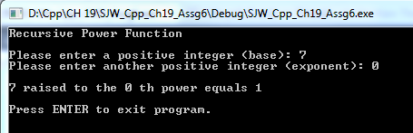
Cool. The “empty product” catch works. Now for some actual numbers.

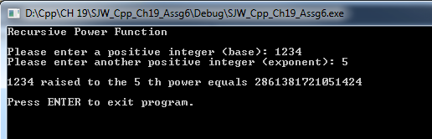

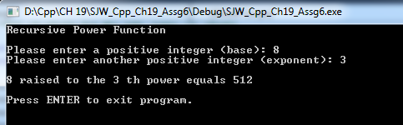

Source Code
/*
Recursive Power Function
Write a function that uses recursion to raise a number to a power.The function should
accept two arguments : the number to be raised and the exponent.Assume that the
exponent is a nonnegative integer.Demonstrate the function in a program.
*/

#include <iostream>
#include <cmath>

//continuing the "no standard namespace" learning experience.

long long int raiseToExponent(long long int, int);

void main()
{

//init console
std::cout << "Recursive Power Function" << '\n' << '\n';

//make variables and get user input for values

int numExponent;
long long int numBase;

std::cout << "Please enter a positive integer (base): ";
std::cin >> numBase;
std::cout << "Please enter another positive integer (exponent): ";
std::cin >> numExponent;

//raise BASE to POWER
std::cout << '\n' << numBase << " raised to the " << numExponent << " th power equals " << raiseToExponent(numBase, numExponent) << '\n';

//keep window open
std::cout <<'\n'<< "Press ENTER to exit program." << std::endl;
std::cin.ignore(256, '\n');
std::cin.get();

}

long long int raiseToExponent(long long int base, int exponent)
{
if (exponent == 0)
return 1;
else
{
return (base * raiseToExponent(base, exponent - 1)); //recursive case
//return BASE * BASE a decreasing number of times until we run out
}
}

