Sarah Wood
Chapter 19
Assignment 8
“isMember Function”

Screen Caps

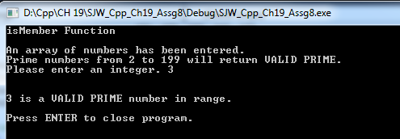

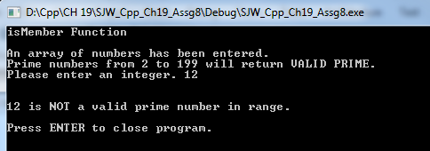

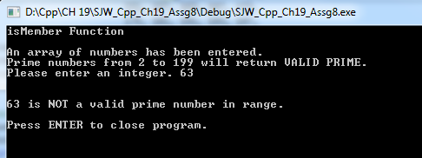

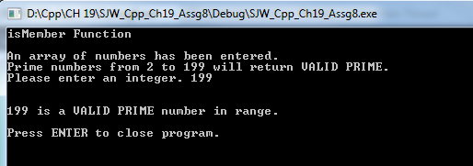

Source Code

/*
isMember Function
Write a recursive Boolean function named isMember . The function should accept two
arguments: an array and a value. The function should return true if the value is found
in the array, or false if the value is not found in the array. Demonstrate the function
in a driver program.

&&&&&&&&&&&&&&&&&&&&&&&&&&&&&&&&&&&&&&&&&&&&&&&&&&&&&&&&&&&&&&&&&&&&&&&&&&&&&&&&&&&
In order to make this work, I had to add a third function parameter for "count" to increment the array subscript.
If there is a more elegant way to do this, I'd love to learn it.

*/

#include <iostream>

//I'll probably go back to standard namespace for the final project, but it isn't that big a headache, and I'm almost sure to run into custom namespaces at some point.

bool isMember(int[], int, int);
const int SIZE = 46; //if I define it globally, I can use it everywhere.

void main()
{
//init console
std::cout << "isMember Function" << '\n' << '\n';

//build an array and get a value from the user
int userEntry, count =0;

int arrayOfPrimes[SIZE] = { 2, 3, 5, 7, 11, //I used prime numbers for ease.
13, 17, 19, 23, 29,
31, 37, 41, 43, 47,
53, 59, 61, 67, 71,
73, 79, 83, 89, 97,
101, 103, 107, 109, 113,
127, 131, 137, 139, 149,
151, 157, 163, 167, 173,
179, 181, 191, 193, 197,
199 };
std::cout << "An array of numbers has been entered." << '\n';
std::cout << "Prime numbers from 2 to 199 will return VALID PRIME." << '\n';
std::cout << "Please enter an integer. ";
std::cin >> userEntry;

//check userEntry against array, return VALID or !VALID
if (userEntry < 0 || userEntry>199)
std::cout << "Invalid Entry. Restart program to try again.";
else if (isMember(arrayOfPrimes, userEntry, count))
{
std::cout << '\n'<<'\n' << userEntry << " is a VALID PRIME number in range." << '\n';
}
else if (!isMember(arrayOfPrimes, userEntry, count))
{
std::cout << '\n' <<'\n'<< userEntry << " is NOT a valid prime number in range." << '\n';
}
else
{
std::cout << "An unknown error occurred." << '\n';
}

//keep window open
std::cout << '\n' << "Press ENTER to close program." << '\n';
std::cin.ignore(256, '\n');
std::cin.get();

}

bool isMember(int arrayOfPrimes[], int userEntry, int count)
{

if (count == SIZE)
{
return false;
}

if (arrayOfPrimes[count] == userEntry)
{
return true;
}
else
{
return isMember(arrayOfPrimes, userEntry, count +1);
}

}

