Sarah Followill

PLAN 372 – Bhagat-Conway

10 April, 2023

Final Project Proposal: Green Infrastructure in NYC Boroughs

I am primarily interested in green architecture and infrastructure, so I plan to incorporate that interest in my final project for this course. I found a dataset of green infrastructure locations in New York City, New York. These points are the locations from the NYC Green Infrastructure initiative where sustainability initiatives such as green roofs or stormwater swales exist. I noticed that one of the attributes in the infrastructure locations table was for the borough where each point was located. Therefore, I also downloaded a dataset of New York borough boundaries that was created by the Department of City Planning and joined it to the points table in QGIS by borough name. Both of these datasets were accessed from NYC OpenData.

I am interested in exploring the distribution of green infrastructure locations across the various boroughs, and will likely use the buffer tool to set various radii around the infrastructure points to identify areas of the New York City boroughs that do not have any green infrastructure. I would also like to determine the proportion of infrastructure locations to the population of each NYC borough. Therefore, I downloaded another dataset from NYC OpenData created by the Department of City Planning with populations by borough in 2020 and projected populations by borough in 2040 based on past population trends.

I would then use this data to determine which boroughs have the lowest density of green infrastructure in R by dividing the number of green infrastructure points by total borough population for each NYC borough. I will create a chart in R to demonstrate the comparative densities by borough. Then, I will use this information to make policy recommendations regarding the expansion of green infrastructure initiatives in New York City. New York City currently has a policy that building projects with at least a $2.6 million estimated cost have to achieve a LEED Gold or higher rating for sustainable building initiatives. Other cities, such as San Francisco, have policies in place that mandate any new build over a certain square footage to meet certain sustainability infrastructure standards, such as LEED certification. Policies like this, as well as potential incentives to retrofit existing buildings with green infrastructure, could also be implemented amongst the NYC boroughs to help increase green infrastructure density.

It would also be interesting to use my population dataset’s 2040 population projection to explore how much green infrastructure by 2040 would need to be built in response to population changes in order to match or surpass current density of sustainable building initiatives. In my initial work with the data, I am having a bit of trouble joining the population data to the green infrastructure locations in QGIS, as I am just seeing null values post-join, but I believe with a little workshopping, I can use these three datasets to produce a meaningful analysis of New York City green infrastructure density by borough and predict future infrastructure density needs. By the end of this project, I plan to deliver the following: a map of NYC green infrastructure by borough using QGIS, maps using various buffers to show areas where there is a need for more green infrastructure, density reports for infrastructure by borough in both 2020 and 2040 (projected) using R, and policy suggestions of how to increase the density of sustainable infrastructure in New York City and what benefits that could provide to the city.

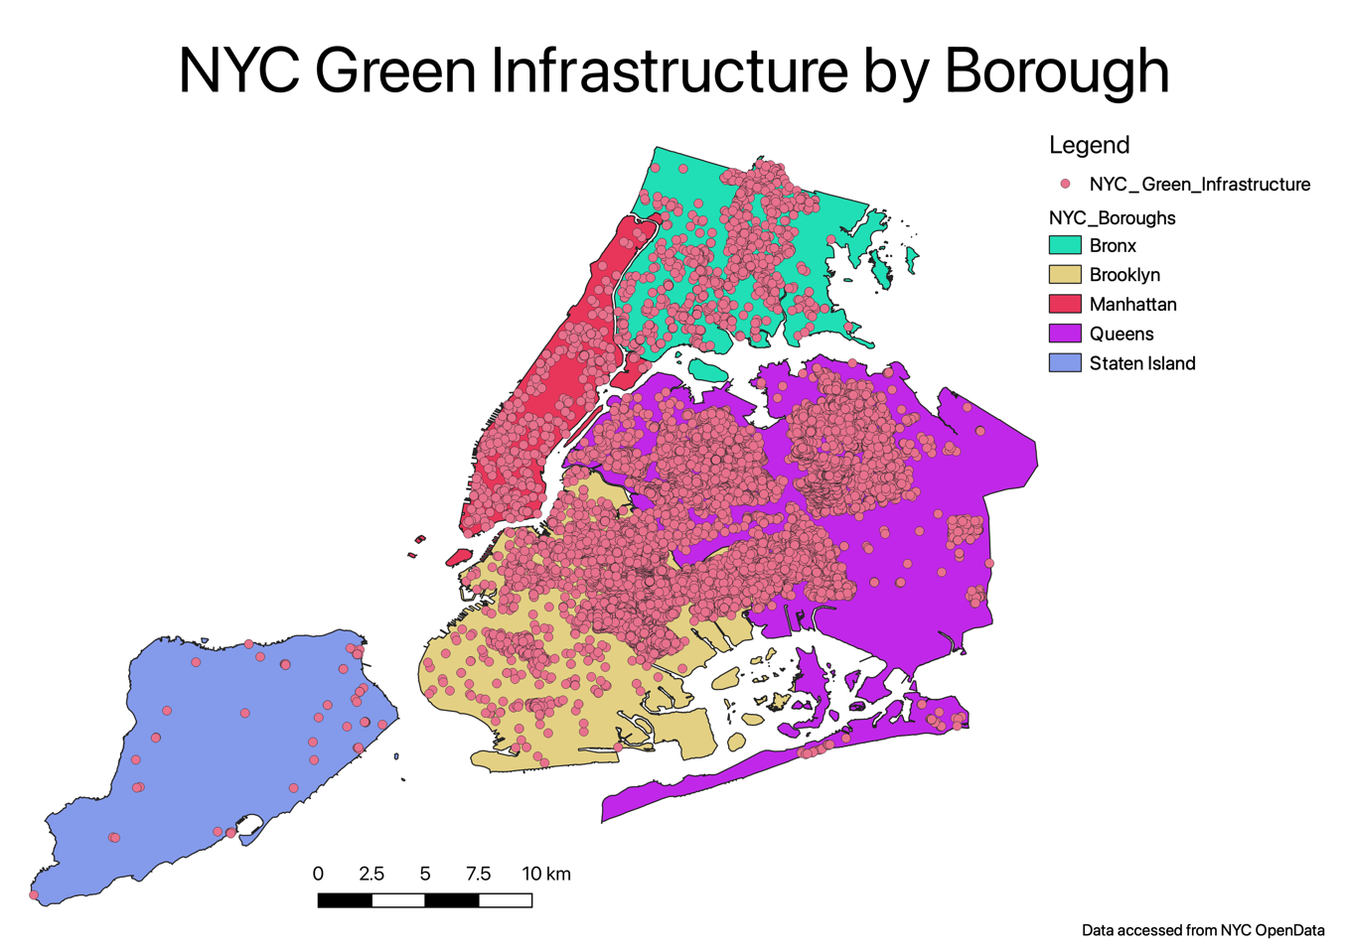

*Initial map of NYC green infrastructure by borough*

Sources – Working List

<https://data.cityofnewyork.us/City-Government/Borough-Boundaries/tqmj-j8zm>

<https://data.cityofnewyork.us/Environment/DEP-Green-Infrastructure/spjh-pz7h>

https://data.cityofnewyork.us/City-Government/New-York-City-Population-by-Borough-1950-

2040/xywu-7bv9

https://www.nyc.gov/site/oec/green-building/green-building-requirements.page

https://data.sfgov.org/Housing-and-Buildings/SF-Municipal-Green-Building-Inventory/yuvm-3ujh