Sarah Followill

PLAN 372 – Bhagat-Conway

1 May, 2023

Green Infrastructure in NYC Boroughs

1. **Introduction and Motivation**

I am primarily interested in green architecture and infrastructure and plan to pursue a future in designing such sustainable infrastructure in the future. Additionally, I am currently studying for the LEED Green Associates Exam, and have been learning about various ways to make both buildings and surrounding dense urban area more sustainable. I knew that I wanted to incorporate these interests into my final project, and eventually found a dataset of green infrastructure locations in New York City, New York. The points from this dataset are the locations from the NYC Green Infrastructure Program, piloted in 2010 by the New York City Department of Environmental Protection (DEP), and are where sustainability initiatives such as green roofs, rain gardens, or stormwater swales exist. These initiatives are primarily focused on reducing the amount of paved area that contributes to the urban heat island effect, reducing impermeable surfaces, and diverting potentially-polluted stormwater runoff from sewers to avoid Combined Sewer Overflow (CSO) events.

Due to my interest in sustainable urban developments such as this one, I decided to explore this dataset of green infrastructure locations in one of the largest and most well-known urban environments in the United States: New York City. Alongside this exploration, I also wanted to examine the density of green infrastructure in the five main neighborhoods, or boroughs, of New York in comparison to the population of those boroughs, and also use a future population projection to recommend how and where green infrastructure will need to expand in order to account for the projected population increase in New York City.

1. **Literature Review**

I began to research further into the New York City Green Infrastructure Program and found their most recent progress report from 2021. As of this report, the group’s initiative totaled a 507 million-gallon CSO reduction in 2021 through their collection of over 9,100 infrastructure assets. Listed project goals for 2022 included advancement of porous pavement design, a new Community Stormwater Resiliency Grant Program, continuing to promote incentives for green infrastructure on private property (DEP has already committed $14 million to private property owners for constructing new green infrastructure projects), and new research and development partnerships. Finally, NYC Green Infrastructure is on its way to a 2030 goal of reducing 1.67 billion gallons of CSO water per year ([NYC Green Infrastructure 2021](https://www.nyc.gov/assets/dep/downloads/pdf/water/stormwater/green-infrastructure/gi-annual-report-2021.pdf)).

The New York City Green Infrastructure Program is primarily seeking to reduce Combined Sewer Overflow events and the Urban Heat Island Effect. According to the NYC DEP, about 60% of NYC operates on a combined sewer system, where one pipe is responsible for carrying both stormwater runoff and sewage waste from buildings to a wastewater treatment plant. However, when heavy rainfall events occur, the single pipe can experience higher-than-normal volumes of stormwater, which, combined with sewage, cannot be handled in such a quantity by the treatment facility. Therefore, excess sewage and stormwater must flow out through an overflow drain, which discharges directly into local water bodies, as exemplified in *Fig. 1*. This overflow event negatively impacting water quality, damaging biodiversity, and affecting recreational use of water bodies (NYC DEP 2023). This phenomenon can be combatted through minimizing impervious surfaces that rainwater cannot naturally seep into such as asphalt and concrete, increasing vegetated area in urban environments, and capturing and storing rainwater for reuse at a later time. The NYC Green Infrastructure Program is seeking to increase use of these types of infrastructure and more in New York in order to minimize environmental damage from CSO.

While the NYC Green Infrastructure Program is primarily focused on CSO reduction, its efforts also help to combat the urban heat island effect. The urban heat island effect is characterized by increased urban temperatures due to the sun’s heat being absorbed by non-vegetated surfaces like concrete and asphalt that are concentrated in cities, and that heat being re-emitted into the local atmosphere, leading to increased temperatures ([EPA 2023](https://www.epa.gov/heatislands#:~:text=Structures%20such%20as%20buildings%2C%20roads,temperatures%20relative%20to%20outlying%20areas.)). Urban areas’ daytime temperatures can range from being 1 – 7ºF higher than surrounding, less-infrastructure-dense areas, and urban temperatures at night can be anywhere from 2 – 5ºF higher (EPA 2023). This phenomenon can be reduced by decreasing non-vegetated surface area in cities and by installing infrastructure like green roofs on building tops and building greenspaces in cities. Both of these solutions to minimize the urban heat island effect also help to reduce stormwater runoff as vegetation is much better at absorbing rainfall than asphalt, so the NYC Green Infrastructure Program can simultaneously combat both CSOs and the urban heat island effect by installing such green infrastructure.

1. **Data Review**

My primary dataset of New York Green Infrastructure Project point locations is from the New York City OpenData website, which hosts thousands of free public datasets published by established NYC agencies and governmental partners. This dataset includes over 15,000 features of green infrastructure and includes the site area of each asset and the borough in which it is located. I was confident on the completeness of this dataset as none of the features had null values for asset area or borough name. I also accessed another spatial dataset from NYC OpenData that includes borough boundaries for the five boroughs of NYC: Bronx, Brooklyn, Manhattan, Queens, and Staten Island. My third dataset was tabular data that included the 2020 population of each New York borough as well as a 2040 population projection for each borough based on current and predicted population trends.

1. **Methodology**
2. **QGIS Methods**

I began my investigation by creating a map in QGIS of New York City borough boundaries and green infrastructure asset points layered on top as seen in *Fig. 2* to visualize the distribution of assets across the city. I made each borough a different color in order to easily visualize the borough boundaries. In addition to just examining number of assets alone, I also wanted to evaluate the total area of assets in each borough. Some assets might have a larger surface area and therefore create more benefit as there is greater surface that is both capturing and diverting rainfall and reducing the effects of urban heat island, so it is important to evaluate the size of each asset in addition to asset count alone. I therefore joined my green infrastructure data to my borough boundaries layer in order to find total asset area for each borough in NYC, and created a choropleth map of total infrastructure area by borough, as seen in *Fig. 3*.

Next, I wanted to use the buffer tool in QGIS to identify areas in New York where there is no green infrastructure, and therefore areas where new infrastructure could be built by the NYC Green Infrastructure Project in the future. I started by creating 1-mile buffers around each green infrastructure location point and dissolving the result to create a zone of area that is within 1-mile of a green infrastructure point from all points within the zone. I clipped this buffer to the borough boundaries layer to limit the zone area to just within the borough boundaries, and was left with a resultant map of the 1-mile buffer zone shown in black, and areas of each borough that were not within 1-mile of green infrastructure, shown in *Fig. 4* in full color depending on borough. I also created a second map using 0.5-mile buffer in order to more narrowly highlight areas in New York City that could benefit from the installation of green infrastructure as well as areas that already have a denser concentration of assets, shown in *Fig. 5*, that was created using the same method as the 1-mile buffer and displayed in similar fashion.

I also added population data for New York City boroughs in 2020 and 2040 (projected) from the population dataset to my infrastructure dataset by using expressions, shown in *Figs. 8-9*, to create two new columns of population data.

1. **R Methods**

I then transitioned to working with my data in R. First, I exported my NYC Green Infrastructure dataset as a CSV file in order to read it into R. I then created a frequency table to calculate the counts of infrastructure assets per borough. Next, to that table I added an average area column in which I calculated the average asset area per borough for all assets in each borough using the `group_by( )` and `summarize( )` functions. I also added two more columns to the table for 2020 and 2040 (projected) populations by borough. Next, I wrote an equation for how I wanted to estimate green infrastructure density by borough in both 2020 and 2040, accounting for average asset area by borough and population by borough in both years. The equation is as shown in *Fig. 10* and estimates the density of green infrastructure surface area by population. I then stored each year’s density results by borough into two new columns, one for each year’s density.

My current equation calculated density for 2040 as if no additional green infrastructure assets were added to each borough between 2020 and 2040. Therefore, I wanted to write a new equation to evaluate how many new assets would need to be added to each New York City borough between 2020 and 2040 to make the density equal to what it is in 2020 considering projected population increase in each borough and assuming that average asset area remains the same in each borough. This equation is shown in *Fig. 11* and I stored the results of each borough’s required infrastructure change in a new column. Additionally, I then plotted that column’s contents on a bar chart, shown in *Fig. 7*, to visualize the distribution of necessary infrastructure additions by borough to maintain the 2020 area density.

Next, I added a population change by borough column by subtracting the 2020 population from the 2040 population in order to visualize the magnitude of each borough’s projected population increase during the 20-year span. I then made a bar chart of the population change distribution between the boroughs, seen in *Fig. 6*. My final table is shown in *Fig. 12*.

1. **Analysis and Results**

The borough with the greatest number of green infrastructure installations is Queens, with a total of 7,089 assets, and the borough with the least number of installations is Staten Island with only 57 assets.

From this map, I discovered that even though Queens has the highest count of assets, it is actually only the third highest in total asset area, and Brooklyn actually has the greatest total asset area at 1,944,560 ft^2.

Staten Island has least infrastructure instances, least area, and largest proportion of the borough not close to a point of green infrastructure.

1. **Policy Recommendations**

Repository

<https://github.com/sarahfollowill/PLAN372-finalproject>

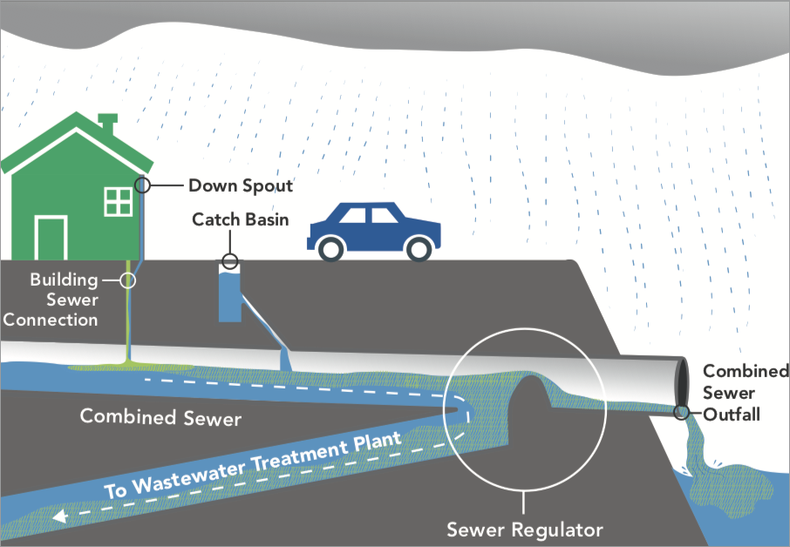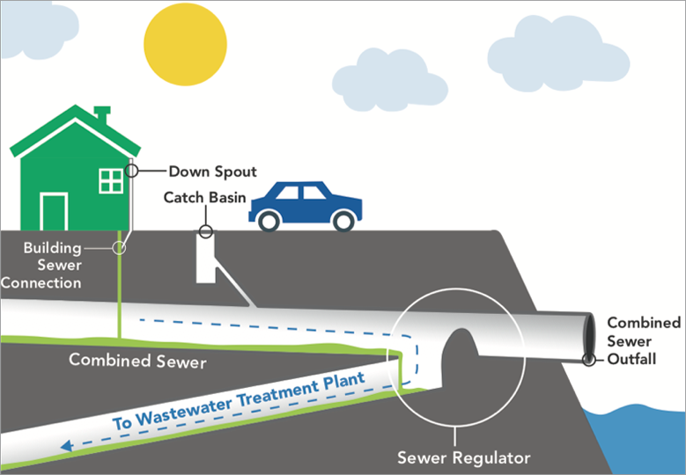 Appendix

*Fig. 1*

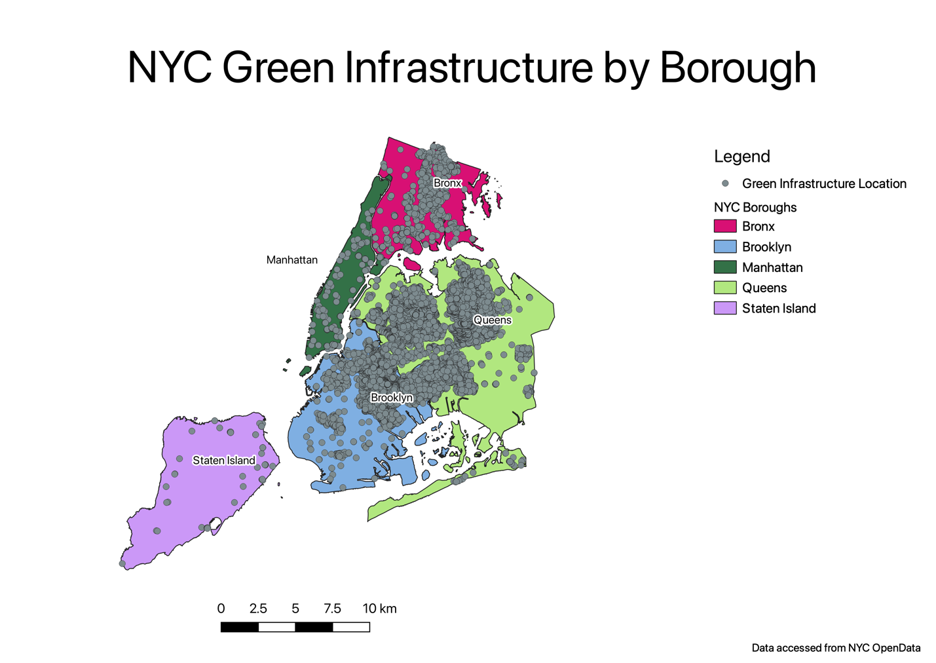

*Fig. 2*

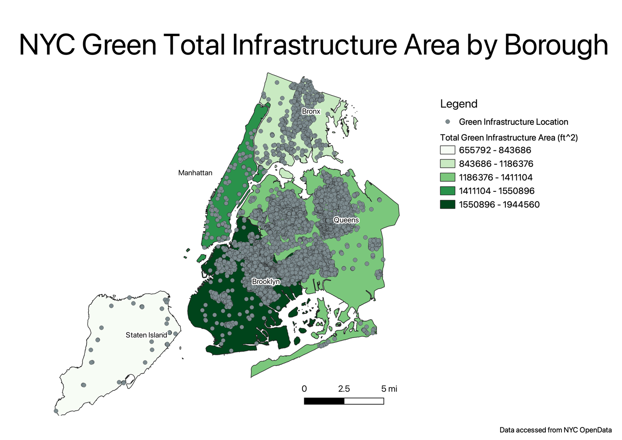

*Fig. 3*

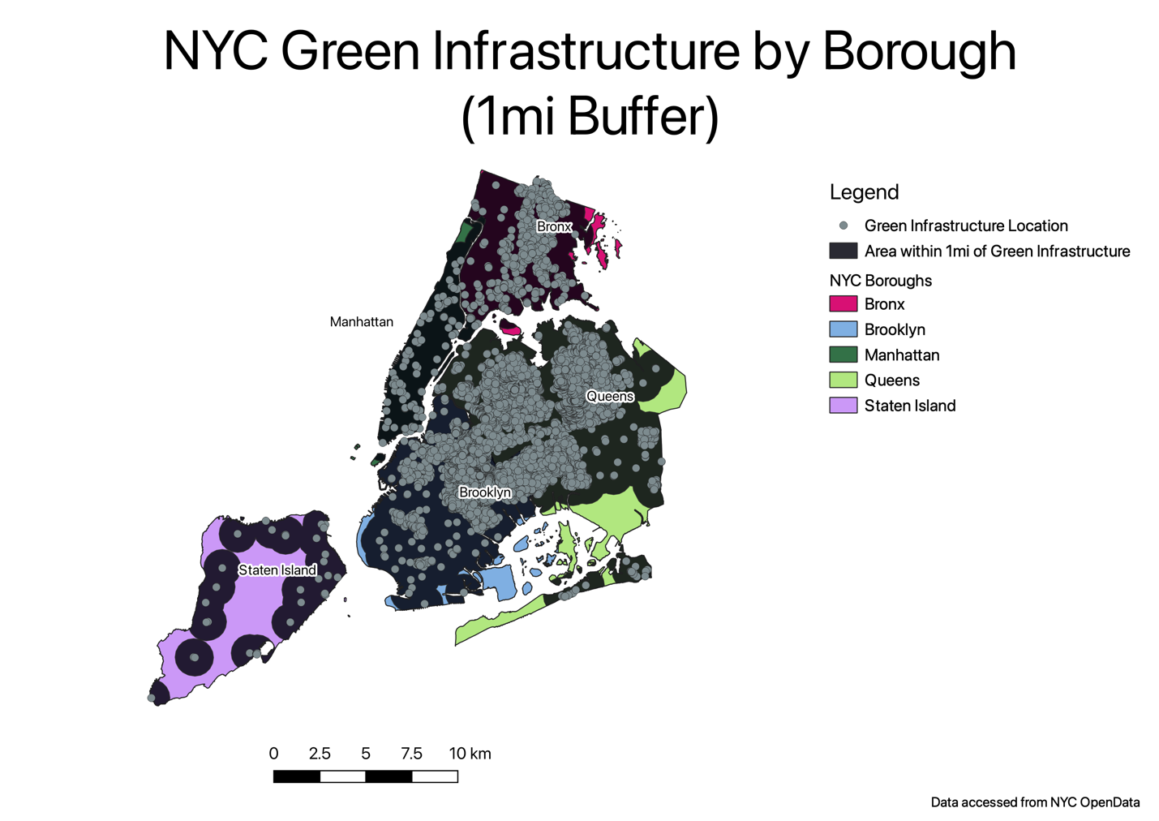

*Fig. 4*

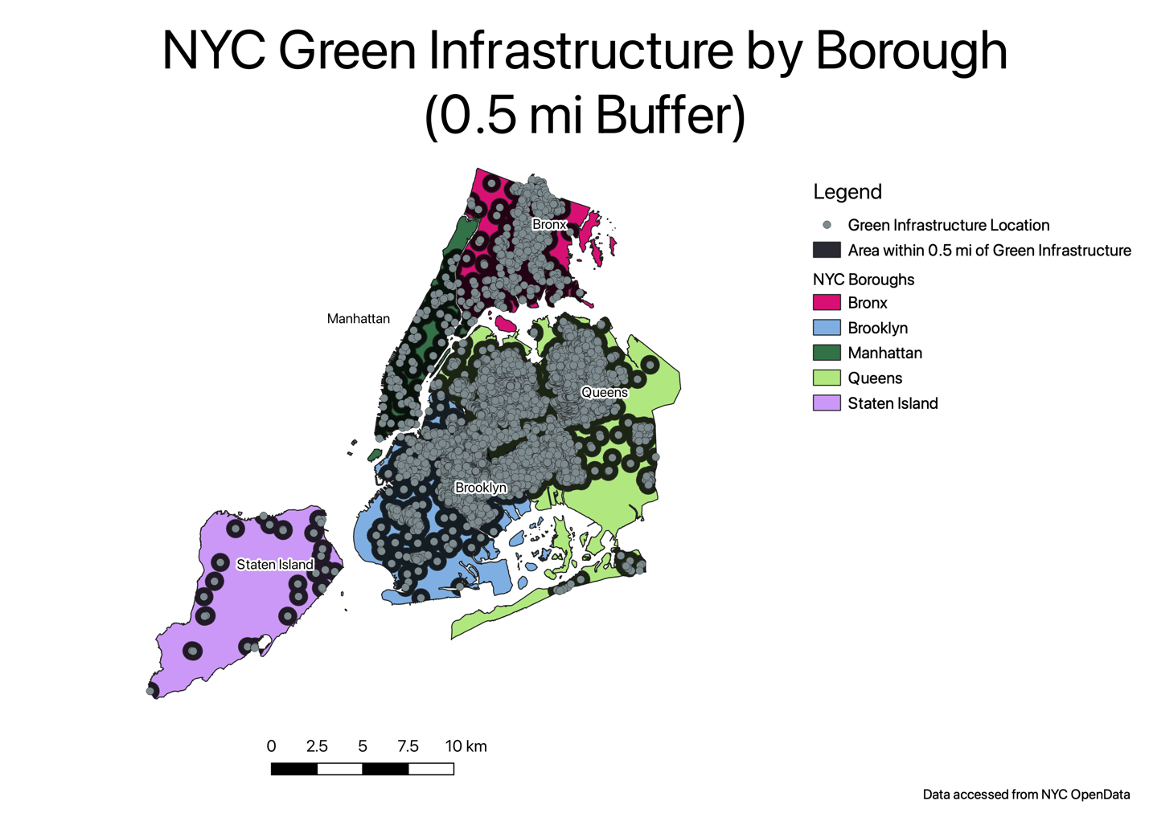

*Fig. 5*

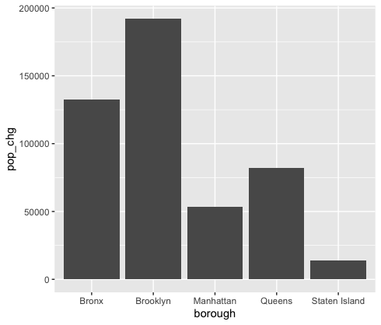

*Fig. 6*

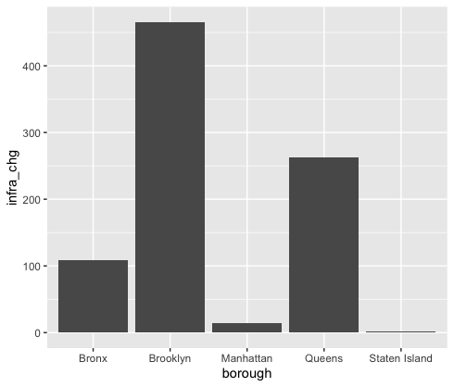

*Fig. 7*

CASE

WHEN borough = 'Bronx' THEN 1446788

WHEN borough = 'Brooklyn' THEN 2648452

WHEN borough = 'Manhattan' THEN 1638281

WHEN borough = 'Queens' THEN 2330295

WHEN borough = 'Staten Island' THEN 487155

ELSE 0

END

*Fig. 8*

CASE

WHEN borough = 'Bronx' THEN 1579245

WHEN borough = 'Brooklyn' THEN 2840525

WHEN borough = 'Manhattan' THEN 1691617

WHEN borough = 'Queens' THEN 2412649

WHEN borough = 'Staten Island' THEN 501109

ELSE 0

END

*Fig. 9*

Density = (average area * infrastructure count) / population

*Fig. 10*

Density 2020 = (average area * (infrastructure count 2020 + x)) / population 2040

*Fig. 11*

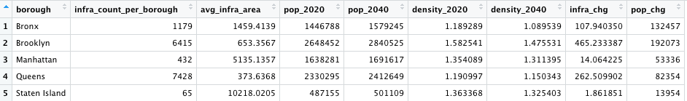

*Fig. 12*

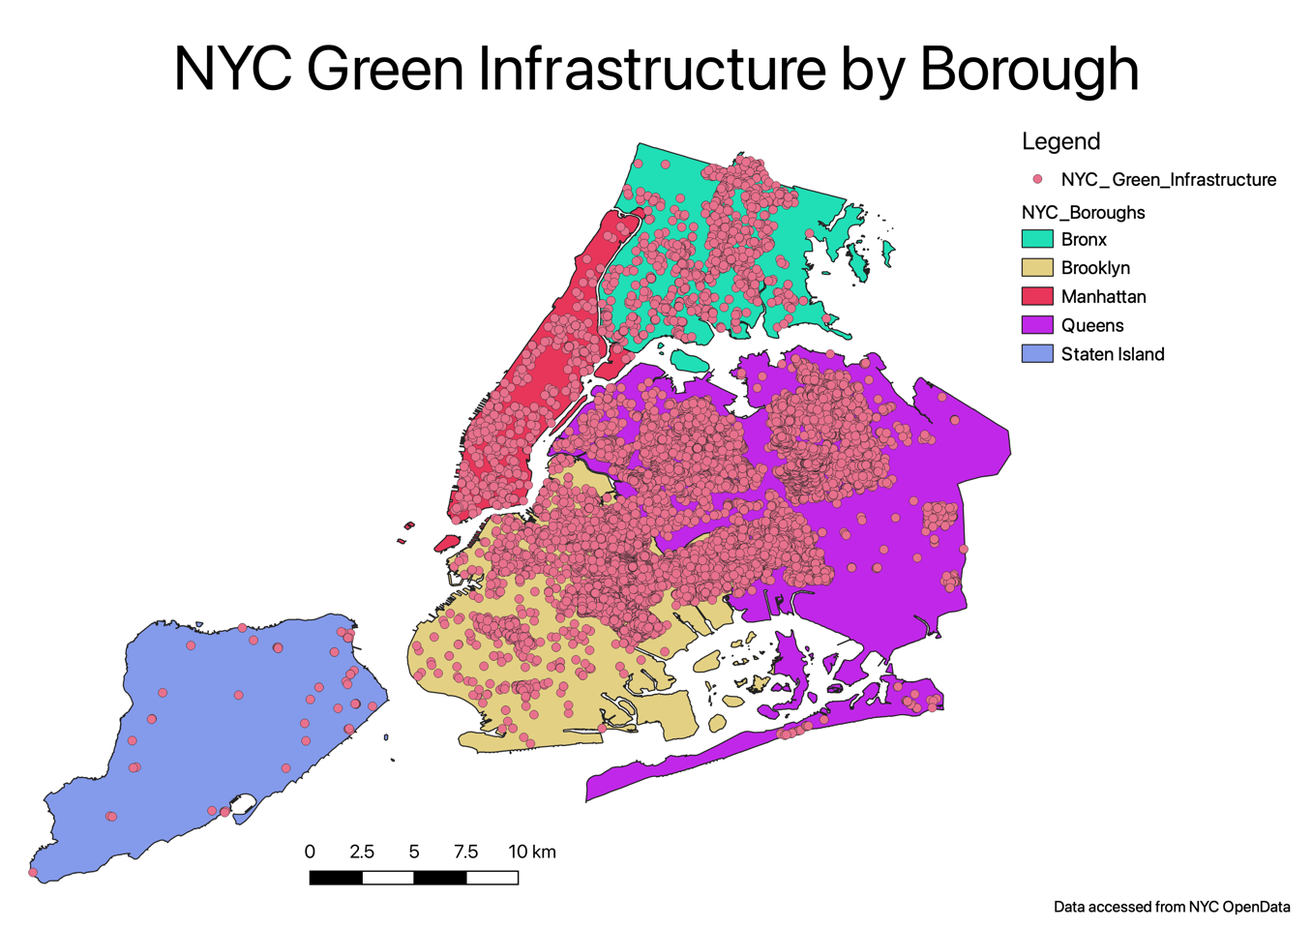

*Initial map of NYC green infrastructure by borough*

Sources – Working List

<https://data.cityofnewyork.us/City-Government/Borough-Boundaries/tqmj-j8zm>

<https://data.cityofnewyork.us/Environment/DEP-Green-Infrastructure/spjh-pz7h>

https://data.cityofnewyork.us/City-Government/New-York-City-Population-by-Borough-1950-

2040/xywu-7bv9

https://www.nyc.gov/site/oec/green-building/green-building-requirements.page

<https://data.sfgov.org/Housing-and-Buildings/SF-Municipal-Green-Building-Inventory/yuvm-3ujh>

<https://www.nyc.gov/site/dep/water/combined-sewer-overflows.page> (image and info)