TO: Wake County Dept. of Health and Human Services

FROM: Sarah Followill Repository:

It is my understanding that the Wake County Department of Health and Human Services seeks to promote healthy food options and availability to all North Carolinians. The Department also worries that programs such as SNAP and WIC will not have the desired effect for low income communities as many of those communities are located in what is known as food deserts. Food deserts are areas in which residents do not have healthy food accessible to them at an affordable price within a 1-mile radius of their residence. In food deserts, residents are often forced to travel longer distances to access healthy foods or shop from convenience stores that are cheaper and nearby, but offer food items that are usually less healthy than supermarkets. Many food deserts are also within lower-income, minority communities that might have fewer opportunities for community growth and accessibility to fresh foods. In this case, I, as the consultant, have conducted an in-depth analysis on food deserts in Wake, Orange, and Durham Counties (with a focus on Wake County) to evaluate the issue and identify a community that would be best served by the introduction of a new nearby supermarket.

First, I started by creating a map of all food deserts in the Wake, Orange, and Durham County areas, which is shown in *Fig. 1*. I plotted each supermarket location on the tri-county map and created a 1-mile buffer zone around each of the supermarket points. The food deserts are the areas that are not within the buffer zone, and are therefore more than 1-mile away from healthy food options. I also included the street system in the counties and labeled major roads using a different color, as the map is too zoomed out (in order to show all three counties) to be labeled with individual highway names. Upon looking at this map, it is plain to see that most of the tri-county area is in a food desert and that most of the markets are along major roads.

The next step was to determine which census block groups could be considered to be in food deserts. To go about this, I ran an program on all census block groups using the buffer zone (non-food-desert zone) layer to see which block groups did not intersect the buffer zone. I chose to characterize food desert census block groups as those who do not touch the 1-mile buffer around supermarkets at all. There are some block groups that barely intersect this buffer, so that some parts of the block group are, by the official definition, in a food desert, but I chose to focus on highlighting the areas of Wake, Durham, and Orange Counties that are most food insecure. Therefore, my analysis resulted in the identification of the census block groups that have no place in the block group that is within 1-mile of a supermarket, and is shown in *Fig. 2*.

Using this information, I was directed to narrow my investigation to Wake County specifically and to make a few calculations to better understand the scope of food deserts in the area and what communities are most severely affected. First, I created a map, *Fig. 3*, of Wake County food desert block groups labeled with the percentage of the total Wake County population that they represent to visualize how much of the population is living in each food desert block group. Next, I calculated the total percentage of Wake County residents that live in food deserts to be 9.90% by dividing the number of people living in Wake County food deserts by the total Wake County population, as seen in *Figs. 5-6*. This is a rather small portion of the population, which makes sense considering that my mapped food deserts appear to be primarily in the more rural, less populous regions of the county. Additionally, since I am only evaluating census block groups that do not touch the non-food-desert zone at all, my calculated percentage is lower than if I were to evaluate all of the people living in the areas that aren’t in the non-food-desert zone, disregarding census block groups.

Next, I calculated what percent of households do not own a car in both Wake County as a whole and Wake County food deserts. According to *Figs. 9 and 7,* there are 15,878 Wake County households without a car and 400,172 households total, resulting in 3.97% of Wake County households not owning a car. According to *Figs. 10 and 8,* there are 1,528 food desert households without a car and 39,266 food desert households total, resulting in 3.89% of Wake food desert households not owning a car. These percentages are fairly close, leading to a conclusion that most households across Wake County, even in food deserts, own a car; however, the almost 4% of households in food deserts that do not own a car would have to find other means of travelling over a mile to obtain fresh foods, making these foods even less attainable to underserved populations such as this 4%.

In continuing to evaluate how underserved communities might be disproportionately impacted by food deserts, I calculated what percent of households make under $35,000 annually in Wake County as a whole and Wake County food deserts. For Wake as a whole, according to *Figs. 11 and 7,* there are 75,233 households living on >$35k per year and 400,172 households total, resulting in 18.80% of households making under $35,000 annually. According to *Figs. 12 and 8,* there are 8,428 food desert households living on >$35k per year and 39,266 food desert households total, resulting in 21.46% of food desert households making under $35,000 annually. This disparity between food desert households and Wake County households as a whole is striking, highlighting the fact that the county’s poorest communities are also those without reasonable accessibility to healthy foods.

After making these calculations on food deserts in Wake County, my first recommendation would be to use the grant from the US Department of Agriculture to construct a new supermarket in one of the food desert census block groups. I created a map, shown in *Fig. 4*, of Wake County that features the non-food-desert zone, and a choropleth of the food desert census block group polygons that are graded according to the percentage of households in that block group living under $35,000 each year. Each block group is also labeled with its census tract number. Additionally, major roads are shown. Looking at the map allows viewers to see which block groups are proportionally the poorest in Wake County, and also where they are in relation to supermarkets.

I believed that looking at income would be the most important demographic to consider, as those who are poor are likely eligible for programs like SNAP and WIC (food stamps), but do not have the financial means to travel a substantial distance to a supermarket to use them, and would likely instead use them at convenience stores that do not have as healthy of options. Everyone, regardless of income, should have access to nourishing foods that could be supplied by the creation of a new supermarket.

I would therefore propose the creation of a new supermarket in census tract 052409, block group piece 1, shown alongside its attributes in *Fig. 13.* This area is in Southwest Raleigh, and seems to be one of the poorest neighborhoods in the county. This tract and, more specifically, block piece, has 74.05% of households living on less than $35,000 per year, making it the poorest of the block group tracts, and the surrounding block group pieces are hardly better. Additionally, 22.90% of this community’s population does not own a car, and the tract is considered a food desert even though it is relatively close to Raleigh’s city center at only about a 10-15-minute drive. This community is likely extremely underserved based on the high percentage of low-income households.

Therefore, tract 052409 would be the best place to construct a new supermarket, but I would recommend consulting the community about where the best location would be as to create the least disruption possible. Ideally, it could also be built on a vacant lot to avoid the demolition of existing structures. It would also be important to consider how the institution of this new store could have the potential to contribute to gentrification of the area, and therefore careful planning and community consultation would need to occur to minimize these potentially harmful effects. All of this considered, I believe that the community of Southwest Raleigh, currently the poorest Wake County food desert community, could benefit greatly from having access to healthy and fresh foods.

Now, suppose we changed the definition of a food desert to being any place outside of a 2-mile radius from a supermarket instead of 1 mile. *Fig. 14* shows how the food desert map of Wake County would change, and the most noticeable difference is that there are far less census block group tracts that could be considered food deserts under this new definition. Therefore, demographic shifts would include a lower percentage of the Wake County population residing in food deserts and a lower percentage of food desert residents living under $35,000 per year since the poorest block groups in the center of Wake County are now not considered to be in a food desert. Additionally, this would make my previously identified area, census tract 052409, block group piece 1, no longer a food desert by definition, even though it is clearly one of the poorest and most underserved communities in Wake County. Therefore, communities like this one that are low income, underfunded, and where a sizable percentage of households do not own a car would continue to struggle, while more rural communities, who are still considered food deserts by this definition but might be better off financially, might get the new grocery store nearer to them instead. This is not to say that they should not have a grocery store nearby, but if there is only one store available to be built, I would recommend that the poorest communities of Wake County be the first recipients of fresh, accessible foods.

For these reasons, I do not believe that the 2-mile criterion would lead to better outcomes than the 1-mile criterion since it erases the need of the poorest communities in Wake County. This shift in criterion would also affect my recommendation as to where the new grocery store should go, and I would then select the census tract that now has the highest percentage of households living on less than $35,000 annually, which would be tract 053109, block piece 2, which has 38.94% of households earning >$35k. This is significantly less than my previous tract selection, that had 74.05% of households living on less than $35,000 per year. Therefore, I suggest that the 1-mile criterion should be maintained to recognize and aid the communities in Wake County that struggle the most to obtain healthy foods

Appendix

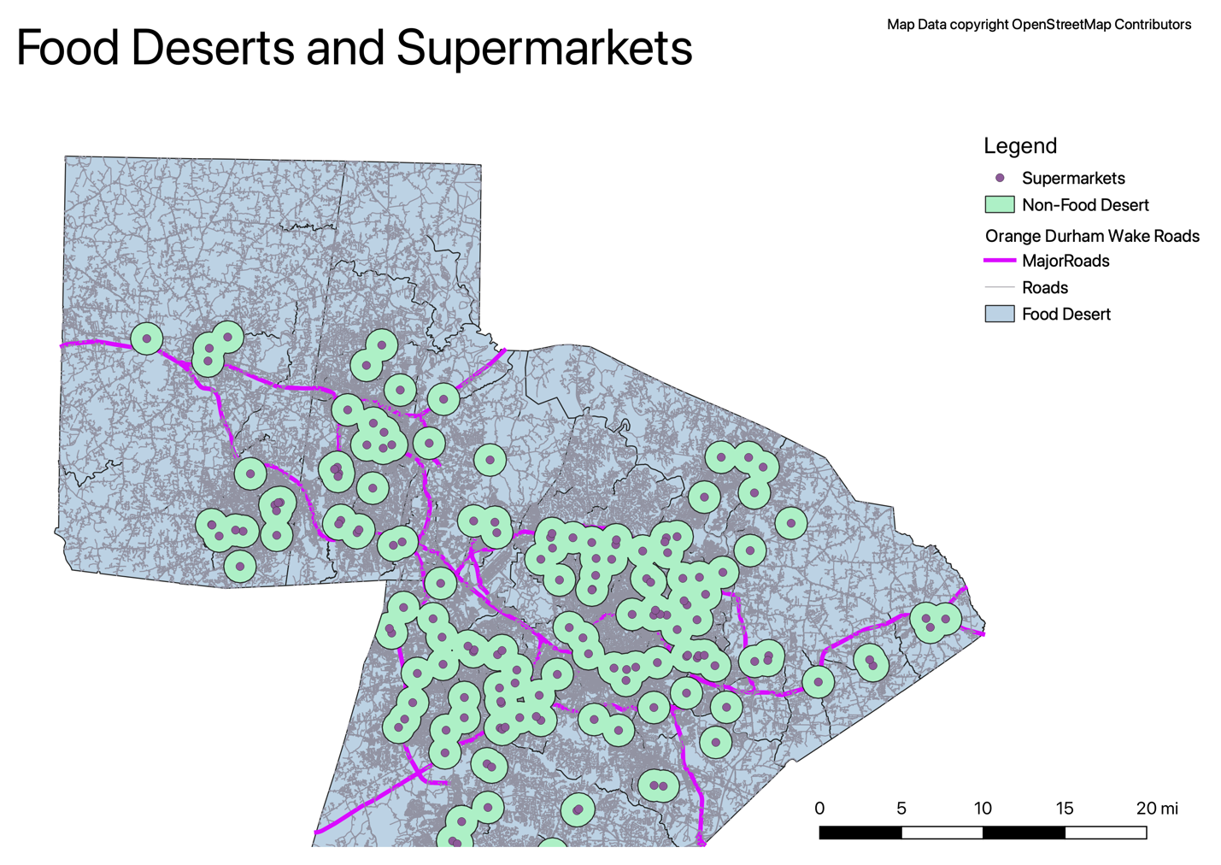

*Fig. 1*

*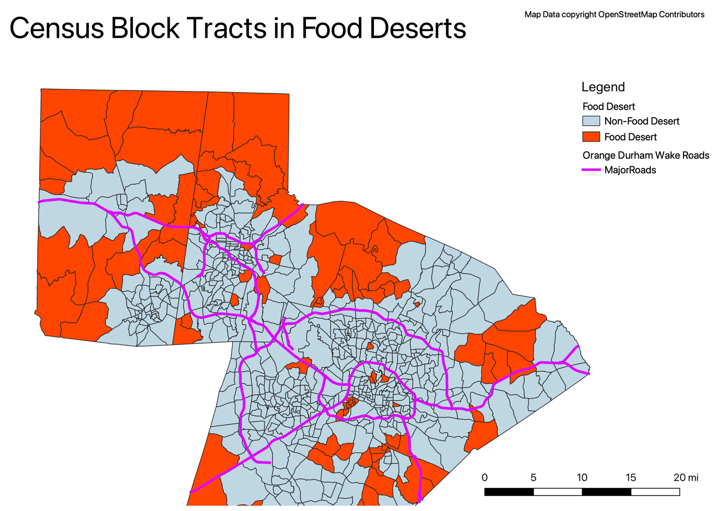Fig. 2*

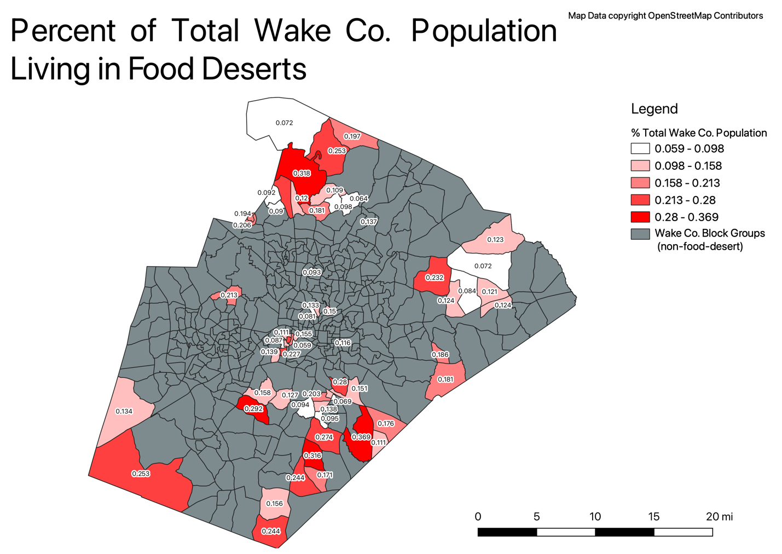

*Fig. 3*

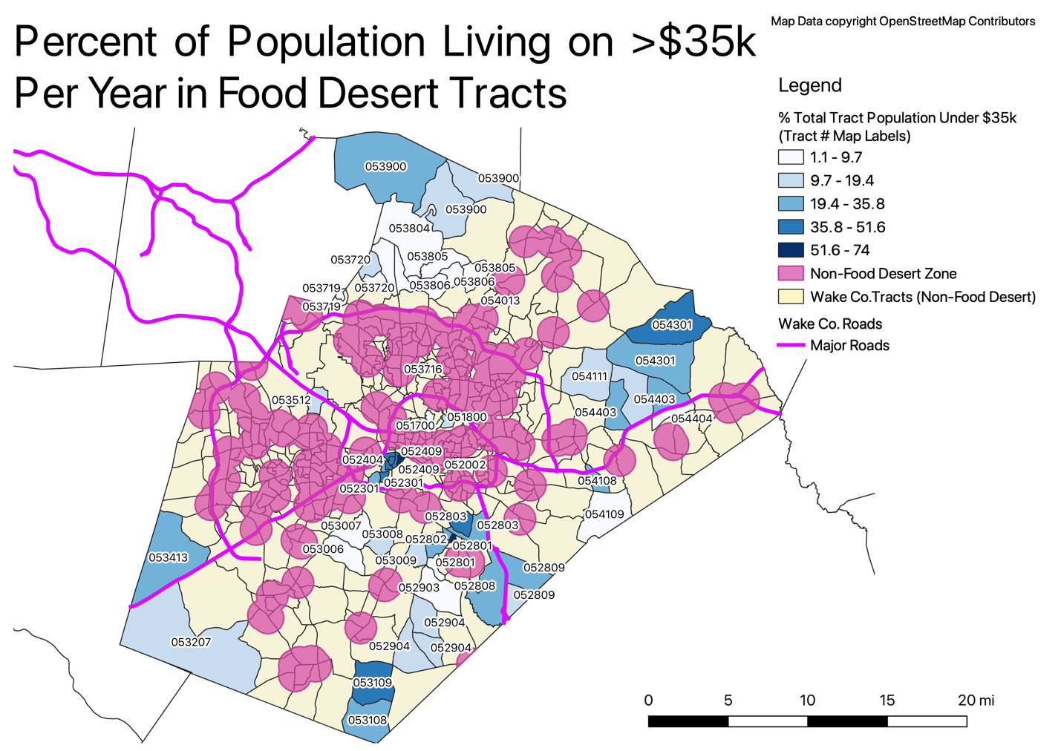

*Fig. 4*

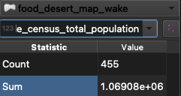

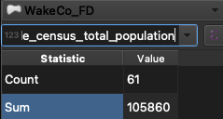

*Figs. 5-6 – Total population in Wake Co. and Wake Food Deserts (top to bottom respectively)*

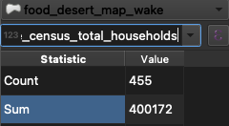

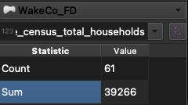

*Figs. 7-8 – Total households in Wake Co. and Wake Food Deserts (top to bottom respectively)*

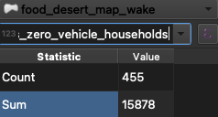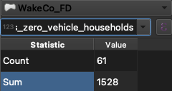

*Figs. 9-10 – Zero vehicle households in Wake Co. and Wake Food Deserts (top to bottom respectively)*

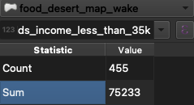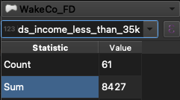

*Figs. 11-12 – Households earning >$35,000 per year in Wake Co. and Wake Food Deserts (top to bottom respectively)*

*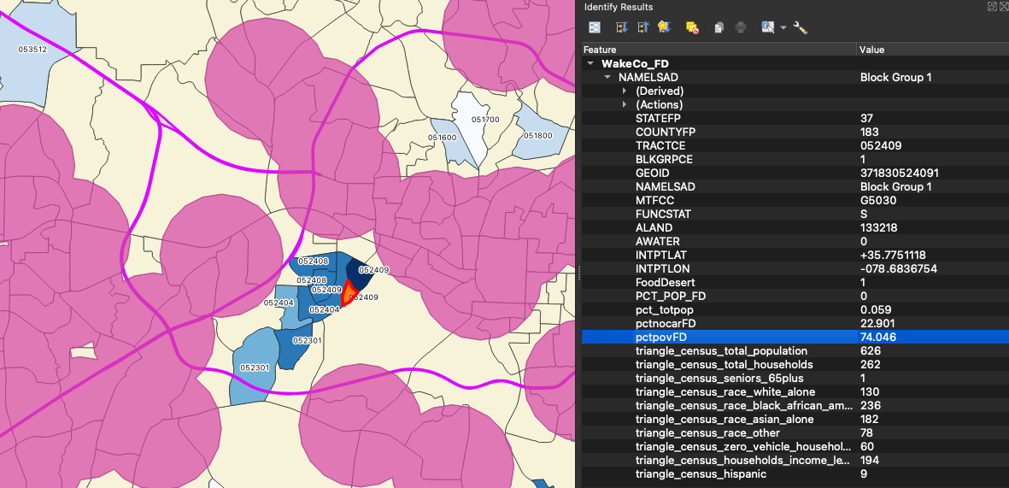*

*Fig. 13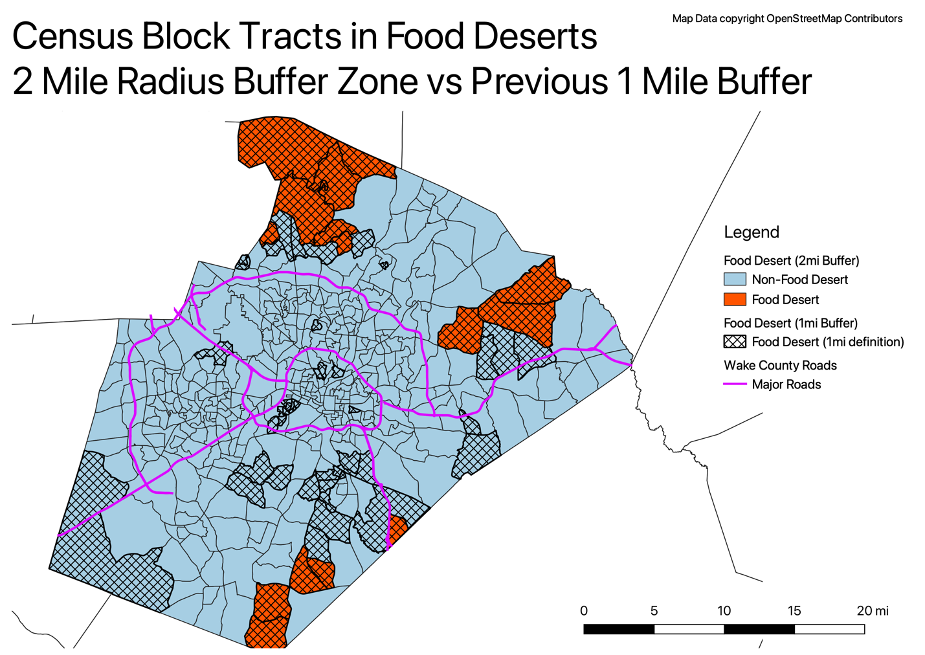*

*Fig. 14*