Sarah Followill

PLAN 372 – HW6 Report

Repository Link: <https://github.com/sarahfollowill/plan372-hw6>

Question 1

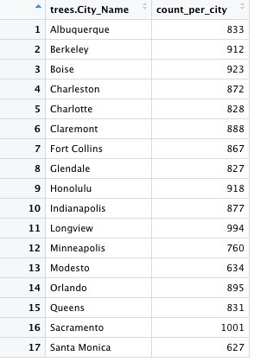

Question 2

The cities where data was collected in North Carolina and South Carolina are Charlotte, NC and Charleston, SC.

Question 3

The tree genus with the largest average crown diameter in North Carolina and South Carolina is the Quercus, at 13.62 meters.

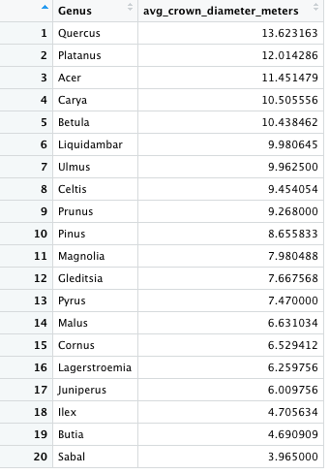

Extra Credit

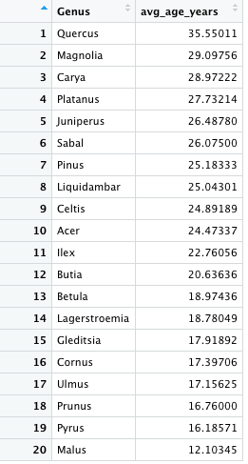

Yes, there are differences in the average ages of tree genera, ranging from 12 - 35.6 years old. Since the Quercus is the genus with the oldest average age by a margin of 6 years, this could potentially explain the result to question 3, that the Quercus was the genus with the largest average crown diameter by a much smaller margin from the second-largest genus’ diameter. It is possible that another genus could have the largest crown diameter if all genera were measured at the same age.