Abstract

Large language models (LLMs) are popular tools for creative ideation, but have been shown to homogenize outputs across users. We test if encouraging people to use an AI tool with high (vs. low) human agency can mitigate this homogenization effect by augmenting one’s creativity, rather than offloading it. Participants were experimentally assigned to one of three conditions (high-agency approach with AI access, low-agency approach with AI access, or a human-only control) and generated creative uses for everyday objects. Contrary to our expectations, on the whole ideas did not differ in individual-level perceived creativity (as rated subjectively by human evaluators). However, a per-protocol, preregistered similarity-to-centroid analysis and an exploratory cluster analysis provided convergent evidence of AI-induced homogenization among the low-agency condition—conditional associations among participants who complied with the AI-use instructions. Thus, while readily available LLMs afford rapid idea generation at scale, our research suggests the degree of agency with which people approach their AI tool has downstream consequences on collective creativity.

Keywords: human-AI interaction, creativity, agency, homogenization

0 Introduction
One of the cornerstones of human cognition and communication is our ability to engage in creative ideation: the process of generating, developing and conveying new ideas. People have long relied on tools to support their creative processes, from physical notebooks to mind-mapping software (Frich et al., 2019). One of the newest and most popular tools to stimulate creativity are large language models (LLMs), which are used across domains to generate “novel” ideas and facilitate writing more generally. Fundamentally, LLMs are token predictors that output likely words given a user prompt and context. Their ability to rapidly synthesize massive amounts of text make them useful for a wide range of text-generation tasks, and recent reports suggest that people regularly use these systems for creative ideation (Maslej et al., 2025).
Such use of LLM systems for ideating and communicating creative ideas is part of a broader phenomenon of human-AI co-creativity, whereby humans use AI tools in an attempt to improve the quality of their output (Kortenbach et al., 2025). Research to date suggests two important patterns in artificial creativity that are relevant to the integration of AI into the creative act (Runco, 2025). The first is that LLM systems perform as well as or even better than humans on commonly accepted creative ideation benchmarks (Guzik et al., 2023; Guo et al., 2025). However, when humans use AI systems to be creative, there is a risk of homogenization: People who use AI tend to produce more similar outputs compared to their counterparts who do not—an effect that has been shown in a range of contexts involving open-ended output, such as product design (Anderson et al. 2024; Nave et al., 2024) and short-story writing (Doshi & Hauser 2024). In recent years computer scientists have termed this paradox algorithmic monoculture (Kleinberg & Raghavan, 2021), or, in the case of generative AI, generative monoculture (Wu et al., 2024). Derived from the notion of monoculture in agriculture, these terms capture the vulnerabilities incurred by mass reliance on a single algorithm: While each AI-assisted individual may generate an idea more creative than what they could achieve on their own, this comes at a risk on the collective level. What may seem creative to an individual may in fact be trite among a group of individuals using the same AI assistant, especially if many individuals use AI without bringing their own human experience to the interaction. While such steerability is traditionally conceptualized as a property of a generative model (Vafa et al., 2026), the proclivity to steer a model away from its default outputs may be linked to characteristics of the human user. Specifically, we posited that agency—the capacity to exercise control over one’s thoughts and actions (Bandura, 2001)—would have downstream consequences on the homogeneity of a group’s ideas.
In the present study, we examine the extent to which encouraging varying levels of human agency impacts the homogenizing effects of LLMs. Specifically, we explore whether a high-agency approach, in which a person approaches a tool in a way that supports their own agency (rather than replacing it) has downstream consequences on individual- and collective-level ideation outcomes. For example, when people exercise high agency over technologies such as social media, they believe they can control the amount and nature of their use (Lee & Hancock, 2024). Similarly, encouraging individuals to develop a more intentional orientation towards their AI use may lead them to engage more in creative ideation and increase their likelihood of contributing diverse output to a group.
We test the importance of a high-agency approach in human-AI co-creativity by experimentally manipulating the guidance people receive about AI as a creativity support tool. We compare a group of people who are prohibited from using AI against two treatment groups that were told to use AI: a low-agency condition, in which participants are told to let AI do the bulk of the creative ideation, and a high-agency condition, in which participants are told to leverage their own human creativity in tandem with the AI to develop even better ideas. We assess creativity at both the individual and group levels to explore the effect of agency-oriented framing on both the creativity and homogeneity of ideas produced when humans use AI tools.

0.1 AI and Creativity
Creativity is complex and difficult to assess, but it can be broadly conceptualized as the intersection of novelty and usefulness (Amabile, 1983). Boden’s (1998) foundational writing on creativity and artificial intelligence discusses the possibilities and limitations of AI in terms of three high-level types of creativity: exploratory (exploring structured conceptual spaces), combinational (producing novel combinations of familiar ideas), and transformational (transforming the conceptual space to enable previously impossible ideas; Boden, 1998). Measuring creativity requires defining on which level it is observed. Individual-level creativity refers to the subjective novelty and usefulness value of a single person’s output considered in isolation, while group-level creativity refers to the diversity of outputs generated by a group of individuals (Doshi & Hauser, 2024). Although seemingly paradoxical, it is possible for individual-level creativity to be high but for group-level creativity to be low if a vast majority of individuals generate similar outputs.

0.1.1 Creativity at the Individual Level
Benchmarking studies on LLM creativity suggest LLMs can perform well on creative ideation tasks—often better than humans (Guzik et al., 2023). While some sound the alarm for existential threats to human creativity (Hubert et al., 2024), others assert that LLMs still fall short relative to the most creative humans (e.g., Chakrabarty et al., 2024; Koivisto & Grassini 2023). Creativity scholars even suggest that the definition of creativity itself should be updated to account for qualities that LLMs cannot possibly possess, like authenticity or intentionality (Kharkhurin & Corazza, 2026; Runco, 2025). As with any research involving LLMs, complicating the comparison between humans and models is the rapid pace at which the technology develops and the heterogeneity of model outputs across time, temperature, and system prompts (Haase and Hanel 2023).
Nevertheless, because of LLMs’ standalone potential to generate output that seems novel and useful, people have widely adopted them to generate ideas in schoolwork, product innovation, and even research (Si et al., 2024). To the skepticism of prominent creative thinkers (e.g., Chiang, 2024), when the average person uses an LLM to generate open-response content, they tend to produce more creative responses than they would unassisted. For instance, in an experiment in which participants were tasked with writing short stories, participants using ChatGPT produced stories that were evaluated as creative, better written, and more enjoyable than those produced by people who wrote their stories on their own (Doshi & Hauser, 2024). Similarly, participants using ChatGPT to generate creative solutions produced ideas that were rated as more creative than those of participants who used their unaided human intuition or basic web search (Lee & Chung, 2024). Research that focuses on individual-level dynamics of LLM usage would seem to suggest enhancing effects of ChatGPT for creative tasks.

0.1.2 Homogeneity at the Group Level
While using an LLM may improve the creative performance of each individual relative to their baseline, some analyses of group-level dynamics reveal an important tradeoff. A number of studies have found that the content generated by people working with LLMs tends to be more homogeneous, exhibiting a lower diversity of thought than the set of ideas produced by participants who relied only on their own human cognition (Doshi & Hauser 2024; Anderson et al., 2024). For instance, although individual ChatGPT-assisted essay performance can be quite high, across the group of students the concepts expressed in the essays are more similar in meaning than the concepts in unassisted essays (Kosmyna et al., 2025).
In creative contexts, the tradeoff between individual-level performance and group-level homogeneity is especially paradoxical: what may seem original to an individual can be banal in a whole group. Studies focusing on group-level effects of LLM usage highlight this paradox. For example, participants who used an LLM for creative writing prompts wrote short stories that were evaluated as more creative, better written, and more enjoyable than those written by their unassisted counterparts. However, the AI-enabled stories were more similar to each other than those written by humans alone (Doshi & Hauser, 2024). Similarly, using AI to brainstorm creative ideas for gifts and household toys reduced the collective diversity of ideas relative to those generated by humans alone (Nave et al., 2024). Although the individual user may perceive the AI’s output as creative and experience real gains relative to their own, unassisted performance, the group as whole suffers from a lack of diversity of thought.
There are a number of technical reasons why LLMs might produce more homogeneous output than a collection of humans. Fundamentally, LLMs are designed to optimize for a response that represents the aggregate of its training data for the particular context invoked by the user (Hicks et al., 2024). This manifests in key model behaviors. For one, LLMs seem to possess an upper limit to the number of new ideas they can generate, due to statistical and technical constraints such as available training data and recombinations within it (Si et al. 2024). Second, LLMs are designed to predict likely tokens for a given context. When prompted for “creative” ideas, they may provide information related to other instances in their training data in which the notion of creativity has been invoked for the particular use case in the past. Third, as an individual interaction with an LLM proceeds and the context window fills, the LLM is more likely to rehash material it has already produced.
From the perspective of those using LLMs for creativity support, specific LLM affordances may create an illusion of creative capacity, making homogenization more likely. A user can input a spare prompt (e.g., “Write an essay on [topic]”) and get a lengthy output from the LLM. Without awareness of this homogenization, however, a society of users relying on the same LLM without variation to their individual behavior may create a cultural problem (Sourati et al. 2025). However, polling data suggests the general public may be unaware of such pitfalls (Poushter et al. 2025). Providing some lay explanations of the mechanisms and consequences of LLM usage may help mitigate passive usage (e.g., copy-pasting without much refinement) and subsequent homogenization at the group level.

0.2 Encouraging Human Agency to Buffer Against Homogenization
The technical reasons for AI-induced homogenization are quite simple, but mitigating homogenization via human behavior is not. To improve people’s creative work with AI, a growing body of research has focused on improving the technological affordances of AI creativity support tools, including features that allow the user to draw connections between seemingly unrelated concepts (O’Toole & Horvát 2024) or better steer the model toward their creative vision (Louie et al., 2022). While such solutions seem promising in the laboratory context, human-AI interaction research suggests the need to consider human psychology in addition to design changes to the technology. (Tankelevitch et al., 2025; Hancock et al., 2020).
Another route to disrupting AI-induced homogenization lies in addressing how people understand the role of AI tools in extending their cognition (Clark & Chalmers, 1998). People do not use technologies in a vacuum, but rather approach them with implicit beliefs about what the technology is for and the role it may play in their lives (Crum et al., 2017; Lee et al., 2023). In the case of AI, past work suggests that individuals hold distinct beliefs influencing the extent to which they trust AI and rely on its outputs. For instance, people who view AI as a “powerful search engine” are more willing to accept its suggestions than those who see it as a “friend,” or a “tool that they use” (Cheng et al., 2026). People also hold specific beliefs about the capabilities of AI to perform specific tasks. Given widespread public narratives about the potential for AI to both turbocharge humans’ creative potential (Shneiderman, 2020) and disempower entire workforces (Dung, 2025), people should hold specific beliefs about the role that AI tools may play in creative thinking processes that influence the outcomes of such collaborations.
A particularly important belief in the context of creative collaboration revolves around the idea of agency: the extent to which individuals perceive themselves, rather than the AI, as the primary driver of creative work. This fundamental psychological need has been shown to play an important role in other forms of technology use. For example, people with agentic social media mindsets, who perceive social media as a tool they can leverage, use social media to do things that are meaningful, useful, and satisfying to them (Lee et al., 2023). In an experimental setting, appealing to adolescents’ drive for autonomy tended to increase their willingness to control their social media use, relative to traditional messages about the benefits of avoiding social media altogether (Galla et al., 2021). In the context of creativity with LLMs, having a high-agency approach would mean perceiving the LLM as a tool to support one’s own human creative tendencies. In contrast, a low-agency approach would mean expecting the LLM to drive most of the creative vision with little human insight. If agency-oriented framing causes people to use LLMs in a manner that leverages their own cognition (versus the LLM’s next-token prediction), then the group of people who are instructed to operate use AI with high human agency should produce more diverse outcomes than a group of people who are instructed to use it with low human agency.

0.3 The Present Study
In the present study, we investigate human-AI co-creativity by examining the role of agency-oriented framing on individual-level creativity and group level homogenization. We experimentally manipulate the type of guidance participants receive before they work with AI on a creativity task. In the experimental conditions, participants are encouraged to either stay in control of the AI tool (high-agency condition) or let it do the heavy lifting (low-agency condition).
To assess creativity, we use a classic creativity paradigm: the Alternative Uses Task (AUT; Torrance, 1966), in which a person’s goal is to repurpose everyday objects (e.g., a paperclip) in a way that is both novel and useful. To score well on the task, participants must be able to overcome functional fixedness, or the tendency to focus on the intended uses of the object. Higher scores on the task are indicative of “little-c” or “everyday” creativity (Ivcevic & Grandinetti, 2024). Despite its limitations, the AUT has been widely used because it allows for a relatively standardized way to compare divergent thinking across various conditions. It also relies on little cultural knowledge and writing ability, which is an important task criterion when assessing creativity in a verbal modality.
We test two primary hypotheses. First, given prior literature indicating that LLMs perform well at creative tasks, we hypothesize that people who are instructed to use AI with a high-agency approach will produce ideas that are of higher perceived creativity at the individual level relative to the control condition. Out of the two treatment conditions, we also predict that the high-agency condition will produce ideas of higher perceived creativity than the low-agency condition.
H1: Ideas produced by participants in the high-agency condition will be rated as more a) creative, b) original and c) useful than ideas produced in the control or low-agency conditions.
The second hypothesis concerned the effect of approach on group-level homogeneity (the similarity of the proposed ideas to each other). In the context of creative ideation, having a high-agency approach should lead people to generate an idea that is not only original in isolation but across a population. We hypothesized that ideas produced by participants in the high-agency condition would be more semantically diverse, or less homogenized, than the ideas produced in the low-agency approach or control conditions.
H2: Ideas produced by participants in the high-agency condition will be rated as less homogeneous than ideas produced in the control or low-agency conditions.
Finally, we also explored how approaches influence the way that participants interact with the LLM system to generate creative ideas. We examine the ways in which high versus low agency approaches influenced how participants prompted the AI system, how often they exchanged turns and words with the system, and finally, if these behavioral changes influenced outcomes at the individual level of creativity and group level of homogenization.

1 Method

1.1 Preregistration
The study was pre-registered on OSF including hypotheses, power analysis, procedure and analytic approach https://osf.io/2d7fe/overview?view_only=c34f80bd046e4c85aafdee3d2c33a74e.

1.2 Participants
We recruited two samples of adult participants from the U.S. to participate in the study: a sample of submitters and a sample of evaluators. Submitters were community college students in the San Francisco Bay Area (N = 150; age: M = 25.1 years, SD = 9.2; 72% female, 24% male, 1.3% non-binary, 2.7% self-described) who participated for research credits. An additional three submitters were excluded for failing an initial attention check. Evaluators were U.S. adults recruited from the CloudResearch Connect platform (Hartman et al., 2023) (N = 142; age: M = 46.7 years, SD = 16.3; 49% female, 51% male) who were compensated financially for their time. Six participants were excluded for failing an initial attention check and five participants were excluded due to idea data logging issues.

1.3 Measures and Procedure
Methods were approved by the [ANONYMIZED] Institutional Review Board. All participants provided informed consent.

1.3.1 Submission Phase
Upon consent, participants were asked to read a general description of the Alternative Uses Task (AUT), in which they were asked to generate non-standard uses for three ordinary objects: bubble wrap, frisbee and brick. They were provided with a rubric with our definitions of overall creativity and its two canonical subcomponents: originality and usefulness (Runco & Charles, 1993). After consenting, participants were randomly assigned to one of three conditions that varied whether they completed the idea-generation task with or without access to an AI chatbot (please see Figure A1 for representative excerpts from the instructions shown in each condition). The low- and high-agency conditions provided participants with access to a custom AI chatbot that was designed for the study, which was built on top of gpt-3.5 and embedded into the survey through a web-application. Participants in the low-agency condition were told that “AI recognizes patterns, styles, and connections that would take years of study to master on your own…The beauty of AI is that it does the heavy lifting for you.” They were instructed to let AI’s creative power work for them. Conversely, in the high-agency condition, participants were instructed to use AI to expand upon their own ideas and generate ones that are even more creative. This aspect of the manipulation was informed by prior research on growth mindsets, in which interventions encourage strengthening one’s cognitive muscles (Yeager et al., 2019). In the control condition, participants completed the same AUT without access to an AI chatbot. Given that past work suggests that online survey respondents frequently use AI tools to generate answers (Veselovsky et al., 2023), we explicitly instructed participants in the control condition to not use AI in this task. Before the start of the AUT, participants read, “We value your individual human creativity, so please do NOT use AI during the task.” (See the Appendix for the complete task instructions for each condition.) Additionally, copy-paste functionality was disabled using JavaScript code embedded in the Qualtrics survey. Participants were required to spend a minimum of 10 seconds on the instruction page in each condition before proceeding to the AUT.

1.4 Occasions
Submitters completed the experiment in one session, with an average completion time of 30 minutes. For each of three objects (frisbee, bubble wrap, and brick), submitters were asked to generate five alternative uses for the object and enter their ideas in form fields. The presentation of the three objects was counterbalanced. Participants in the high-agency and low-agency conditions had access to ChatGPT through an embedded web-app in the Qualtrics survey; they entered their alternative uses below the web-app interface. Participants in the control condition had no web-app, just the fields to enter their alternative uses for each object. In line with prior research on induction with the AUT (Madore et al., 2016), all participants were given as much time as they needed to complete the task. This avoided penalizing the participants in the low-agency and high-agency conditions for taking time to work with the AI chatbot. Across conditions, submitters produced a total of n = 2,250 ideas.
After completing the AUT, submitters were asked to rate their own ideas in terms of overall creativity and its subcomponents: originality, and usefulness (Boden, 1998). Each submitter was provided with the following rubric to guide their scoring (See Table A1). To reduce survey fatigue, each participant was asked to rate one of the ideas they had submitted for a brick, one for bubble wrap, and one for frisbee. These ideas were randomly selected from their set of submissions (e.g., “One of your alternative use ideas for a frisbee was a [dish]. Provide your ratings of this idea below.”) Responses to the creativity, originality, and value questions were on a Likert scale from 1 = Not at all to 5 = Maximally. To gauge participants’ perceptions of the uniqueness of their ideas, we also asked, “Do you think many other people came up with this idea as well?” Response options included “No one thought of this”, “Some people thought of this”, “Most people thought of this”, and “Everyone thought of this.”
Finally, all submitters provided a brief description of their idea generation process in a text box. Participants in the high-agency and low-agency conditions were asked to self-report the extent to which the AI helped them with the creative process (1 = Strongly Disagree to 7 = Strongly Agree; (Lee & Chung 2024), the extent to which they perceived AI as a conversational partner (1 = Strongly Disagree to 7 = Strongly Agree; $ω$ = 0.86) (Lee & Chung, 2024), and their intrinsic motivation during the AUT (how interesting, enjoyable, fun, and engaging it was; 1 = Not at all to 7 = Completely; $ω$ = 0.92) (Shin & Grant, 2019). All participants answered demographic questions before being debriefed on the purpose of the study and granted research credits for their participation.

1.4.1 Evaluation Phase
Next, we asked our evaluators to rate the compliant ideas from the submitters. Evaluators were shown the same definitions of creativity, originality, and usefulness as the submitters, which served as their rubric upon which to score the ideas. Each evaluator rated a random subset of 15 of the total set of ideas. The submitted ideas were stratified by object type, such that each evaluator rated five ideas for bubble wrap, five ideas for a brick, and five ideas for a frisbee. For each of the 15 ideas they saw, the evaluators rated it in terms of overall creativity, originality, and usefulness, resulting in 45 ratings produced by each evaluator. Due to our randomization procedure, some ideas were evaluated multiple times, while others were never evaluated and thus were excluded from this analysis. All participants answered demographic questions before being debriefed on the purpose of the study and compensated for their participation.

1.4.2 Manipulation Checks
We conducted manipulation checks to ensure that submitters followed the instructions for their conditions. Using the chat log data, we identified trials in which participants in the high-agency and low-agency treatment conditions did not use the AI tool as instructed. In 24% of low-agency trials and 38% of high-agency trials participants did not use the AI tool. Object trials from the high- and low-agency conditions were excluded if they did not include chat data. On the participant level this resulted in 12 participants in the high-agency condition and 10 participants in the low-agency condition being completely excluded from the analysis. Of the remaining participants, we conducted an exploratory classification of their prompting patterns as a passive measure of compliance with the specific intervention instructions.

1.5 Data Analysis

1.5.1 Data Structure
Each participant produced five ideas for three objects (brick, bubble wrap, frisbee). For participants in the high-agency and low-agency conditions, the survey was designed such that each object corresponded to one human-AI interaction, with chat data logged using JavaScript.

1.5.2 Analytic Approach
We assessed the creative qualities of participants’ submitted ideas at both the individual level and the condition level. To assess creativity, we examined the ratings from evaluators at the individual participant level. To assess homogeneity, we measured the semantic similarity of ideas generated by participants at the condition level (cf. Anderson et al., 2024). We used the sentence embedding model all-MiniLM-L6-v2 (Reimers & Gurevych, 2019) to generate embeddings in a 384-dimension embedding space.
We note two key deviations from our preregistration. First, funding constraints at the time of data collection resulted in a smaller sample size than initially planned; however, the results of our simulated a priori power analysis indicated that we would be powered to detect a medium effect ($η_{p}^{2}$ = .06) at 80% power. Second, upon collection of the data, analysis of participants’ chat-log data indicated that a substantial portion of the participants in the high-agency (N = 12) and low-agency (N = 10) conditions did not comply with the task instructions to use AI and were therefore excluded from the final analyses.

2 Results

2.1 Individual-Level Creativity
To examine the perceived creativity of the submissions, we used the lme4 package in R (Bates et al., 2015) to conduct separate mixed-effects linear regression models predicting each of the individual-level variables (overall creativity, originality and usefulness ratings) from the fixed effect of condition, with random effects for submitters, evaluators, and objects (bubble wrap, brick, frisbee). Contrary to our first hypothesis (H1), there were no significant differences in individual-level perceived creativity across the treatment conditions relative to control, ps > .20, as shown in Figure 1. Interrater reliability was fairly low for overall creativity (ICC = 0.33), originality (ICC = 0.37), and usefulness (ICC = 0.41)—values similar to other studies collecting third-party creativity ratings (cf., Rietzschel et al., 2026). Hence, any perceived differences that may have existed were obscured by evaluators’ varying interpretations of the constructs. Regression results for all three metrics of individual-level outcomes are shown in Table A2.

Figure 1. Individual-Level Creativity Across Conditions
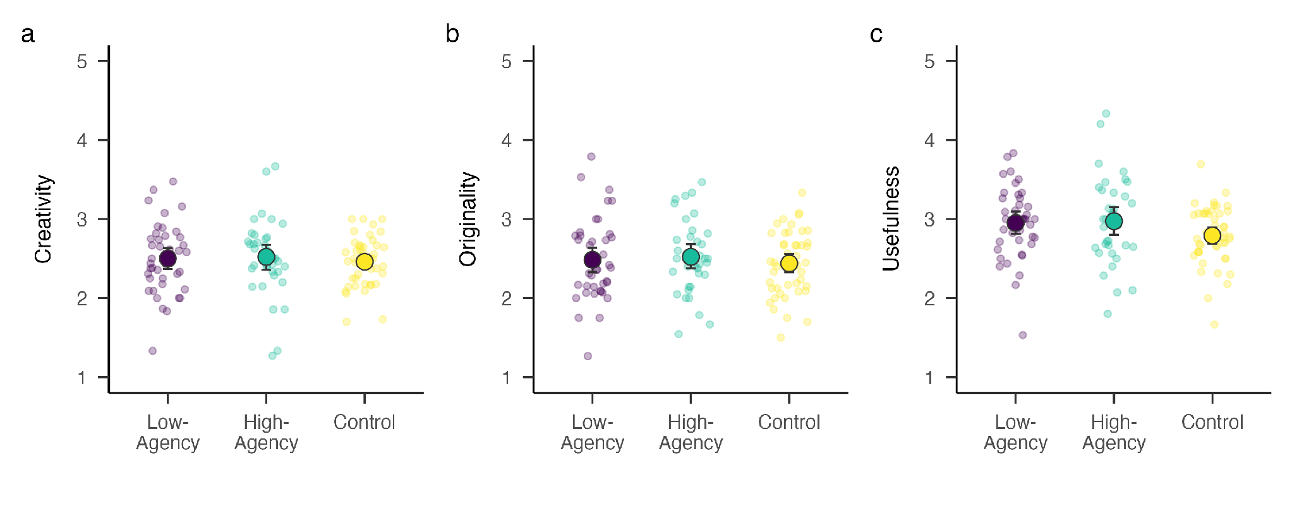

Note: Large colored dots indicate condition means across objects, with bootstrapped 95% confidence intervals. Jittered points in the background indicate each evaluator’s (a) overall creativity, (b) originality, and (c) usefulness scores for a given idea.

2.2 Homogeneity
Our second hypothesis (H2) predicted that participants in the high-agency condition would have lower homogeneity across their submitted ideas than participants in the low-agency condition. We operationalized group-level homogeneity using the most common approach from prior research on creative idea generation: the cosine similarity of each idea to the centroid embedding of the other ideas in the same condition for the same object (Doshi & Hauser, 2024). At a conceptual level, the centroid is a statistical representation of the “average” semantic meaning as represented in an embedding space. Cosine similarity is a measure of how similar ideas are to one another on that embedding space (i.e., Are participants in the control condition producing more similar ideas for “frisbee” than their low-agency counterparts?). Because some submitters contributed more ideas than others (due to exclusions), we used a procedure that weighted each submitter equally in the calculation of the centroid: For each participant we randomly sampled one idea they had generated for each object (brick, bubble wrap, frisbee) and computed cosine similarity between the embedding for the idea and the embedding for the condition-object centroid. The centroid embedding used a leave-one-out approach: the average embedding of all ideas other than the one being compared. In our analysis code, we used the scipy.spatial.distance.cosine function from the Python library scipy to first compute cosine distance; subtracting the values from 1 yielded cosine similarity scores, where higher values indicate greater homogeneity.
Figure 2. Homogeneity (Cosine Similarity to Condition-Object Centroid)

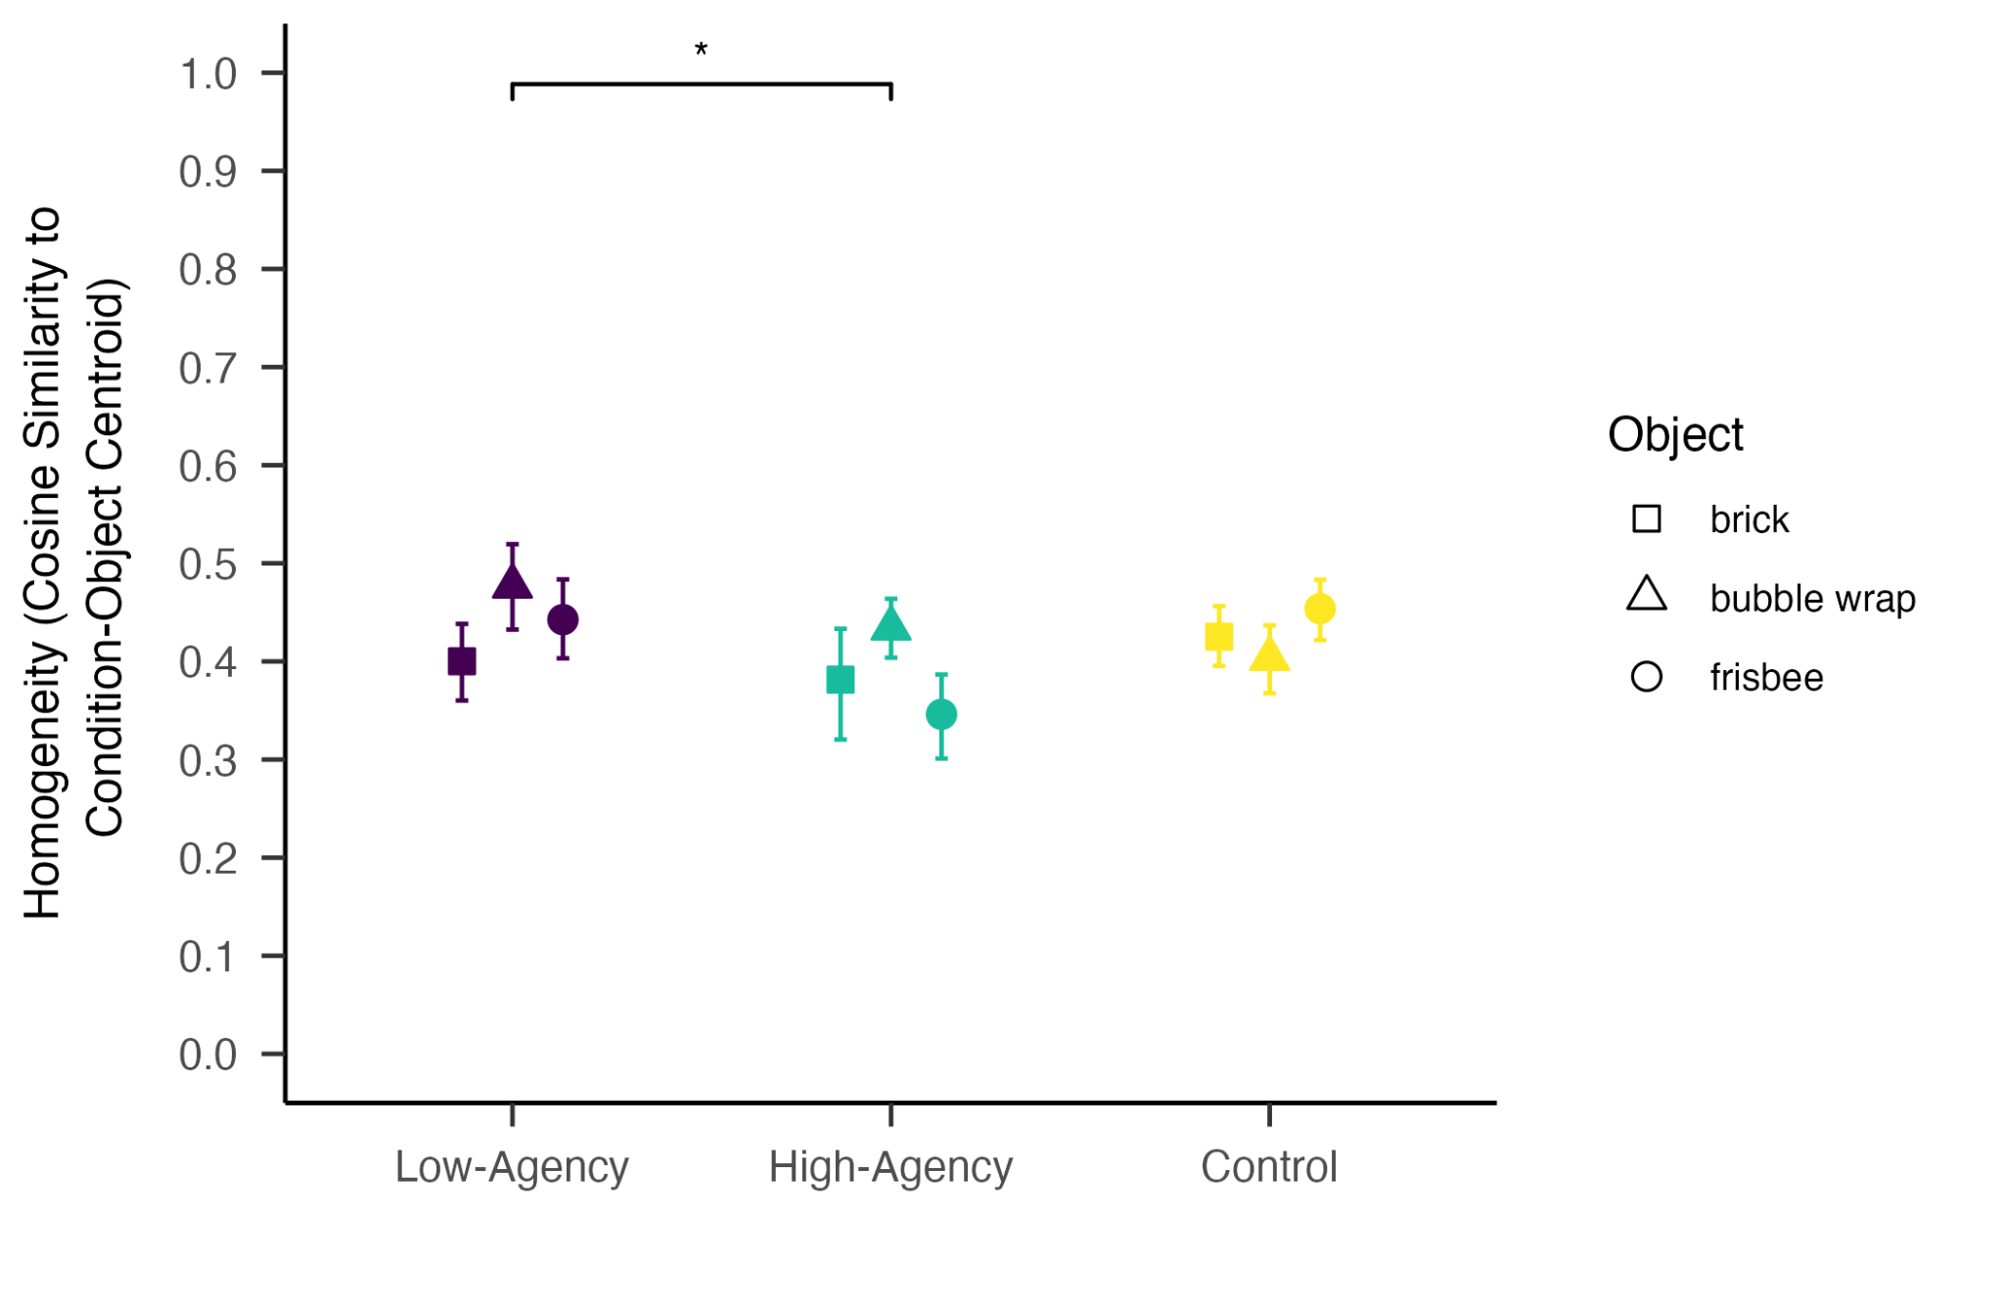
Note: Mean homogeneity operationalized as cosine similarity to condition-object centroids, with bootstrapped 95% confidence intervals for each object.
A linear mixed-effects model with condition as fixed effect and participants and objects as random effects revealed that, consistent with H2, there was a significant effect of experimental condition on homogeneity, F(2, 121.67) = 3.15, p < .05, $η_{p}^{2}$ = .07 (see Table A3). Pairwise comparisons with Tukey’s HSD revealed that participants in the high-agency condition submitted ideas that were less similar to their condition-object centroid (M = 0.394, SD = 0.010) than participants in the low-agency condition (M = 0.421, SD = .009), t(125) = -2.45, p < .05. No significant differences were observed between the control (M = 0.417, SD = .008) and the high-agency condition, t(122) = 1.87, p = .15, nor the control and the low-agency condition, t(113) = -0.74, p = .74. To assess sensitivity to idea selection, we ran 5,000 Monte Carlo simulations by repeatedly randomly selecting one idea per submitter before computing similarity to the condition-object centroid. Relative to the low-agency condition, submitters in the high-agency condition consistently produced ideas that were less semantically similar to the centroid embedding, ΔM = −.027, 95% Monte Carlo interval [-.053, -.001]. The low-agency condition did not differ significantly from the control condition, ΔM = -.004, 95% Monte Carlo interval [-.027, .020]. This pattern of results suggests that participants in the high-agency conditions produced less homogenous ideas (i.e., that were less similar to ideas produced by others in their same condition) than those in the low-agency condition.
Although the centroid approach is standard among the literature on AI-induced homogenization in creative domains, it relies on the assumption that the structure of ideas can be distilled into a single point estimate of an average. However, as this approach aggregates across embeddings, it fails to capture the inherent variability in the structure of each condition’s collective ideas. To address this concern, we conducted an exploratory clustering analysis (HDBSCAN; McInnes et al., 2017) to uncover categories of ideas, ideas that did not clearly fall into a single category of ideas, and evidence of participants glomming onto a single category—our key indicator of homogeneity at the group level.

Figure 3. Clusters of Ideas Across Conditions and Objects
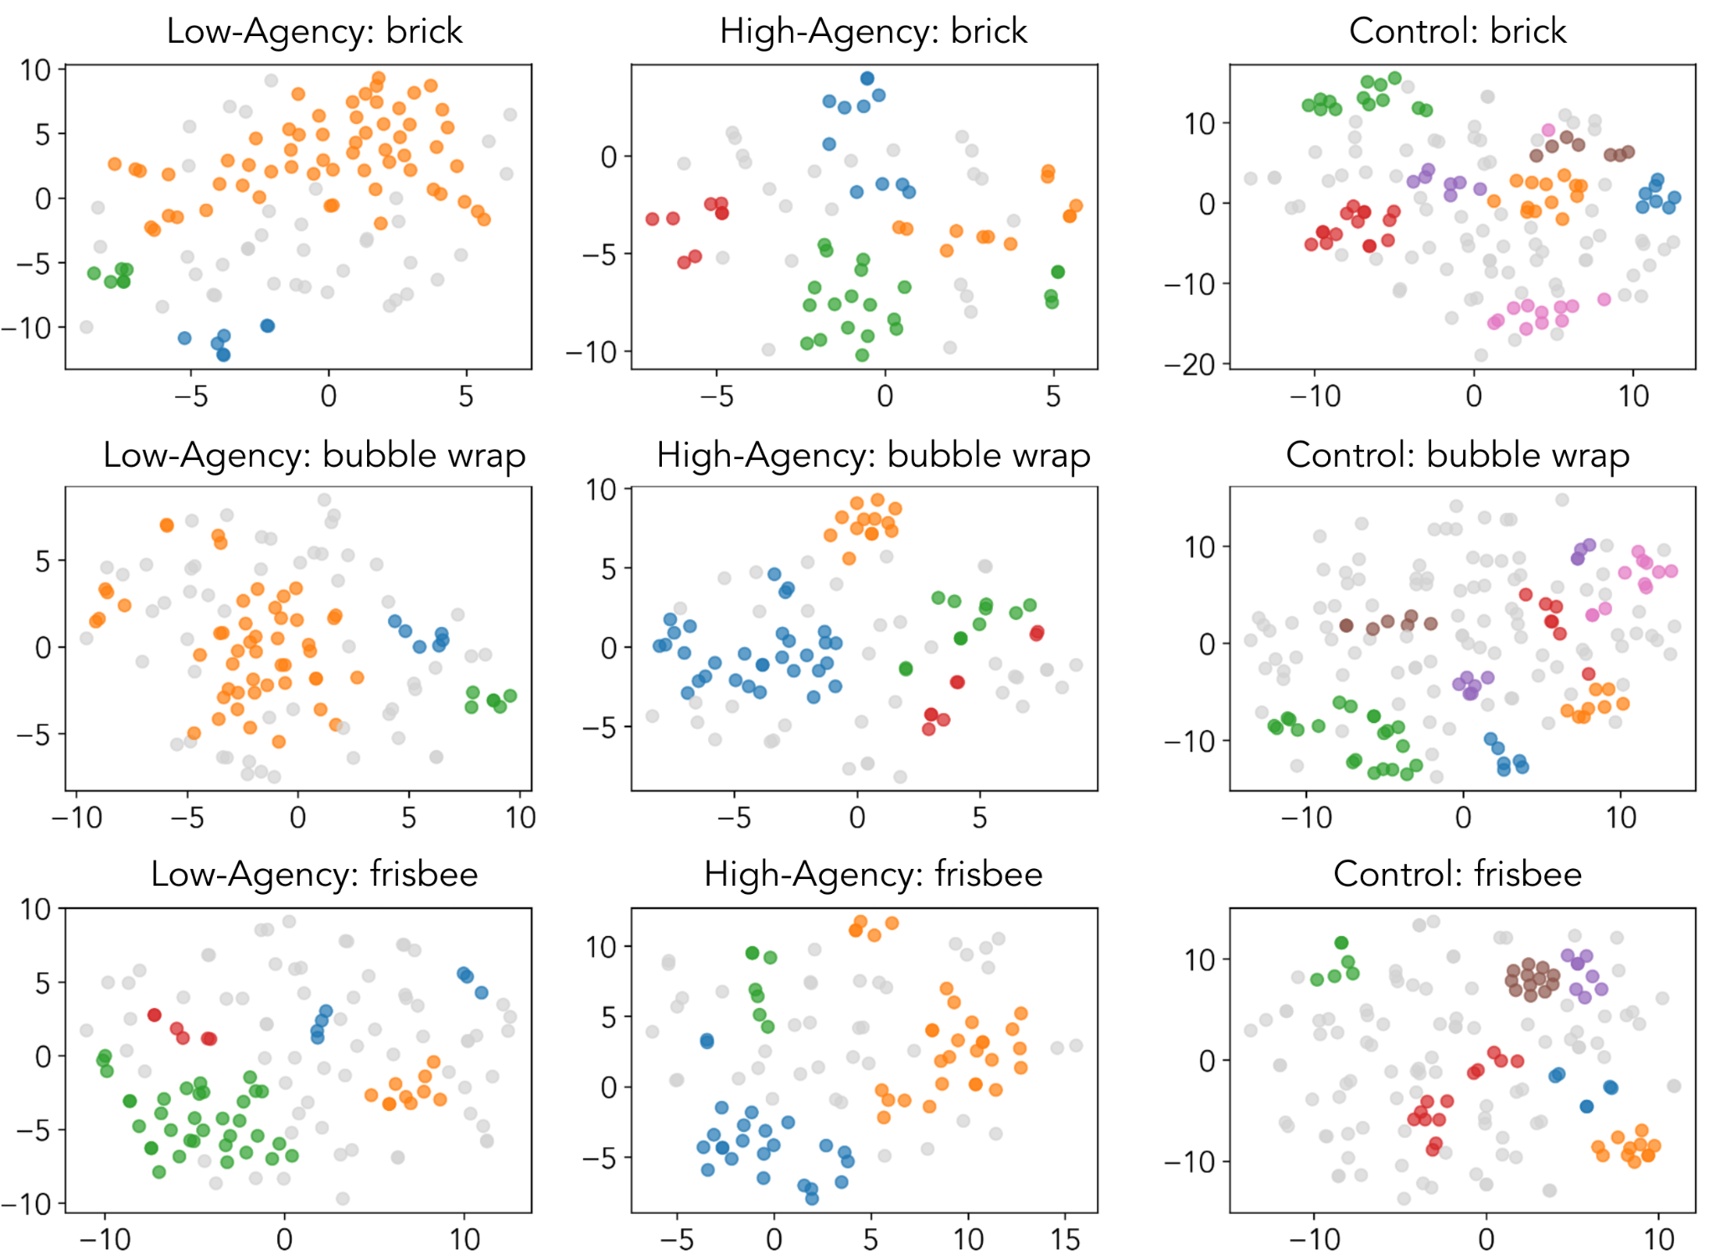
Note: Clusters were identified for each combination of object and condition using HDBSCAN and visualized in 2D using t-SNE. Ideas that were classified as “noise” by the clustering algorithm appear as light gray points, while ideas from unique clusters each appear as a brightly colored point.
We used three metrics to quantify the results of the clustering analysis: (1) number of unique clusters, (2) noise ratio, and (3) coefficient of variation. The number of unique clusters served as a proxy for the number of unique categories of uses proposed by participants in each condition. Noise ratio is the proportion of ideas that did not fall under any of the dense clusters, serving as a proxy for the “outlier” ideas indicative of greater diversity; mathematically, each noise point can be thought of as its own singleton cluster. The coefficient of variation (CV; standard deviation of cluster sizes divided by the mean cluster size) indicates the extent to which the clusters are equal in size; a higher CV suggests greater imbalance in cluster sizes. As shown in Figure 3, the three conditions showed distinct patterns in these metrics.
To explore whether the observed differences in clustering patterns showed potential systematic trends, we conducted a preliminary exploratory analysis. Using permutation tests (n = 5,000 permutations), we compared the maximum and minimum condition means for each metric. For the number of unique clusters, the observed difference between conditions was 3.33, a difference driven by the statistically higher number of clusters in the control condition relative to the low-agency condition, p = .04. For noise ratio, the observed difference was 0.22, again driven by a higher noise ratio in the control condition relative to the low-agency condition, p = .02. For coefficient of variation, the observed difference was 0.75, driven by the low-agency condition having a significantly higher coefficient of variation than the control condition, p = .005. Taken together, the clustering results suggest that our experimental manipulation resulted in homogeneity outcomes significantly different from what would be expected by chance.

2.3 Comparing Intent-to-Treat and Per-Protocol Analyses
A relatively high rate of noncompliance was observed in the treatment conditions, with 20% of participants in the high-agency condition and 28% of participants in the low-agency not using AI for at least one of the three objects in the task. Examination of the open-text responses from noncompliant participants indicated a substantial number expressed defiance against AI (e.g., a participant assigned to the low-agency condition who wrote, “If I used AI, it would give me all the answers, and I wouldn’t have to think anymore. That’s why I tried to think for myself”). Given this, we conducted exploratory intent-to-treat analyses alongside the preregistered per-protocol analyses of the above creativity and homogeneity measures. Comparing the results of these two approaches provided additional information on whether observed condition-level differences may have been influenced by characteristics of compliant vs. noncompliant participants, rather than simply our intervention. In the context of our study, this may indicate whether condition-level differences were specific to participants who were inclined to follow our guidance about AI usage.
For the individual-level creativity models, results indicated that in the intent-to-treat analysis, there were no significant differences by condition in overall creativity, originality, or usefulness (ps > .10)—aligning with the per-protocol analysis. As in the per-protocol analysis, these nonsignificant differences may be related to the low interreliability in evaluators’ subjective ratings. For the preregistered homogeneity models, there were no significant differences by condition in similarity-to-centroid embeddings, F(2, 136.03) = 0.08, p = .91, differing from the per-protocol analysis. In contrast, for the exploratory cluster analysis, the intent-to-treat analysis produced a similar pattern of findings as the per-protocol analysis: across a sweep of parameters for the cluster metrics, the most common ranking of conditions was control, followed by high-agency, and low-agency. Procedural details and full results can be found in the Appendix.

3 Discussion
In the present study, we investigated how psychological approaches to AI usage may affect creativity at both the individual and group levels. By experimentally assigning people to read one of three common forms of guidance about AI usage (stay in control of the AI tool, let the AI tool do the heavy lifting, or don’t use AI at all), we observed preliminary evidence of agency-oriented framing. First, at the individual level we observed no significant differences in the ideas as assessed by third-party evaluators’ subjective ratings of overall creativity, originality, and usefulness. Although qualitative examination of the responses suggested that low-agency ideas were markedly more mundane or nonsensical (e.g., “bubble wrap packaging” or “bubble wrap art”) compared to the richer concepts produced in the high-agency or control conditions (e.g., a sensory toy for a child with ADHD), this qualitative distinction was ultimately not reflected in the quantitative subjective creativity ratings. At the group level, in line with prior research on the “paradox” of human-AI co-creativity, our analysis of the semantic similarity of ideas revealed that low-agency participants tended to be more homogeneous than their high-agency counterparts; critically, this effect was limited to our per-protocol analysis, not the intent-to-treat analysis that included noncompliant participants. Our exploratory cluster analysis offered additional insight into the group-level structure of ideas: Specifically, ideas in the low-agency condition tended to fall under 1-2 dominant clusters, with fewer ideas being classified as “noise” relative to the human-only control condition. These patterns were robust across the per-protocol and intent-to-treat analyses. On the whole, our homogeneity analyses lend support to the hypothesis that individuals using AI contribute to greater group-level homogeneity when they use it in a way that largely offloads ideation to the system.
Our findings are consistent with previous research on human-AI co-creativity, whereby people who work with AI tend to produce more similar creative output than people who rely on their own minds (Luchini et al., 2025). On a broader level, the present study contributes to a growing body of research suggesting that LLMs flatten human variability (Wang et al., 2025), which has important implications for creativity. Within the two AI-assisted conditions, the high-agency condition was less homogeneous than the low-agency condition; our exploratory cluster analysis further illustrated that the control condition with solely human-produced ideas was arguably the most idiosyncratic (e.g., the greatest number of clusters and the most “noise”).
We also contribute to creativity research more broadly through our analytic approach. In our paradigm we captured not only the creative product (participants’ ideas), but the process by which participants worked with AI to generate those ideas (Green et al., 2024). By probing the prompting strategies people used to solicit creative help from AI, we uncovered strategies similar to those in research on stimulating creativity among humans. For example, the Exploratory category of prompts (in which participants specify a context in which the object may be used) aligns with the notion of “creative constraints” (Medeiros et al., 2025), whereby people actually generate more creative ideas when they have a degree of constraint on the type of output they are allowed to create. In such an open-ended task as the Alternative Uses Task, the Exploratory prompting strategy—used at a higher rate by our high-agency participants compared to our low-agency participants—may funnel a greater number of unique ideas into the set of generated ideas. Furthermore, our exploratory cluster analysis provided additional insight into the group-level homogeneity of people’s ideas, beyond what could be identified from the similarity-to-centroid analysis typical of the idea generation literature. In our study, the cluster analysis offered both a visual and empirical demonstration of how collective creativity outcomes varied across a range of perceived human agency. Extending upon the preregistered similarity-to-centroid analysis, our cluster analysis identified higher-level semantic groupings, enabling an analysis of the number of unique categories of ideas, their relative size, and the proportion of ideas that constituted their own singleton categories.
Amid widespread adoption of AI, human-centered AI research consistently calls for “designing AI systems that support human self-efficacy, promote creativity, clarify responsibility, and facilitate social participation” (Shneiderman, 2020). Additional efforts are needed to combine both design-level interventions designed to support agency in human-AI interactions with individual-level interventions that can help everyday people approach and leverage AI tools without deferring their own autonomy. For instance, psychological interventions that remind individuals that they should retain ownership of their work and that there are long-term benefits to exercising their cognitive abilities may help establish a high-agency foundation for people using AI during developmentally critical periods (i.e., early adolescence, upon first adoption) (Walton & Wilson, 2018). Furthermore, AI literacy interventions that explicitly increase individuals’ knowledge about the inner workings, capabilities, and limitations of modern AI tools may similarly help people feel a greater sense of control over their interactions (Long & Magerko, 2020).

3.1 Limitations
The results of this study should be interpreted with respect to its limitations. While our study suggests that agency-oriented framing plays a role in how people engage in creative ideation with AI, the generalizability of our findings is limited in several key ways. First, we focused on participants’ ability to engage in divergent thinking, which is one of many ways of conceptualizing and assessing creative thinking (Byrge et al., 2025). Furthermore, the Alternative Uses Task is just one measure of divergent thinking. It is unclear whether agency-oriented framing may shift individual performance on other creative tasks or other types of creative thinking (e.g., convergent thinking). This study also relied on third-party evaluators to subjectively assess aspects of creativity. Although we provided each evaluator with a rubric with which to score ideas, evaluators could vary in their criticality, as evidenced by the relatively low interrater reliability in the subjective evaluations for individual-level metrics of creativity. Additionally, as we focused our study on the human side of the human-AI interaction, computational work is needed to probe model behavior for the AUT across various parameters, such as temperature, which is known to affect the randomness of generative models (Peeperkorn et al., 2024). And as in any study investigating the impact of emerging technologies, the results are limited in their temporal validity (Munger, 2023): the particular model used at the time of the study (in our case, gpt-3.5 in late 2025).
Notably, the study was limited by the relatively high rate of noncompliance that was observed in the AI-access conditions, where participants did not use AI for the AUT even when instructed to do so. Because noncompliance-related attrition can undermine internal validity, we conducted an intent-to-treat analysis to assess homogeneity outcomes regardless of the actual treatment participants received (Sagarin et al., 2014). Our intent-to-treat analysis revealed that the intervention did not have an effect on the full sample, pre-exclusion (see Appendix for details), suggesting that our findings around agency-oriented framing may be limited to people who are willing to use AI as instructed. Therefore, the preregistered similarity-to-centroid homogeneity analysis, which was nonsignificant when noncompliant participants were included in the analysis, suggests conditional associations among participants who complied with the AI-use instructions.
This noncompliance revealed real reactions to AI guidance that may occur in the wild, as individuals may opt to not engage or even reject AI when asked to use it. While the design of our study precluded us from identifying the specific reasons behind this behavior, several potential explanations may arise from the literature. Beyond mere inattention, individuals also may be experiencing a degree of psychological reactance (Reynolds-Tylus & Martina Gonzalez, 2025) when asked to engage with an AI tool, particularly given a context as central to human identity as creation (Morewedge, 2022). While the design of this study precluded us from identifying the specific reasons or mechanisms that drove individuals to reject AI, the fairly high self-reported intrinsic motivation across the sample suggests that participants may have felt that the chatbot interfered with their ability to enjoy the experience of generating ideas on their own. Such a phenomenon would be consistent with prior research on the use of generative AI in the workplace (Wu et al., 2025). It is also possible that our experimental manipulation affected not only the intended construct of perceived human agency but also constructs such as AI overreliance and perceived competence with AI tools. All of these constructs are likely interrelated, but because we aimed to mitigate survey fatigue by reducing the number of self-report questions in the survey our study cannot empirically disentangle these potential mechanisms.

3.2 Future Directions
Our results support several promising directions for future research. First, participant feedback indicated that intervention text either reinforced or clashed with their preexisting beliefs about the role of AI in the creative process. For example, as one participant in the low-agency condition wrote about the intervention text, “I think the text made me more against using AI because I didn't want AI to do the heavy lifting for me, I'd like to think for myself, especially in these creative tasks.” The high-agency text also seemed to motivate some participants to bypass AI in favor of their own human ideas: “I did not really use Al until the last 2 objects were mentioned. I was focused more on trying to utilize my own mind before trying to use an exterior entity.” In both cases, reading about AI’s potential to control the user may have influenced some participants to refuse its help altogether—an unintended consequence of our experimental manipulation. Such psychological reactance would be in line with prior research on the forced adoption of self-service technology (Feng et al., 2019) or the broader phenomenon of aversion to AI in conventionally human domains (Candrian & Scherer, 2023). Future research might explore the extent to which such belief congruence moderates the effect of AI usage guidance like that of our High- and low-agency intervention texts. If an individual already has strong inclinations against the use of AI in idea generation, it may not matter whether they are urged to steer a model (a la high-agency) or lean on it heavily (a la low-agency). Similarly, some of the most creative individuals may not use AI at all for their creative work, either because they are better at the creative task on their own or because they refuse to use it on principle. Characterizing such individual differences may be beneficial to understand the boundary conditions of a similar intervention on downstream consequences like diversity of thought.
A second direction for future work is to track how individual-level psychological outcomes of LLM-assisted idea generation changes over time among those who use them. As highlighted by several researchers investigating effects of chatbot usage on cognition more broadly, it is unclear whether ChatGPT can be conceptualized as an “addictive” medium that impairs critical thinking and other mental processes (Yankouskaya et al., 2025) or a tool to enhance it (Suriano et al., 2025). A longitudinal study could shed light on changes in divergent thinking over time as a function of various psychological approaches to AI. Additionally, future studies might strengthen the manipulation of ChatGPT usage by having participants in the high-agency and low-agency conditions behave differently, not just think differently (O’Toole & Horvát, 2024). For example, instead of simply providing a chatbot for participants to use, future studies might embed a tutorial in which participants have the opportunity to ask questions to the AI system and push back on its suggestions for creative ideas.
AI systems have lowered the barrier to entry for many forms of creative work and expression. While this has democratized idea generation for people who may feel the need for creativity support, our study suggests that without an agentic approach people who use large language models may unwittingly contribute to an algorithmic monoculture. Mass reliance on the same model may have a more insidious effect on collectives of everyday users who count on an idea being just a prompt away.

Acknowledgments
We extend thanks to members of the Social Media Lab for helpful discussion; Jennifer Pan for detailed comments on the manuscript; Harrison Nicholls for feedback on the exploratory cluster analysis; and the [ANONYMIZED] Institute for Research in the Social Sciences and the community college students involved in the Research Experience Program.

Competing Interests
Authors with BetterUp affiliations are paid employees of BetterUp Inc.; A.Y.L. and J.H. are paid consultants within BetterUp Labs at BetterUp, Inc. S.H.W. and Y.Y. do not have any affiliation with BetterUp and have no conflicts of interests to declare.

Appendix

4.1 Web App and Language Model
We developed a simple web application in Vercel which emulated the generic AI chatbot experience (e.g., ChatGPT). The interface was embedded in the Qualtrics survey using Javascript. Participants’ chat interactions with the AI, including message sender (i.e., AI or user), message content, and timestamp, were logged as responses together with other survey data through the Qualtrics API. We used the gpt-3.5 model, with the temperature parameter set to 0.7, in line with other research on ChatGPT for creative tasks (e.g., Ashkinaze et al., 2024).

4.1.0.1 System Prompt
The model was given the following system prompt for all interactions with participants: “You are a helpful AI assistant in a chat interface. Be conversational, friendly, and helpful. Keep responses concise but informative.”

4.2 Experimental Paradigm

Figure A1. Experimental Paradigm

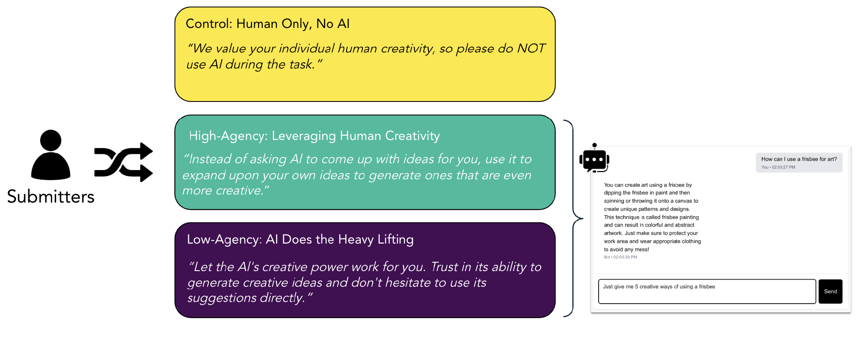
Note: Submitters were randomly assigned to one of three between-subjects conditions. All participants completed the Alternative Uses Task, but the two treatment conditions were provided with access to ChatGPT; chat data was logged in Javascript.

4.2.1 Full-Length Instructions for Each Condition

High-Agency
The AI tool is not magic. Behind the scenes, it predicts words that are likely to occur next in a body of text and outputs sentences that are highly probable for that context. Without realizing this, many people let AI do their thinking for them. For example, a simple prompt like “Give me creative ideas for my project” could give you a coherent response to copy-paste. But the response will not be original, and it won't reflect your own creativity.

People who copy-paste AI responses are letting the tool control them. On the other hand, people who engage with AI are in control of the tool. Instead of letting AI think for them, they might offer AI an initial concept and ask for help identifying blind spots or taking on other perspectives. Ultimately, by engaging in dialogue with AI you will strengthen your cognitive muscles and develop more creative ideas.

For the purpose of this task, remember that you are in charge of the tool. Instead of asking AI to come up with ideas for you, use it to expand upon your own ideas to generate ones that are even more creative.

We will evaluate the creativity of your idea based on originality and usefulness.

The arrow button will appear once 10 seconds have passed. Please click the arrow button when you are ready to begin.

Low-Agency
AI tools can transform even the simplest spark of an idea into something remarkable. Because these tools have been trained on a wealth of data, AI recognizes patterns, styles, and connections that would take years of study to master on your own.

The beauty of AI is that it does the heavy lifting for you. Simply describe what you’re looking for and watch as the AI transforms your basic request into something creative. A simple prompt like "Give me creative ideas for my project" can unlock possibilities you never would have imagined on your own.
For the purpose of this task, let the AI's creative power work for you. Trust in its ability to generate creative ideas and don't hesitate to use its suggestions directly. They're designed to be compelling right out of the box.

We will evaluate the creativity of your idea based on originality and usefulness.
The arrow button will appear once 10 seconds have passed. Please click the arrow button when you are ready to begin.

Control
Please enter your ideas for creative uses of the object provided, one at a time in the fields that will be provided below. You will be asked to provide exactly 5 creative uses for each of three objects. There is no time limit for each object, but please remember that you have a maximum of 30 minutes to complete the whole study.
We will evaluate the creativity of your idea based on originality and usefulness.
Note: We value your individual human creativity, so please do NOT use AI during the task. We have disabled copy-paste for this reason.
The arrow button will appear once 10 seconds have passed. Please click the arrow button when you are ready to begin.

4.3 Individual-Level Creativity Scoring Rubric
Submitters and evaluators were provided with the following definitions to guide their ideation and evaluation, respectively.
Table A1

Creativity Scoring Rubric, Provided to Both Submitters and Evaluators
Metric | Definition Provided to Participants
Overall creativity | This is your single, overall impression. Does the idea strike you as clever, ingenious, or highly innovative? Does it provide a surprisingly good solution to a real-world challenge?
Originality | Originality means an idea is new, uncommon, or unique. It’s something that hasn’t been done before in the exact same way. Think of it as the “surprise” factor. To guide your originality scoring, you can ask yourself: “Is this the first thing that comes to mind, or is it something I wouldn’t have thought of?”
Usefulness | Usefulness means the idea is effective, appropriate, or valuable in some way. It has to work, make sense, or solve a problem. In short, it must have a purpose. An idea that is impossible or nonsensical is not useful.

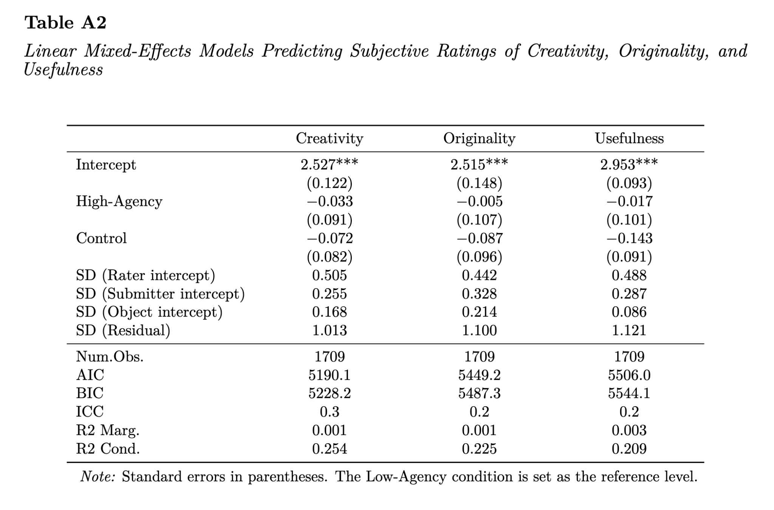

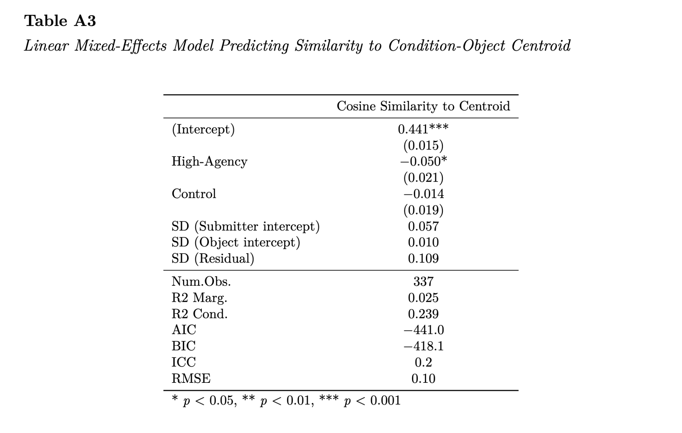

5 Additional Results

5.1 Behavioral Outcomes
We conducted a series of independent-samples t-tests comparing the following features of the participants’ conversations with AI: number of conversational turns, chat duration (in seconds), average word count per turn, and number of copy-paste events. These values did not significantly differ between the high-agency and low-agency conditions, ps > .17, suggesting that while the experimental manipulation affected the types of initial prompts participants made, they did not manifest in subsequent behaviors.

5.2 Treatment Noncompliance
Analysis of participants’ behavioral interactions with the AI chatbot indicated noncompliance in both the high-agency and low-agency conditions. In 24% of the low-agency trials and 38% of the high-agency trials, participants did not use the AI web-app. Examination of qualitative participant feedback indicated that in some cases, this noncompliance may have been due to a lack of clarity in the task instructions, but in most cases this was due to the participant’s deliberate choice to refuse help from AI on principle (e.g., a participant in the high-agency condition who explained that they did not use the chatbot because “AI takes away my critical thinking and would make this boring”).

5.2.1 Intent-to-Treat Analysis
To assess the extent to which our preregistered and exploratory homogeneity analyses applied to the full sample of participants who completed the study (not just those who complied with their condition’s instructions), we conducted an intent-to-treat analysis. In this analysis, all trials in the treatment conditions were included regardless of whether the participant used AI as per the intervention text. The preregistered linear mixed effects model predicting similarity to condition-object centroid from the fixed effect of condition and random effects for object and submitter revealed that neither the high-agency (b = 0.01, 95% CI [-0.02, 0.03], p = .719) nor the Control condition (b = 0.00, 95% CI [-0.03, 0.03], p = .995) differed significantly from the low-agency condition, indicating that the intervention did not affect group-level homogeneity when noncompliant participants were included in the analytic sample (e.g., Doshi & Hauser, 2024). Running the cluster analysis with the noncompliant participants revealed similar patterns to the per-protocol version, whereby the control group tended to produce the highest number of unique clusters, followed by the high-agency condition and the low-agency condition. Similarly, the control group consistently had the lowest coefficient of variation (suggesting the greatest balance in cluster sizes), followed by the high-agency condition and the low-agency condition.

Figure A2. Clusters of Ideas Across Conditions and Objects (Intent-to-Treat)
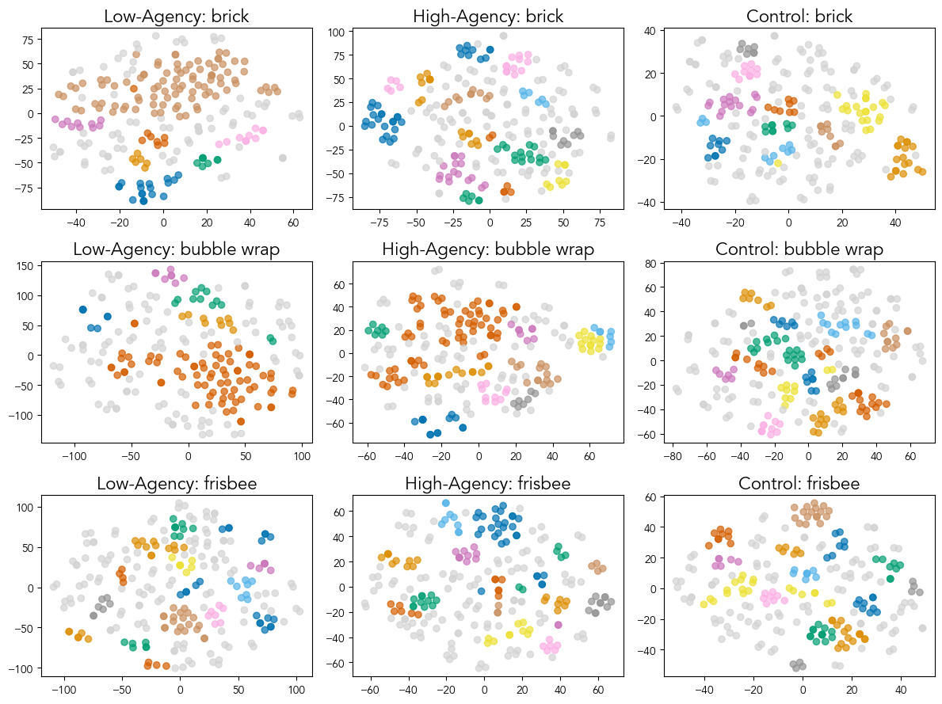

5.3 Robustness Sweep for Exploratory Cluster Analysis
To identify appropriate parameters for our exploratory cluster analysis, we conducted a robustness sweep of the key parameters for the hdbscan.HDBSCAN() function: min_cluster_size (the smallest acceptable cluster size) and min_samples (the minimum number of neighbors to a core point, where the higher the value the more points are considered “noise”). We first plotted the clustering metrics (unique clusters, noise ratio, and coefficient of variation) across a range of values for min_cluster_size and min_samples. We set a stability threshold defined where each clustering metric was normalized by its observed range:

​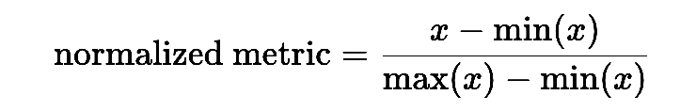

Using this heuristic, we calculated the average absolute change between neighboring parameter values across the three metrics and experimental conditions. With a cutoff to 0.25, the average neighboring change was limited to be no larger than roughly 25% of the observed metric range after normalization.
Next, we defined substantive constraints on overall clustering metrics: a minimum number of two unique clusters and a maximum noise ratio of 0.50. Combining the stability threshold with the substantive constraints, we identified regions of acceptable parameter values for HDBSCAN. Our cluster analysis in the main text was based on min_cluster_size = 6 and min_samples = 1.

Figure A3. Robustness Sweep Across Clustering Parameters
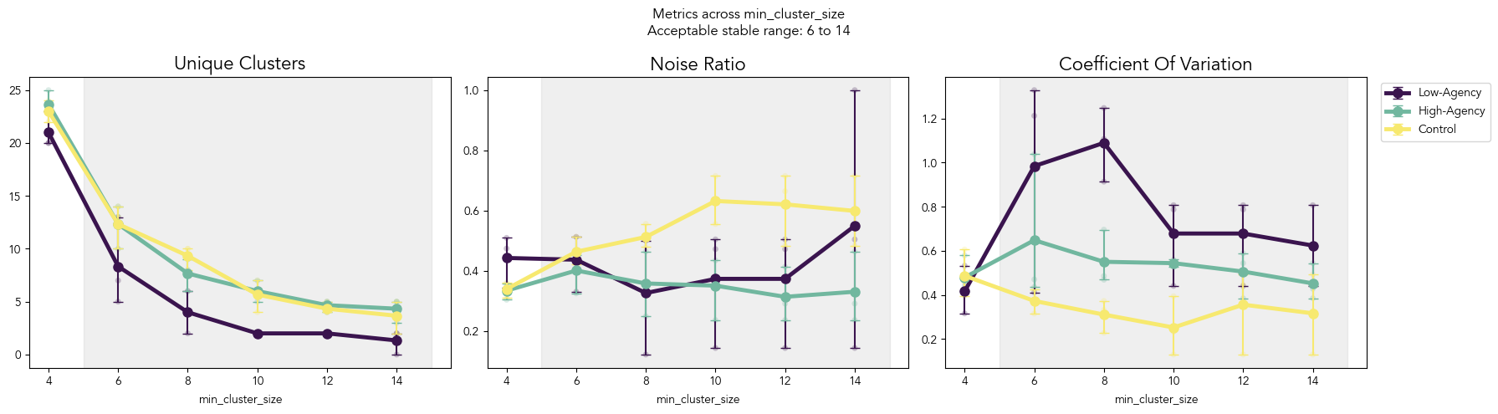
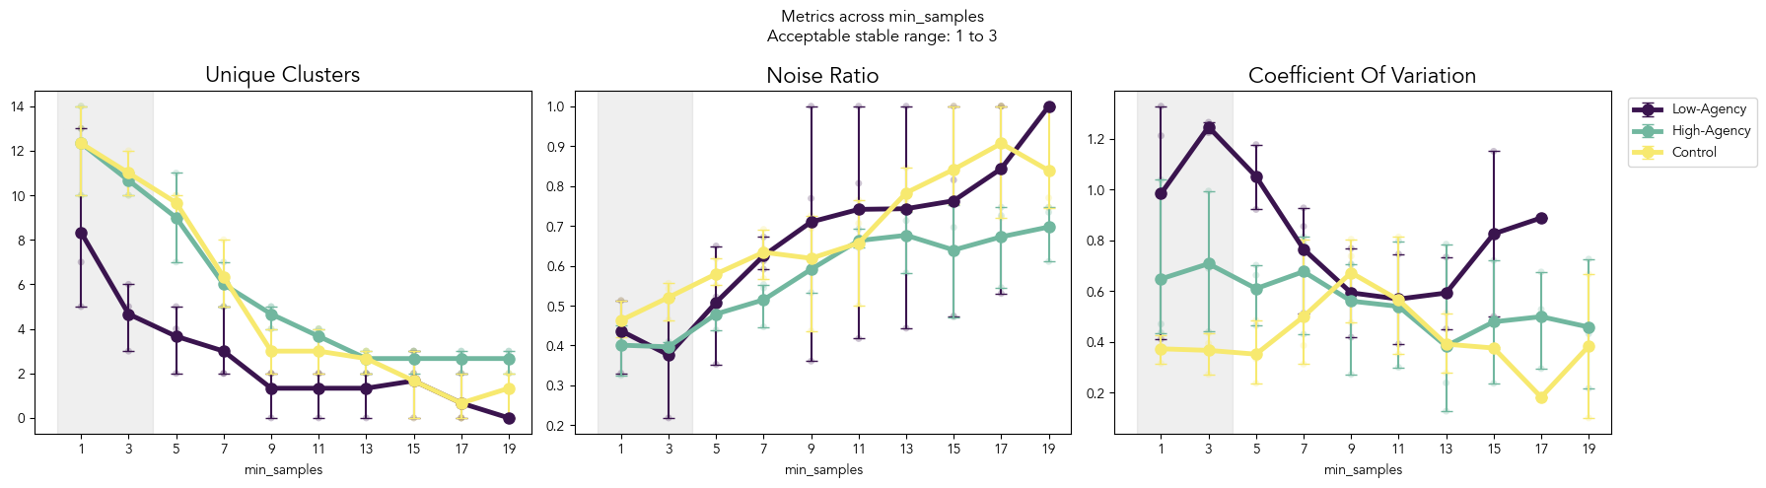
Note. Clustering metrics (number of unique clusters, noise ratio, and coefficient of variation) are plotted as connected points for each of the three experimental conditions. Bold points indicate condition-level means and smaller semi-opaque points indicate object-level values. At each parameter value, the range of clustering metric values across individual objects (brick, bubble wrap, frisbee) is indicated with a vertical line connecting the two objects with the maximum and minimum values for each condition. The region of acceptable parameter values is shaded in gray.

5.4 Participants’ Prompts to the AI System

5.4.1 Prompt Coding Procedure
We developed a coding scheme to categorize participants’ initial prompts to the AI system. First, we randomly selected 20% of the participants and coded their prompts based on patterns in the subset. A vast majority of initial prompts simply repeated the task instructions (e.g., “Give me creative uses for a brick.”). The first and second author coded these as “Direct Asks.” For the remaining initial prompts, the two authors used inductive coding and reached $κ=0.89$. Disagreements were resolved through discussion. To guide our subsequent coding, we drew upon Boden’s (1990) framework of three types of creativity: Exploratory, Combinational, and Transformational. Exploratory creativity discovers novel ideas within a constrained space; combinational creativity merges existing concepts to form a new one; transformational creativity completely alters the rules of the conceptual space. In the human-coded subset (n = 42 messages), GPT-5-mini classifications agreed with human labels for 37 messages (88.1% agreement; Cohen’s κ = .769). We used GPT-5-mini to classify participants’ first prompts in each conversation with the AI.

5.4.2 System Prompt to GPT-5-mini
CATEGORY_DEFINITIONS
You are analyzing user prompts sent to an AI assistant about alternative uses for objects. Classify each prompt into exactly one of the following categories:
- DIRECT_ASK: User directly asks the AI to generate ideas.
- Examples:
  - “5 creative ways to use a brick”
  - “Please come up with 5 creative ways to use a frisbee”
  - “give me alternative uses for bubble wrap”
- TRANSFORMATIONAL: The restructuring or alteration of the fundamental rules and constraints of a conceptual space. User imagines changing the object’s fundamental properties or nature.
- Examples:
  - “A brick that uses brain signals/waves to mold onto something we are imagining, like durable play dough”
  - “if I melted bubble wrap what would it become”
  - “what if a brick could change shape”
- EXPLORATORY: Searching a defined space. This includes information seeking or exploring using an object under a specific context.
- Examples:
  - “Bubble wrap is the same as pop its?”
  - “come up with 5 creative ways to use a frisbee, that have to do with pets or food”
  - “what properties does a brick have”
  - “how does bubble wrap work”
  - “can bubble wrap be used as a pillow”
- COMBINATIONAL: Generating new ideas by combining or connecting existing, familiar concepts. Putting together known ideas in novel ways.
- Examples:
  - “how could I use a frisbee to replace or aid a piece of machinery”
  - “can I use a brick with cement”
  - “combine bubble wrap with tape”
  - “could I grind up a brick and mix it with some things to make clay or cement”
Important: Each prompt must fall into exactly one category. Choose the category that best fits the primary intent of the prompt.
Respond with only one of the following labels:
DIRECT_ASK
EXPLORATORY
TRANSFORMATIONAL
COMBINATIONAL
For each participant, we calculated the proportion of their initial prompts (across up to three objects) falling into each category. We then compared the rate of each type of prompt between participants in the high-agency and low-agency conditions.

Figure A4. Proportion of “Direct Asks” Across AI-Access Conditions

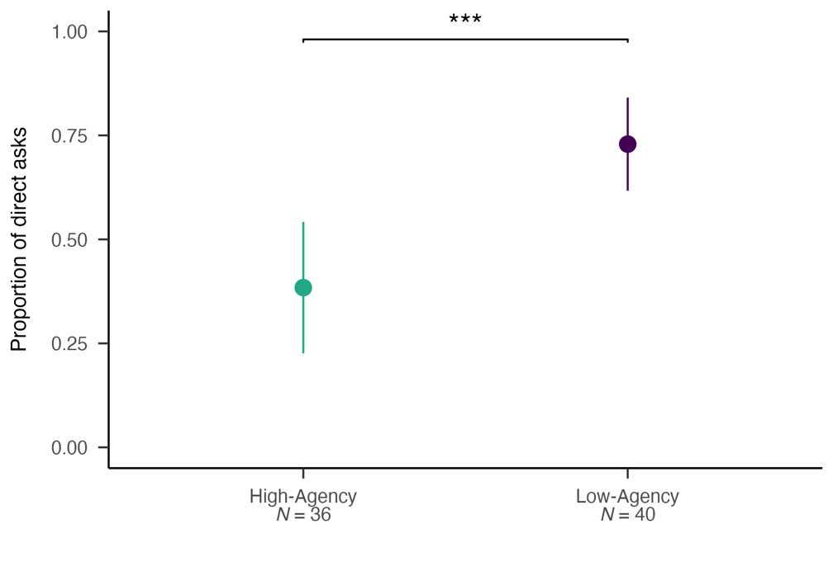
Note: Large dots indicate condition means. Error bars indicate 95% confidence intervals.

5.4.3 Prompt Classification Results

5.4.3.1 Direct Ask
Participants in the low-agency condition used significantly more Direct Ask prompts (M = 0.73, SD = 0.35) than participants in the high-agency condition (M = 0.38, SD = 0.47), t(74) = 3.67, p < .001, d = 0.84.

5.4.3.2 Exploratory
Participants in the high-agency condition used significantly more Exploratory prompts (M = 0.46, SD = 0.44) than participants in the low-agency condition (M = 0.15, SD = 0.26), t(79) = 3.81, p < .001, d = 0.86.

5.4.3.3 Transformational and Combinational
Transformational and Combinational prompts were rare (<2% in each condition). There was no significant difference in the rate of Transformational prompts between the low-agency condition (M = 0.01, SD = 0.05) and the high-agency condition (M = 0.02, SD = 0.11), t(79) = -0.50, p = 0.620, d = -0.11. There was no significant difference in Combinational prompts between the low-agency condition (M = 0.01, SD = 0.05) and the high-agency condition (M = 0.03, SD = 0.11), t(79) = -1.19, p = 0.24, d = -0.26.

References
Amabile, T. M. (1983). The social psychology of creativity: A componential conceptualization. Journal of Personality and Social Psychology, 45(2), 357. https://doi.org/10.1037/0022-3514.45.2.357
Anderson, B. R., Shah, J. H., & Kreminski, M. (2024). Homogenization effects of large language models on human creative ideation. Creativity and Cognition, 413–425. https://doi.org/10.1145/3635636.3656204
Bandura, A. (2001). Social cognitive theory: An agentic perspective. Annual Review of Psychology, 52(1), 1–26. https://doi.org/10.1146/annurev.psych.52.1.1
Bates, D., Mächler, M., Bolker, B., & Walker, S. (2015). Fitting linear mixed-effects models using lme4. Journal of Statistical Software, 67, 1–48. https://doi.org/10.18637/jss.v067.i01
Boden, M. A. (1998). Creativity and artificial intelligence. Artificial Intelligence, 103(1-2), 347–356. https://doi.org/10.1016/s0004-3702(98)00055-1
Byrge, C., Guzik, E. E., & Gilde, C. (2025). Artificial intelligence and the creative process: Does AI-creativity extend beyond divergent thinking? Journal of Creativity, 35(2), Article 100105. https://doi.org/10.1016/j.yjoc.2025.100105
Candrian, C., & Scherer, A. (2023). Reactance to human versus artificial intelligence: Why positive and negative information from human and artificial agents leads to different responses. SSRN. https://ssrn.com/abstract=4397618
Chakrabarty, T., Laban, P., Agarwal, D., Muresan, S., & Wu, C.-S. (2024). Art or artifice? Large language models and the false promise of creativity. arXiv. https://doi.org/10.48550/arXiv.2309.14556
Cheng, M., Lee, A. Y., Rapuano, K., Niederhoffer, K., Liebscher, A., & Hancock, J. (2026). Metaphors of AI indicate that people increasingly perceive AI as warm and human-like. Communications Psychology. https://doi.org/10.1038/s44271-025-00376-6
Chiang, T. (2024, August 31). Why A.I. isn’t going to make art. The New Yorker. https://www.newyorker.com/culture/the-weekend-essay/why-ai-isnt-going-to-make-art
Clark, A., & Chalmers, D. (1998). The extended mind. Analysis, 58(1), 7-19. https://doi.org/10.1111/1467-8284.00096
Crum, A. J., Akinola, M., Martin, A., & Fath, S. (2017). The role of stress mindset in shaping cognitive, emotional, and physiological responses to challenging and threatening stress. Anxiety, Stress, & Coping, 30(4), 379–395. https://doi.org/10.1080/10615806.2016.1275585
Doshi, A. R., & Hauser, O. P. (2024). Generative AI enhances individual creativity but reduces the collective diversity of novel content. Science Advances, 10(28), eadn5290. https://doi.org/10.1126/sciadv.adn5290
Dung, L. (2025). The argument for near-term human disempowerment through AI. AI & SOCIETY, 40(3), 1195–1208. https://doi.org/10.1007/s00146-024-01930-2
Feng, W., Tu, R., Lu, T., & Zhou, Z. (2019). Understanding forced adoption of self-service technology: The impacts of users’ psychological reactance. Behaviour & Information Technology, 38(8), 820–832. https://doi.org/10.1080/0144929X.2018.1557745
Frich, J., Vermeulen, L. M., Remy, C., Biskjaer, M. M., & Dalsgaard, P. (2019). Mapping the landscape of creativity support tools in HCI. Proceedings of the 2019 CHI Conference on Human Factors in Computing Systems, 1–18. https://doi.org/10.1145/3290605.3300619
Galla, B. M., Choukas-Bradley, S., Fiore, H. M., & Esposito, M. V. (2021). Values-alignment messaging boosts adolescents’ motivation to control social media use. Child Development, 92(5), 1717-1734. https://doi.org/10.1111/cdev.13553
Green, A. E., Beaty, R. E., Kenett, N. Y., & James, C. K. (2024). The process definition of creativity. Creativity Research Journal, 36(3), 544–572. https://doi.org/10.1080/10400419.2023.2254573
Guo, S., Shariatmadari, A. H., Xiong, G., et al. (2025). IdeaBench: Benchmarking large language models for research idea generation. Proceedings of the 31st ACM SIGKDD Conference on Knowledge Discovery and Data Mining v.2, 5888–5899. https://doi.org/10.1145/3711896.3737419
Guzik, E. E., Byrge, C., & Gilde, C. (2023). The originality of machines: AI takes the Torrance test. Journal of Creativity, 33(3), Article 100065. https://doi.org/10.1016/j.yjoc.2023.100065
Haase, J., & Paul, H. P. H. (2023). Artificial muses: Generative artificial intelligence chatbots have risen to human-level creativity. Journal of Creativity, 33(3), Article 100066. https://doi.org/10.1016/j.yjoc.2023.100066
Hancock, J. T., Naaman, M., & Levy, K. (2020). AI-mediated communication: Definition, research agenda, and ethical considerations. Journal of Computer-Mediated Communication, 25(1), 89–100. https://doi.org/10.1093/jcmc/zmz022
Hartman, R., Moss, A., Jaffe, S., Rosenzweig, C., Litman, L., & Robinson, J. (2023). Introducing Connect by CloudResearch: Advancing online participant recruitment in the digital age. CloudResearch.
Hicks, M. T., Humphries, J., & Slater, J. (2024). ChatGPT is bullshit. Ethics and Information Technology, 26(2), Article 38. https://doi.org/10.1007/s10676-024-09775-5
Hubert, K. F., Awa, K. N., & Zabelina, D. L. (2024). The current state of artificial intelligence generative language models is more creative than humans on divergent thinking tasks. Scientific Reports, 14(1), Article 3440. https://doi.org/10.1038/s41598-024-53303-w
Ivcevic, Z., & Grandinetti, M. (2024). Artificial intelligence as a tool for creativity. Journal of Creativity, 34(2), Article 100079. https://doi.org/10.1016/j.yjoc.2024.100079
Kharkhurin, A. V., & Corazza, G. E. (2026). The authenticity gap: Why generative AI cannot replicate human creativity. Journal of Creativity, 100132. https://doi.org/10.1016/j.yjoc.2026.100132
Kleinberg, J., & Raghavan, M. (2021). Algorithmic monoculture and social welfare. Proceedings of the National Academy of Sciences, 118(22), Article e2018340118. https://doi.org/10.1073/pnas.2018340118
Koivisto, M., & Grassini, S. (2023). Best humans still outperform artificial intelligence in a creative divergent thinking task. Scientific Reports, 13(1), Article 13601. https://doi.org/10.1038/s41598-023-40858-3
Kosmyna, N., Hauptmann, E., Yuan, Y. T., et al. (2025). Your brain on ChatGPT: Accumulation of cognitive debt when using an AI assistant for essay writing task. arXiv. https://doi.org/10.48550/arXiv.2506.08872
Kortenbach, T., Yin, Y., Gonçalves, M. G., Price, R. A., & Wang, P. (2025). The relation between humans and LLMs in the creative act. Journal of Creativity, 100114. https://doi.org/10.1016/j.yjoc.2025.100114
Lee, A. Y., Ellison, N. B., & Hancock, J. T. (2023). To use or be used? The role of agency in social media use and well-being. Frontiers in Computer Science, 5, Article 1123323. https://doi.org/10.3389/fcomp.2023.1123323
Lee, A. Y., & Hancock, J. T. (2024). Social media mindsets: A new approach to understanding social media use and psychological well-being. Journal of Computer-Mediated Communication, 29(1), Article zmad048.
Lee, B. C., & Chung, J. (2024). An empirical investigation of the impact of ChatGPT on creativity. Nature Human Behaviour, 8(10), 1906–1914. https://doi.org/10.1038/s41562-024-01953-1
Long, D., & Magerko, B. (2020). What is AI literacy? Competencies and design considerations. Proceedings of the 2020 CHI Conference on Human Factors in Computing Systems, 1–16.
Louie, R., Engel, J., & Huang, C.-Z. A. (2022). Expressive communication: Evaluating developments in generative models and steering interfaces for music creation. Proceedings of the 27th International Conference on Intelligent User Interfaces, 405–417. https://doi.org/10.1145/3490099.3511159
Luchini, Simone, Pronchick, J., Ceh, S., et al. (2025). The roles of idea generation and elaboration in human-AI collaborative creativity. PsyArXiv. https://osf.io/preprints/psyarxiv/xm2f5_v1
Madore, K. P., Jing, H. G., & Schacter, D. L. (2016). Divergent creative thinking in young and older adults: Extending the effects of an episodic specificity induction. Memory & Cognition, 44(6), 974–988. https://doi.org/10.3758/s13421-016-0605-z
Maslej, N., Fattorini, L., Perrault, R., ..., & Oak, S. (2025). The AI Index 2025 Annual Report. Stanford University. https://doi.org/10.48550/arXiv.2504.07139
McInnes, L., Healy, J., & Astels, S. (2017). Hdbscan: Hierarchical density based clustering. The Journal of Open Source Software, 2(11), Article 205. https://doi.org/10.21105/joss.00205
Medeiros, K., Cropley, D. H., Marrone, R. L., & Reiter-Palmon, R. (2025). Human-AI co-creativity: Does ChatGPT make us more creative? The Journal of Creative Behavior, 59(2), Article e70022. https://doi.org/10.1002/jocb.70022
Morewedge, C. K. (2022). Preference for human, not algorithm aversion. Trends in Cognitive Sciences, 26(10), 824–826. https://doi.org/10.1016/j.tics.2022.07.007
Munger, K. (2023). Temporal validity as meta-science. Research & Politics, 10(3), 20531680231187271. https://doi.org/10.1177/20531680231187271
Nave, G., Meincke, L., & Terwiesch, C. (2024). ChatGPT decreases idea diversity in brainstorming. PsyArXiv. https://doi.org/10.31234/osf.io/yqb29
O’Toole, K., & Horvát, E.-Á. (2024). Extending human creativity with AI. Journal of Creativity, 34(2), Article 100080. https://doi.org/10.1016/j.yjoc.2024.100080
Peeperkorn, M., Kouwenhoven, T., Brown, D., & Jordanous, A. (2024). Is temperature the creativity parameter of large language models? arXiv. https://doi.org/10.48550/arXiv.2405.00492
Poushter, J., Fagan, M., & Corichi, M. (2025, October 15). How people around the world view AI. Pew Research Center. https://www.pewresearch.org/global/2025/10/15/how-people-around-the-world-view-ai/
Reimers, N., & Gurevych, I. (2019). Sentence-BERT: Sentence embeddings using Siamese BERT-networks. In K. Inui, J. Jiang, V. Ng, & X. Wan (Eds.), Proceedings of the 2019 Conference on Empirical Methods in Natural Language Processing and the 9th International Joint Conference on Natural Language Processing (EMNLP-IJCNLP). Association for Computational Linguistics. https://doi.org/10.18653/v1/D19-1410
Reynolds-Tylus, T., & Martinez Gonzalez, A. (2026). Artificial intelligence and psychological reactance: examining responses to health recommendations attributed to a human or AI source. Review of Communication, 26(4), 205–221. https://doi.org/10.1080/15358593.2026.2633198
Rietzschel, E. F., Ritter, S. M., & Baas, M. (2026). A systematic review of creativity evaluation and creativity selection measurement tasks. Psychology of Aesthetics, Creativity, and the Arts, 20(1), 21–46. https://doi.org/10.1037/aca0000638
Runco, M. A. (2025). Updating the standard definition of creativity to account for the artificial creativity of AI. Creativity Research Journal, 37(1), 1–5. https://doi.org/10.1080/10400419.2023.2257977
Runco, M. A., & Charles, R. E. (1993). Judgments of originalities and appropriateness as predictors of creativity. Personality and Individual Differences, 15(5), 537–546. https://doi.org/10.1016/0191-8869(93)90337-3
Sagarin, B. J., West, S. G., Ratnikov, A., Homan, W. K., Ritchie, T. D., & Hansen, E. J. (2014). Treatment noncompliance in randomized experiments: Statistical approaches and design issues. Psychological Methods, 19(3), 317–333. https://doi.org/10.1037/met0000013
Shin, J., & Grant, A. M. (2019). Bored by interest: How intrinsic motivation in one task can reduce performance on other tasks. Academy of Management Journal, 62(2), 415–436. https://doi.org/10.5465/amj.2017.0735
Shneiderman, B. (2020). Human-centered artificial intelligence: Reliable, safe & trustworthy. International Journal of Human–Computer Interaction, 36(6), 495–504. https://doi.org/10.1080/10447318.2020.1741118
Si, C., Yang, D., & Hashimoto, T. (2024). Can LLMs generate novel research ideas? A large-scale human study with 100+ NLP researchers. arXiv. https://doi.org/10.48550/arXiv.2409.04109
Sourati, Z., Ziabari, A. S., & Dehghani, M. (2025). The homogenizing effect of large language models on human expression and thought. arXiv. https://doi.org/10.48550/arXiv.2508.01491
Suriano, R., Plebe, A., Acciai, A., & Fabio, R. A. (2025). Student interaction with ChatGPT can promote complex critical thinking skills. Learning and Instruction, 95, Article 102011.
Tankelevitch, L., Glassman, E. L., He, J., et al. (2025). Tools for thought: Research and design for understanding, protecting, and augmenting human cognition with generative AI. Proceedings of the Extended Abstracts of the CHI Conference on Human Factors in Computing Systems, 1–8.
Torrance, E. P. (1966). Torrance tests of creative thinking. Educational and Psychological Measurement.
Vafa, K., Bentley, S., Kleinberg, J., & Mullainathan, S. (2026). What's producible may not be reachable: Measuring the steerability of generative models. Advances in Neural Information Processing Systems, 38, 56383-56420. https://doi.org/10.48550/arXiv.2503.17482
Veselovsky, V., Ribeiro, M. H., & West, R. (2023). Artificial artificial artificial intelligence: Crowd workers widely use large language models for text production tasks. arXiv. https://doi.org/10.48550/arXiv.2306.07899
Walton, G. M., & Wilson, T. D. (2018). Wise interventions: Psychological remedies for social and personal problems. Psychological Review, 125(5), 617–655. https://doi.org/10.1037/rev0000115
Wang, A., Morgenstern, J., & Dickerson, J. P. (2025). Large language models that replace human participants can harmfully misportray and flatten identity groups. Nature Machine Intelligence, 7(3), 400–411. https://doi.org/10.1038/s42256-025-00986-z
Wu, F., Black, E., & Chandrasekaran, V. (2024). Generative monoculture in large language models. arXiv. https://doi.org/10.48550/arXiv.2407.02209
Wu, S., Liu, Y., Ruan, M., Chen, S., & Xie, X.-Y. (2025). Human-generative AI collaboration enhances task performance but undermines human’s intrinsic motivation. Scientific Reports, 15(1), Article 15105. https://doi.org/10.1038/s41598-025-98385-2
Yankouskaya, A., Liebherr, M., & Ali, R. (2025). Can ChatGPT be addictive? A call to examine the shift from support to dependence in AI conversational large language models. Human-Centric Intelligent Systems, 1–13. https://doi.org/10.1007/s44230-025-00090-w
Yeager, D. S., Hanselman, P., Walton, G. M., et al. (2019). A national experiment reveals where a growth mindset improves achievement. Nature, 573(7774), 364–369. https://doi.org/10.1038/s41586-019-1466-y

