**TUGAS I**

**ANALISIS ALGORITMA**



Disusun Oleh:

Sarah Hasna Azzahra

140810170010

**PROGRAM STUDI TEKNIK INFORMATIKA**

**FAKULTAS MATEMATIKA DAN ILMU PENGETAHUAN ALAM**

**UNIVERSITAS PADJADJARAN**

**2019**

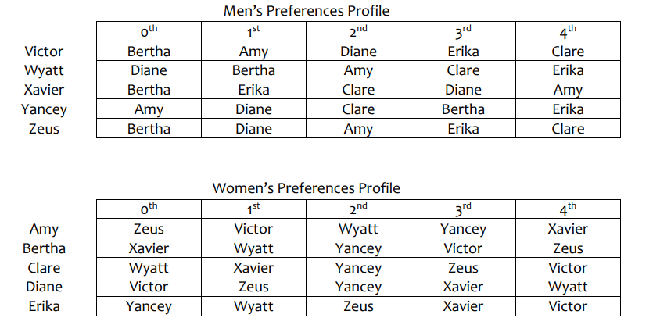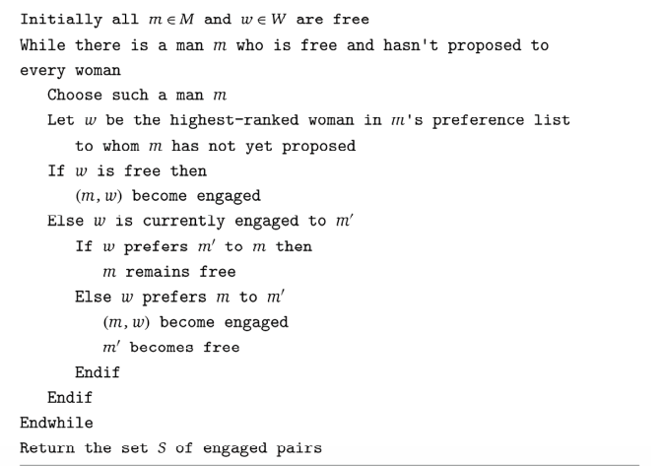

1. Victor choose Bertha 🡪 (Victor,Bertha)
2. Wyatt choose Diane 🡪 (Wyatt,Diane)
3. Xavier choose Bertha 🡪 (Xavier,Bertha)

But Bertha choose Xavier over Victor 🡪 (Xavier>Victor)

**(Xavier,Bertha)**

1. Yancey choose Amy 🡪 (Yancey,Amy)
2. Zeus choose Bertha 🡪 (Zeus,Bertha)

But Bertha choose Xavier over Zeus 🡪 (Xavier > Zeus)

Zeus is free

1. Victor choose Amy 🡪 **(Victor,Amy)**

But Amy choose Victor over Yancey 🡪 (Victor > Yancey)

Yancey is free

1. Yancey choose Diane 🡪 (Yancey,Diane)

But Diane choose Yancey over Wyatt 🡪 (Yancey > Wyatt)

Wyatt is free

1. Zeus choose Diane 🡪 **(Zeus, Diane)**

But Diane choose Zeus over Yancey 🡪 (Zeus > Yancey)

Yancey is free

1. Wyatt choose Amy 🡪 (Wyatt, Amy)

But Amy choose Victor over Wyatt 🡪 (Victor > Wyatt)

Wyatt still free

1. Yance choose Clare 🡪 (Yancey, Clare)
2. Wyatt choose Clare 🡪 **(Wyatt, Clare)**

But Clare choose Wyatt over Yancey 🡪 (Wyatt > Yancey)

Yancey is free

1. (Yancey, Bertha) -> Bertha(Xavier > Yancey)

Yancey still free

1. Yancey choose Erika 🡪 **(Yancey, Erika)**

**Hasil :**

1. (Xavier,Bertha)
2. (Victor,Amy)
3. (Zeus, Diane)
4. (Wyatt, Clare)
5. (Yancey, Erika)